Evaluation of some fruit quality criteria of 17 Moroccan Dates clones (Phoenix dactylifera L.)

Alahyane Abderrahim, Food Sciences Laboratory, Department of Biology, Faculty of Sciences-Semlalia, Cadi Ayyad University, P.O. Box: 2390, 40090 Marrakesh, Morocco
Ayour Jamal, Food Sciences Laboratory, Department of Biology, Faculty of Sciences-Semlalia, Cadi Ayyad University, P.O. Box: 2390, 40090 Marrakesh, Morocco
Ait-Oubahou Ahmed,Horticultural Laboratory , Agronomy and Veterinary Institute Hassan II, BP 6202 N10, Ait Melloul 86150, Morocco
Benichou Mohamed, Food Sciences Laboratory, Department of Biology, Faculty of Sciences-Semlalia, Cadi Ayyad University, P.O. Box: 2390, 40090 Marrakesh, Morocco

Abstract
Statement The date palm (Phoenix dactyliferea L.,) is one of the oldest cultivated trees and the most popular in the hot arid regions. Based on Arabic terms and accepted universal terminology, the fruit of date palm cultivars are classified into five stages of ripening viz.,Hababouk, Kimri, khalal, Rutab and Tamar(Full ripe stage).
Dates are very good source of nutritive components, viz., sugars, proteins, fats, dietary fibers, minerals. It is preferable to consume dates regulary, because of its benifical properties in increasing sexual stamina, reducing sterility,decresing fatigue and stuggishness in anemic patients.
Morocco is one of the most date producing countries in the world (the thirteenth producer), the estimated production of dates in 2012 was 113.000 tones. This production is characterized by the predominance of khalts (spontaneous natural seedings) wich represents 55.6%.
The aim of this work was to assess the chemical composition of 17 types of date palm fruit in Morocco (Phoenix dactylifera L.), to determine nutritive composition (proteins,sugars,fat and ash) . the analysis showed taht the dates were rich in sugars (51.802-87.982%),while ash represented (1.175-3.000%),they contained low concentration of proteins(1.092-2.806%) and lipids (0.169-0.391%).Among the 17 tested dates ,the predominant mineral was Potassium.Morover,they contained a high concentartions of Malic acid (69.485 mg/100 g DW) ,Oxalic acid (18.470-233.351 mg/100g DW) and Tartaric acid (115.702-484.168 mg/100 g DW), and very low concentrations of Fumaric acid(9.540-101.160 mg/100 g DW),Citric acid (19.716-93.061 mg/100 g DW) and Acetic acid (13.816-176.640 mg/100 g DW);The results suggest that the date fruit are nutritious and can be an excellent source for humain nutrition and health benefits.
Image

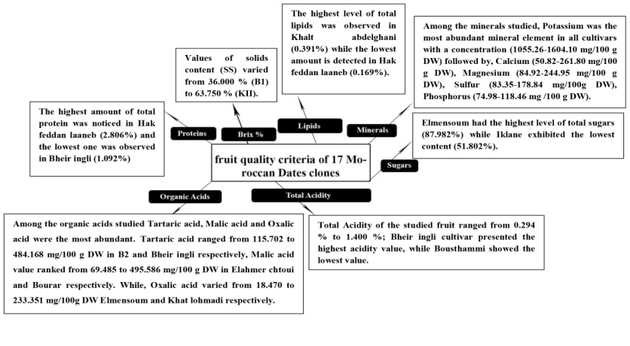

Figure 1 : Evaluation of some fruit quality criteria of 17 Moroccan dates clones.

Recent Publications
- J. Ayour et al., “Evolution of some fruit quality criteria during ripening of twelve new Moroccan apricot clones (Prunus armeniaca L.),” Sci. Hortic. (Amsterdam)., vol. 215, 2017.


Biography
Alahyane Abderrahim was born in Agadir city (Morocco), in 1990. He is a PhD student in Food Biochemistry, food sciences laboratory, Cadi Ayyad University Marrakesh, under the supervision of professors Benichou Mohamed and Ahmed Ait-Oubahou. His main research interest is: Food biochemistry.
Email: ab.alahyanegmail.com

