Carcass characteristics of lambs finishing with the use of mycotoxin adsorbent in ration
Fabiola Cristine de Almeida Rego Grecco, Dra.
University of Northern Paraná
Brazil

Abstract
Concentrates and roughages used in ruminant ration are favorable environments for the development of fungi, making the food contaminated through the production of mycotoxins. The objective of this work was to evaluate the use of mycotoxin adsorbents in lamb finishing rations and their effects on attributes of carcass. Were used 24 Texel breed lambs, 12 males and 12 females, weight of 18.6 kg ± 1.6, distributed in both treatments, allocated in 12 bays, with 2 animals per bay. The experimental design was completely randomized, in a 2 x 2 factorial scheme and six repetitions per treatment. The rations contained, in the dry matter (DM), 30% of corn silage and 70% of concentrate (consisting of ground corn, soybean meal, agricultural residue, calcitic limestone, soybean oil and mineral mix), containing 72% of total digestible nutrients and 16% of crude protein. The rations of both treatments were analyzed for mycotoxin (aflatoxin B1, fumonisin B1 and B2, zearalenone and desoxynilvalenol) composition by Samitec laboratory (Analytical Microbiological and Technological Solutions Ltda.), by high performance liquid chromatography (HPLC) method. The samples of ground corn evaluated showed high contamination by fumonisin (1140.8 to 1738.6 μg/kg) and 1.3 μg/kg by aflatoxin B1.The data were submitted to variance analysis and when significant were submitted to the Tuckey test, at 5% level. There was no effect of adsorbent, sex and interaction between treatment and sex for any of the variables (p>0.05). The animals were slaughtered with 26.4 kg ± 2.2 after 39 days of confinement. The hot carcass performance of lambs were 45.36 kg ± 2.26. The cold carcass performance were 44.12 ± 2.24. The true carcarss performance were 51.09 ± 2.59. The use of mycotoxin adsorbent in lambs rations doesn’t alter the carcass variables.

Image
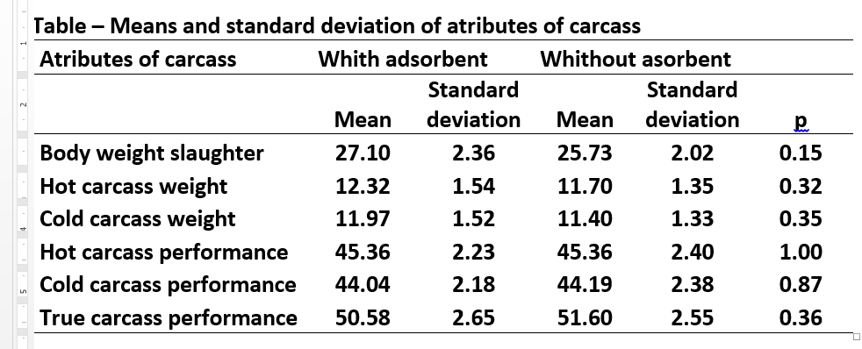

Recent Publications
- Blandino M, Reyneri A, Vanara F (2008) Influence of nitrogen fertilization on mycotoxin contamination of maize kernels. Crop Prot 27:222–230.
.
- Bullerman L. B., Bianchini A (2007) Stability of mycotoxins during food processing. Int J Food Microbiol 119:140–146.
- Logrieco A, Mulè G, Moretti A, Bottalico A. (2002)Toxigenic Fusarium Species and Mycotoxins Associated with Maize Ear Rot in Europe. European Journal of Plant Pathology, 108: 597–609.
.
- Maike T. M. , Bersot.L. S. (2010) Micotoxinas em alimentos produzidos no Brasil. Revista Brasileira de Produtos Agroindustriais, 12,.89-99.
- Streit E., Schatzmayr G., Tassis P. Tzika E., Marin D.,Taranu I., Tabu C., Nicolau A., Aprodu J., Puel O.,Oswald I. P. (2012) Current Situation of Mycotoxin Contamination and Co-occurrence in Animal Feed—Focus on Europe. Toxins , 4(10), 788-809.



Biography
Fabiola Rego has her expertise in Animal Science, with emphasis on Production of Ruminants. Her experimental model based on improving animal performance responses, using diversified products and by-products in the animal diet. Acts as a teacher and researcher of the Strictu Sensu Master Program in Health and Production of Ruminants, University of Northern Paraná.
Email: fabiolaregogrecco@gmail.com
Notes/Comments:

