INTRODUCTION

Background of the Study
Water quality refers to the suitability of water based on chemical, physical, biological, and radiological characteristics of water. It is a measure of the condition of water relative to the requirements of one or more biotic species and or to any human need or purpose. It is most frequently used by reference to a set of standards against which compliance can be assessed. The parameters of water quality are determined by its intended use. Work in the area of water quality tends to focus on water that is treated for human consumption, industrial use, or for the environment. Two potential groundwater contaminants are the inorganic chemicals, calcium from the limes of fertilizers and cadmium from phosphate fertilizer.
Cadmium is toxic and mutagenic. It damages the kidneys and causes anemia and bone diseases. The main exposure route for humans in Europe is the consumption of contaminated agricultural products. Cadmium is relatively easily absorbed from the soil by plants, therefore it is accumulated in the food chain. Phosphate fertilizers are identified as an important source of Cadmium in the soil. Cadmium is a natural contaminant of phosphate rocks and its final content in the fertilizer depends both on the type of raw material, as well as on the manufacturing method. The strict limit of Cadmium content in phosphate fertilizers, due to the unclear reasons behind its implementation, is criticized strongly by the fertilizer industry.
A calcium level that is too high is also harmful to the body. Abnormally high blood calcium levels are usually due to certain disease conditions rather than excessive calcium intake. The causes of high blood calcium levels include bone cancer, overactive thyroid gland or hyperthyroidism and overactive parathyroid gland or hyperparathyroidism. Examples of health conditions that can cause high blood calcium level include kidney stones or nephrolithiasis and milk-alkali syndrome. Calcium can also disrupt the absorption of iron, zinc, magnesium and phosphorous, leading to the deficiency of these essential minerals.

Statement of the Problem
It has been years since the water source of CMU comes the spring water. Before the construction of the deep well and pumping station, 100% of the households and the people in the University rely on springs as their only source of water. Before, the areas which are tributaries to the springs had negligible farming activities. But since 1980s to present, most of the areas are already cultivated. Various farming practices involve contour farming and fertilizer application.
Commercial fertilizers are the major source of pollutants. Without proper use, the soil and the groundwater can be greatly affected. The springs are surrounded with upland fields that use fertilizers to enhance their yields. Commercial fertilizers contain cadmium and calcium that are highly soluble. Accumulation of the said chemicals in drinking water can causes serious health problems.
Significance of the Study
A part of inorganic fertilizers which are applied in the upland farms can leach to the groundwater. Due to the contamination of the spring water by calcium and cadmium, the quality of spring water is compromised. An initial finding on the presence of cadmium and calcium in the spring water at Musuan, Dologon, Maramag, Bukidnon was reported by Toos (2015) during wet season. This study confirmed the effect of farming on water quality.

Objectives of the Study
Generally, the main objective of the study was to determine the effects of fertilizer used in upland farming to the spring water quality at Musuan, Dologon, Maramag, Bukidnon during drought.
The specific objectives were as follows:
- To determine the farming practices of the farmers nearby the springs;
- To determine the concentration of cadmium and calcium from CMU spring water during ENSO (El Niño Southern Oscillation) 2015-2016 (warm episode);
- To interpret the laboratory test results and compare them to the Philippine National Standard of Drinking Water Criteria for Inorganic Constituents; and
- To compare the concentration of cadmium and calcium between the previous non-ENSO year and the current ENSO year.

Scope and Limitations of the Study
The extent of fertilizer application, kinds of fertilizer used and crops planted from previous cropping period were determined through an interview with the farmers only, whose farmlands were adjacent to the springs. The parameters were calcium and cadmium which are highly soluble and always present in all commercial fertilizers and highly hazardous to the human health if taken too much.
The water samples were taken only from spring sources number 2 and 3 because these are the sources previously used by Central Mindanao University Water System.

Time and Place of the Study
The study was conducted at Musuan, Dologon, Maramag, Bukidnon. Data collection was done from March 2016 to May 2016.

REVIEW OF RELATED LITERATURE

Water Quality Issue
According to Water Quality Monitoring - A Practical Guide to the Design and Implementation of Freshwater Quality Studies and Monitoring Programmes prepared by Meybeck, Kuusisto, Mäkelä, and Mälkki (2012), water quality is a term used to express the suitability of water to sustain various uses or processes. Any particular use will have certain requirements for the physical, chemical, or biological characteristics of water. For example, limits on the concentrations of toxic substances for drinking water use, or restrictions on temperature and pH ranges for water supporting invertebrate communities. Consequently, water quality is defined with a range of variables which limit water use. Although many uses have some common requirements for certain variables, each use will have its own demands and influences on water quality.

Water Composition
As stated by the Word Health Organization (1998), the composition of surface and underground waters is dependent on natural factors (geological, topographical, meteorological, hydrological and biological) in the drainage basin and varies with seasonal differences in runoff volumes, weather conditions and water levels. Large natural variations in water quality may be observed even where only a single watercourse is involved. Human intervention also has significant effects on water quality. Some of these effects are the result of hydrological changes, such as the building of dams, draining of wetlands, and diversion of flow. More obvious are the polluting activities, such as the discharge of domestic, industrial, urban and other wastewaters into the watercourse (whether intentional or accidental) and the spreading of chemicals on agricultural land in the drainage basin.
The quality of water may be described in terms of the concentration and state (dissolved or particulate) of some or all of the organic and inorganic materials present in the water, together with certain physical characteristics of the water. It is determined by in situ measurements and by examination of water samples on site or in the laboratory. The main elements of water quality monitoring are on-site measurements, the collection and analysis of water samples, the study and evaluation of the analytical results, and the reporting of the findings. The results of analyses performed on a single water sample are only valid for the particular location and time at which that sample was taken. One purpose of a monitoring program is to gather sufficient data (by means of regular or intensive sampling and analysis) to assess spatial and/or temporal variations in water quality.

Characteristics of Groundwater
According to Chilton and Chapman (1996), groundwater is held in the pore space of sediments such as sands or gravel or in the fissures of fractured rock such as crystalline rock and limestone. The body of rock or sediments containing the water is termed as an aquifer and the upper water level in the saturated body is termed as the water table. Typically, groundwaters have a steady flow pattern. Velocity is governed mainly by the porosity and permeability of the material through which the water flows and it is often up to several orders of magnitude less than that of surface waters. The media (rock or sediment) in an aquifer are characterized by porosity and permeability. Porosity is the ratio of pore and fissure volume to the total volume of the media. It is measured as percentage voids and denotes the storage or water volume of the media. Permeability is a measure of the ease with which fluids in general may pass through the media under a potential gradient and indicates the relative rate of travel of water or fluids through media under given conditions. For water, it is termed as hydraulic conductivity.

Cadmium in Water
Cadmium concentrations in unpolluted natural waters are usually below 1 µg/l (Friberg et al., 1986). Median concentrations of dissolved cadmium measured at 110 stations around the world were <1 µg/l, the maximum value recorded being 100 µg/l in the Rio Rimao in Peru (WHO/UNEP, 1989). Average levels in the Rhine and Danube in 1988 were 0.1 µg/l (range 0.02–0.3 µg/l) (ARW, 1988) and 0.025 µg/l (AWBR, 1988), respectively. In the sediments near Rotterdam harbor, levels in mud ranged from 1 to 10 mg/kg dry weight in 1985–1986, down from 5–19 mg/kg dry weight in 1981 (Ros & Slooff, 1987).
Contamination of drinking-water may occur as a result of the presence of cadmium as an impurity in the zinc of galvanized pipes or cadmium-containing solders in fittings, water heaters, water coolers and taps. Drinking-water from shallow wells of areas in Sweden where the soil had been acidified contained concentrations of cadmium approaching 5 µg/l (Friberg et al., 1986). In Saudi Arabia, mean concentrations of 1– 26 µg/l were found in samples of potable water, some of which were taken from private wells or cold corroded pipes (Mustafa et al., 1988). Levels of cadmium could be higher in areas supplied with soft water of low pH, as this would tend to be more corrosive in plumbing systems containing cadmium. In the Netherlands, in a survey of 256 drinking-water plants in 1982, cadmium (0.1–0.2 µg/l) was detected with only 1% of the drinking water samples (Ros & Slooff, 1987).
A number of new studies of cadmium exposure and health impact in human populations have been carried out and reviewed by Jarup et al. (1998). These include studies of kidney dysfunction and osteoporosis. Some data indicate that adverse effects may occur at lower exposures than was previously thought. Although these data indicate that a proportion of the general population may be at an increased risk for tubular dysfunction when exposed to cadmium at the PTWI. The risk estimates that can be made with current information are imprecise. JECFA (2000a, b) considered all of the new data but decided that, in view of the uncertainties, the existing PTWI of 7 µg/kg of body weight should be retained.

Health Effects of Cadmium
The US WQA (Water Quality Association) (2015) has established a Maximum Contaminant Level (MCL) of 0.005 milligrams per liter (mg/L) for cadmium in drinking water. The Agency has found cadmium to potentially cause a variety of effects from acute exposures, including: nausea, vomiting, diarrhea, muscle cramps, salivation, sensory disturbances, liver injury, convulsions, shock and renal failure. Drinking water levels which are considered "safe" for short-term exposures are: 0.04 mg/L for a 10-kg (22 lb.) child consuming 1 liter of water per day for one- to ten-day exposures, and 0.005 mg/L for a longer-term (up to 7 years) exposure. WQA has established a reference dose (RfD) for cadmium at – 5x10-4 mg/kg/day. The RfD is based upon chronic intake that will result in the kidney concentration of 200 µg/g. No-observed-adverse-effect level (NOAEL) for Cadmium for humans is 0.01 mg/kg/day. Cadmium has the chronic potential to cause kidney, liver, bone, and blood damage from long- term exposure at levels above the MCL. There is an inadequate evidence to state whether or not cadmium has the potential to cause cancer from lifetime exposures in drinking water.

Cadmium in Phosphate Fertilizers
Cadmium is toxic and mutagenic. It damages the kidneys and causes anemia and bone diseases. The main exposure route for humans in Europe is the consumption of contaminated agricultural products. Cadmium is relatively easily absorbed from the soil by plants, therefore it is accumulated in the food chain. Phosphate fertilizers are identified as an important source of Cadmium in the soil. Cadmium is a natural contaminant of phosphate rocks and its final content in the fertilizer depends both on the type of raw material, as well as on the manufacturing method. The strict limit of Cadmium content in phosphate fertilizers, due to the unclear reasons behind its implementation, is criticized strongly by the fertilizer industry. The average Cadmium content in fertilizers marketed in Europe is estimated to be 45 mg Cd/kg P₂ O₅. The limit of 60 mg Cd/kg P₂ O₅ will exclude from the market about 21% of currently sold fertilizers, while the introduction of strict limit of 20 mg Cd/kg P2 O5 may cause serious disturbances of the Community market. Currently in Europe, only one company, Yara, has a low-cadmium apatite reaches such content of Cadmium. The strong centralization of phosphorus deposits outside Europe, puts Europe in the position of strong dependency from external producers, while the shortage risk at the fertilizer market translates into the threat for food production. The importance of the problem is additionally emphasized by the inclusion of phosphate raw materials in Critical Raw Material list.

Calcium Intake in Plants
Agriculture Solutions, Inc. (2012) outlines that calcium is widely recognized for its important function in plants to increase nutrient uptake, build strong cell walls for sturdier plants, and increase vitality. Maintaining high levels of bio-available calcium in the soil is critical in achieving adequate levels of Calcium uptake. Calcium plays a very important role in plant growth and nutrition, as well as in cell wall deposition. The primary roles of Calcium as a soil amendment are to help maintain chemical balance in the soil, reduce soil salinity, and improve water penetration. Calcium also plays a critical metabolic role in carbohydrate removal and neutralizing cell acids. Every plant needs Calcium to grow. However, once fixed, Calcium is not mobile in the plant. It is an important constituent of cell walls and can only be supplied in the xylem sap. Thus, if the plant's supply of Calcium is diminished, it cannot remobilize Calcium from its older tissues. If transpiration is reduced for any reason, the Calcium supply to growing tissues will rapidly become inadequate.
Calcium Toxicity
As clarified by Dr. Ananya Mandal (2014), a calcium level that is too high is also harmful to the body. Abnormally high blood calcium levels are usually due to certain disease conditions rather than excessive calcium intake. With excessive intake, the intestines are programed to shut off further absorption, which prevents calcium intoxication. The causes of high blood calcium levels include bone cancer, overactive thyroid gland or hyperthyroidism and overactive parathyroid gland or hyperparathyroidism. Examples of health conditions that can cause high blood calcium level include kidney stones or nephrolithiasis and milk-alkali syndrome. Calcium can also disrupt the absorption of iron, zinc, magnesium, and phosphorous, leading to the deficiency of these essential minerals.

MATERIALS AND METHODS

The procedural framework used in the study is shown in Figure 1. In this study the following major activities were done which includes: spring water site selection and collection of water samples, laboratory analysis, coordination activities, interview, and data interpretation.
START
Coordination Activities

Spring Water Site Selection
and
Collection of Water Samples
Development of Survey Questionnaire

Data Collection on the Farm Practices of the Respondents on their Previous Cropping Season

Laboratory Analyses
- Calcium Analysis
- Cadmium Analysis

Data Interpretation

END

Figure 1. Procedural Framework of the Study
Locale of the Study
The Musuan, Dologon, Maramag, Bukidnon spring water sources were within the geographical coordinates situated 7$°$50’30’’ to 7$°$53’00’’ north latitude and 125$°$1’30’’ to 125$°$00’3’’ east longitude. It is approximately eighty kilometers away from Cagayan de Oro City. The spring tributaries have a total area of 464 hectares and cover portions of Barangay Dologon on the southern part of Central Mindanao University (CMU), and portion of Barangay Kisanday specially Sitio Kibalagon (Purok 8) and Sitio Narukdukan (Purok 6), and a part of Barangay Guinoyoran, Valencia, specifically Sitio Cabanbanagan. At the eastern part of the spring sources is the Sayre Highway and on the southwestern part is the Dologon-Kisanday barangay road (Figure 2).

Coordination Activities
A communication letter was sent to the barangay chairman of Dologon, Maramag, Bukidnon, Guinoyoran, Valencia, Bukidnon, and Kisanday, Maramag, Bukidnon. The researcher asked permission to conduct the study and for the information about the farmers and other relevant data to be used in the study.

Spring Water Site Selection
The area has four existing groundwater sources. These sources are spring water number 1, 2, 3, and 4. Source number 1 is located near the University Sawmill of Central Mindanao University, then sources number 2 and 3 are located near the University Rubber Plantation, and source number 4 is located along Barangay Kisanday road. The researcher obtained the coordinates of each spring water source using a hand-held Global Positioning System (GPS) device. Sources number 2 and 3 were previously used by Central Mindanao University Water System and source 1 is currently used by Barangay Kisanday water system.
Table 1. Location and Coordinates of the Spring Water Sources
Spring Water Source Number | Coordinates
Spring Water Source Number | Latitude | Longitude
Spring No.2 | 7.86356$°$ N | 125.03276$°$ E
Spring No. 3 | 7.86839$°$N | 125.03497$°$E

Water Sample Collection
Water samples were gathered from the main service areas. A total of four samples for the two parameters were collected on the March 18, 2015 in the afternoon. The plastic bottles were not opened until they were ready for filling. It was made sure that the bottles were not contaminated especially the cap and the neck of the bottles. The plastic bottles were filled after washing them with the spring water. An ample space of 2.5 cm was left for each bottle to facilitate mixing by shaking. The water samples were indicated through the color of their plastic cap and they were labeled also to avoid confusions. The water sample from spring 2 was sealed with a color green plastic cap and white plastic cap for spring 3. Aside from those indications, it was labeled through a masking tape to avoid misleading of the samples. The water samples were placed directly into an ice bucket with a temperature less than 10ºC containing ice as it was recommended by the DOST and Unifruitti. On March 28, 2016, the samples were delivered to the laboratory of DOST and Unifrutti.

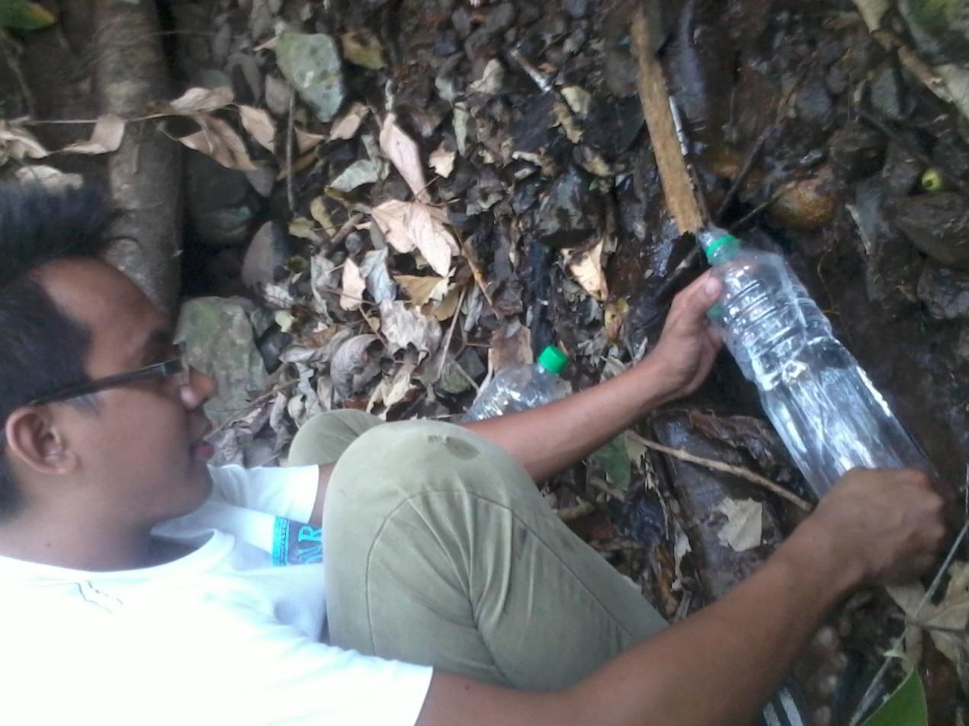

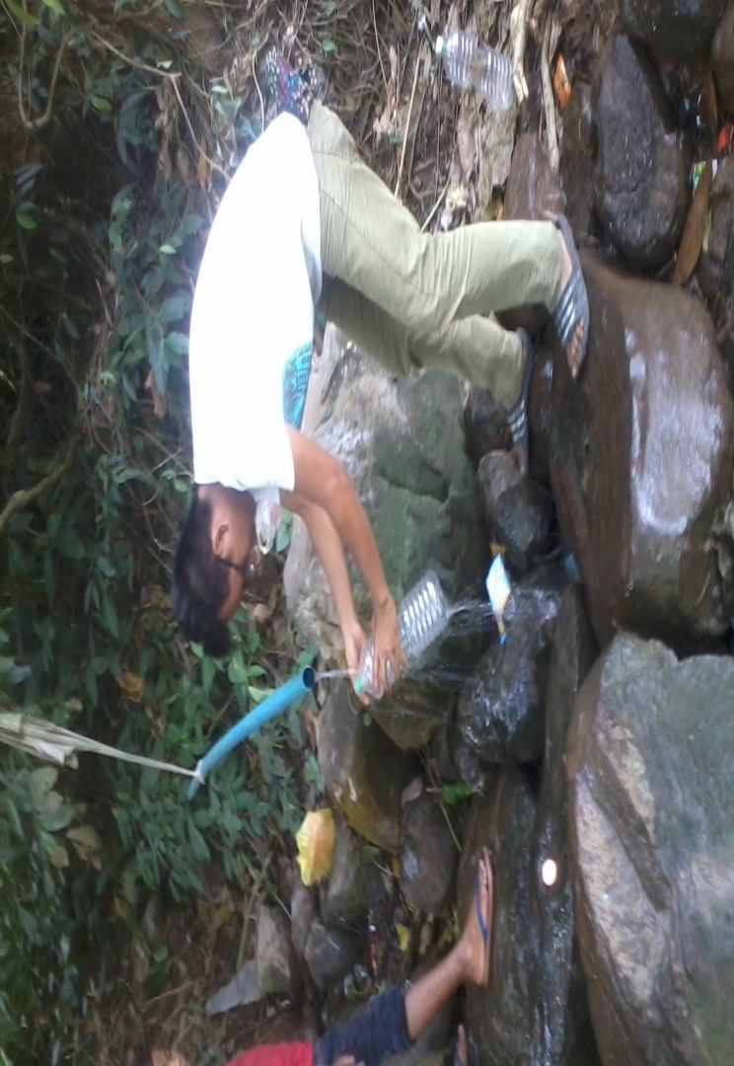
Figure 3. Spring source number 2

Figure 4. Spring source number 3

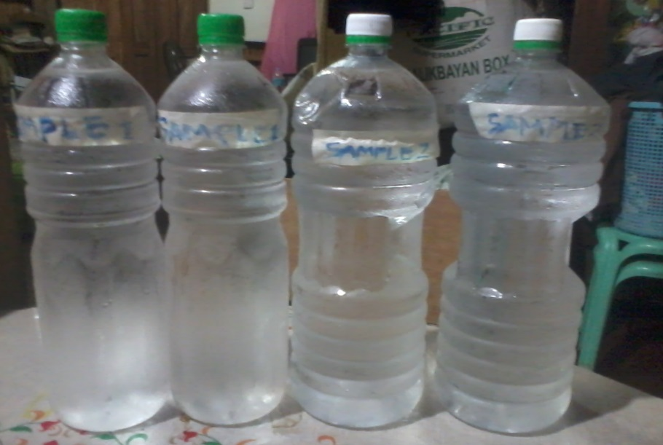


Figure 5. Chilled Water Samples Intended for Cadmium and Calcium Test

Figure 6. Unifrutti Office and Laboratory Entrance

Laboratory Analysis of Collected Water Samples
Laboratory analysis for calcium test was conducted at the Unifruitti Tropical Philippines Inc., MKAVI-1 Compound, Alanib, Lantapan, Bukidnon while the cadmium test was conducted at the Regional Standards and Testing Laboratories Department of Science and Technology, Carmen, Cagayan de Oro City. The method used for the samples subjected to Calcium Test was Ca-HCl/HNO₃ Extraction, AAS. On other hand, the method used for the samples subjected to Cadmium Test was 3030K and 3111b, SMEWW 21st edition.

Interview with the Farmers
A personal interview with the upland rice farmers was conducted at Sitio Kibalagon (Purok 8) and Sitio Narukdukan (Purok 6), Barangay Kisanday, Maramag, Bukidnon and Sitio Cabanbanagan Barangay Guinoyoran, Valencia, Bukidnon in random. A total of 11 upland farmers were interviewed. This was done to evaluate their cultural practices in farming and the fertilizers that they used during their last cropping season. The personal data and economic profile of the respondents were gathered.

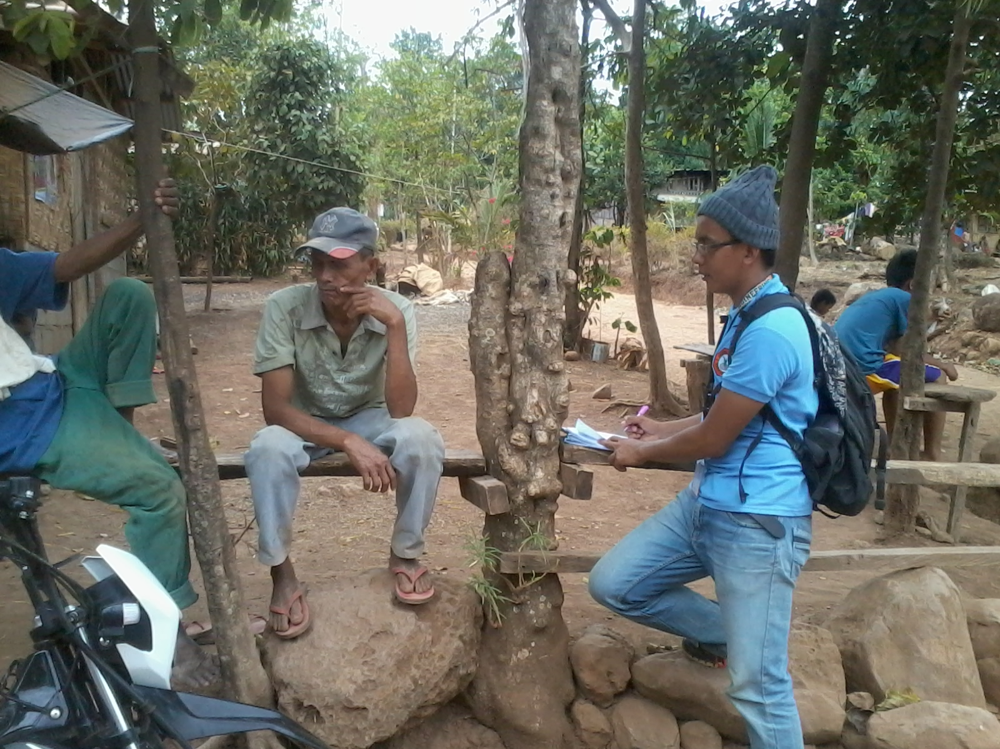

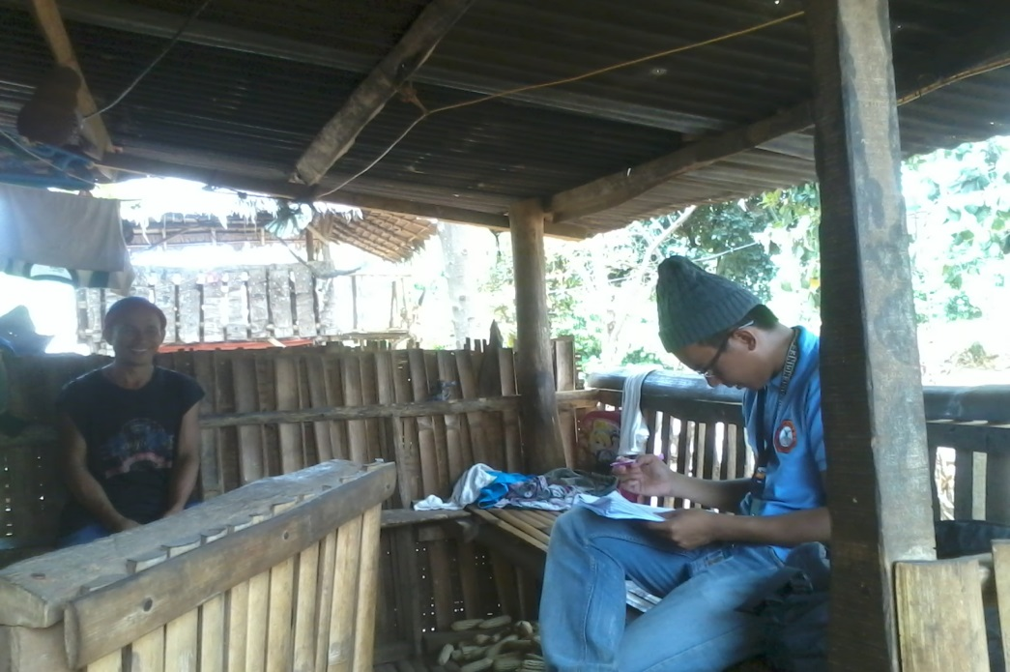

Figure 7. Interview with the Farmers

Data Interpretation
After the laboratory released the laboratory results, the data were interpreted base on the Philippine National Standards for Drinking Water for the Inorganic Constituents Standard Values for Physical and Chemical Quality: Health Significance for the maximum allowable level of contamination for Cadmium which is 0.003 mg/L and Calcium which is 300mg/L.

RESULTS AND DISCUSSIONS

Farmers believed in many practices in farming crops. The type of cultivation is known to be upland farming, depending on the rain as their source of water. Upland farmers in the tributary areas can accommodate two croppings per year for corn, rice, and banana and once a year for cassava and sugarcane. For corn, most farmers apply fertilizer twice per cropping while others cannot apply even once per cropping. They also apply fertilizer before planting which is termed as basal application and 30 days after planting called side dressing. For cassava, they do not apply fertilizer.
The survey for the cultural practices of the farmers were limited only to their last cropping season. A total of 10 hectares per crop (cassava, corn, and sugarcane) and a hectare of the rice were the extent of the survey with a total of 11 respondents. About 6 out of 11 farmers effectively used inorganic fertilizers such as 14-14-14, 21-0-0, 46-0-0 and 16-20-0 fertilizers and none of them used 0-0-60. Most of them (4 out of 6) applied fertilizers twice per cropping. The use of pesticides, insecticides and fungicides were not merely practiced by the farmers. For weed management, about 3 out of 11 farmers applied herbicides as their weed control practice specifically roundup, clincher, 24D, and atrazine. Liming was not verily practiced by the farmers in the site. To be more comprehensive, Table 2 and the survey results in the appendix can be used as reference.

Table 2. Inorganic Substance Applied
Category | Frequency(N=11) | Percent
Fertilizers  - Application Frequency  - None  - Once per cropping  - Twice per cropping  - Application Rate  - None  - 1 bag/cropping/ha.  - 2 bags/cropping/ha.  - >2 bags/cropping/ha. | 5  2  4  5  2  0  4 | 45.45  18.18  36.36  45.45  18.18  0  36.36
Pesticides/Insecticides/Fungicides  - Application Frequency  - None  - Once per cropping  - Twice per cropping  - Application Rate  - None  - 1 liter/cropping/ha.  - 2 liter/cropping/ha | 11  0  0  11  0  0 | 100  0  0  100  0  0
Herbicides  - Application Frequency  - None  - Once per cropping  - Twice per cropping  - Application Rate  - None  - 1 liter/cropping/ha.  - 2 liter/cropping/ha. | 8  1  2  8  2  1 | 72.73  9.09  18.18  72.73  18.18  9.09
Liming  - Applied  - Applied Nothing | 0  11 | 0  100

Personal Profile of the Respondents
Table 3 reveals the personal profile of the farmers farming on areas which are tributaries to the spring water sources. Majority of the respondents were male (81.82%) and followed by female (18.18%). In terms of age, the majority (54.55%) of the respondents were 31-50 years old, followed by the respondents with 50 years old and above (45.45%) and nothing was recorded with 21-30 years old. There is an equal percentage of respondents between 20-30 years in farming and 31-50 years in farming (45.45%), and least at greater than 50 years of farming (9.09%).
Table 3. Personal Profile of the Respondents
Category | Frequency(N=11) | Percent
AGE  20-30 y/o  31-50 y/o  >50 y/o | 0  6  5 | 0  54.55  45.45
SEX  Male  Female | 9  2 | 81.82  18.18
EDUCATIONAL ATTAINMENT  Elementary Level  Elementary Graduate  Secondary Level  Secondary Graduate  College Level  College Graduate | 8  2  1  0  0  0 | 72.73  18.18  9.09  0  0  0
YEARS OF FARMING  20-30 years  31-50 years  >50 years | 5  5  1 | 45.45  45.45  9.09

Economic Profile of the Respondents
Table 4 shows the economic profile of the farmers farming on areas which are tributaries to the spring water sources. It shows that the main source of the respondents’ income was farming. All of the respondents had a land area ranging from 1-10 hectares and nothing was recorded of owning 10-20 hectares and beyond 20 hectares. Most (54.55%) of the respondents used inorganic fertilizers and about 45.45% did not use fertilizers due to lack of finances.

Table 4. Economic Profile of the Respondents
Description | Frequency(N=11) | Percent
Sources of Income  - Farming | 11 | 100
Size of Land (ha.)  - 1-10  - 10-20  - >20 | 11  0  0 | 100  0  0
Fertilizer  - Inorganic only  - Organic only  - Both Inorganic and Organic  - Do not used Fertilizer | 6  0  0  5 | 54.55  45.45

Fertilizer Used by the Respondents
Table 5 shows the fertilizer used by the farmers farming on areas which are tributaries to the spring water sources. About 27.27 % of the respondents used Complete 14-14-14, Ammonium Phosphate (16-20-0), Ammonium Sulfate (21-0-0), and Urea (46-0-0), 9.09 %of the respondents used Muriat of Potash (0-0-60) and about 45.45 % of the respondents did not used fertilizers.
Table 5. Fertilizer Used by the Respondents
Fertilizer Used | Frequency(N=11) | Percentage
Complete 14-14-14 | 3 | 27.27
Ammonium Phosphate 16-20-0 | 3 | 27.27
Ammonium Sulfate 21-0-0 | 3 | 27.27
Muriat of Potash 0-0-60 | 1 | 9.09
Urea 46-0-0 | 3 | 27.27
Nothing Used | 5 | 45.45

Amount of Cadmium present in Spring Number 2 and Spring Number 3
The following data were the results of Cadmium analysis obtained at the Department of Science and Technology Region-X in spring number 2 and 3.
Table 6. Amount of Cadmium in ppm during ENSO 2015-2016(warm episode)
Sample Description | Method Used | Result
Spring number 2  Spring number 3 | Method 3030K and 3111B, SMEWW 21st Edition | MDL=0.0038ppm  MDL=0.0038ppm

Table 7. Amount of Cadmium in ppm during the wet season of 2014
Sample Description | Method Used | Result
Spring number 2  Spring number 3 | Method 3030K and 3111B, SMEWW 21st Edition | LOD=0.0096ppm  LOD=0.0096ppm
Source: Toos (2015)
Since the result were given in parts per million (ppm), it should be converted in mg/L. Since the solution is water which has density of 1kg/L, therefore 1ppm=1mg/L.
The data shown above were the amount of Cadmium traces examined in the Laboratory Test Report at the Department of Science and Technology in spring number 2 and 3. Using the Standard Method of Examination for Water and Waste Water method number 3030K and 3111B known in the laboratory as Microwave-Assisted Digestion and Flame Atomic Absorption Spectrometry, the amount of Cadmium concentration in the two springs were determined. The spring 2 and 3 had a result of MDL=0.0038ppm during ENSO 2015-2016 (warm episode) and a result of LOD=0.0096ppm during the wet season of 2014. This amount of Cadmium level in the water samples indicates that the spring water in the two springs is not safe for drinking according to the Philippine National Standard for drinking water of 2007 on the list of Standard Values for Physical and Chemical Quality: Health Significance for Inorganic Constituents given the value for the maximum level for Cadmium as 0.003 mg/L. The table for the safe level or the maximum level set by the Philippine National Standards for Drinking Water is shown in Appendix Table 1.
Both springs were tested during ENSO 2015-2016 (warm episode) and during the wet season of 2014. The results revealed that the water is unsafe for human consumption compared to 0.003mg/L set by the PNSWD for the inorganic constituents. This level of Cadmium concentration can be hazardous to human health.

Amount of Calcium present in Spring Number 2 and Spring Number 3

The following data were the results of Calcium analysis conducted at Unifruitti Tropical Philippines, Inc., MKAVI-1 Compound, Alanib, Lantapan, Bukidnon in spring number 2 and 3.
Table 8. Amount of Calcium in ppm during ENSO 2015-2016 (warm episode)
Sample Description | Method Used | Result
Spring number 2  Spring number 3 | Ca-HCl/HNO₃ Extraction, AAS | 13.51ppm  13.13ppm

Table 9. Amount of Calcium in ppm during wet season of the 2014
Sample Description | Method Used | Result
Spring number 2  Spring number 3 | Ca-HCl/HNO₃ Extraction, AAS | 2.87ppm  2.75ppm
Source: Toos (2015)
The data shown above are the amount of Calcium traces stated in the Laboratory Test Report by the MKAVI in spring number 2 and 3 using the standard Ca-HCl/HNO₃ Extraction, AAS. For the spring number 2 and 3, the results were 13.51 ppm and 13.13 ppm respectively during ENSO 2015-2016 (warm episode) and 2.87 ppm and 2.75 ppm respectively during the wet season of 2014. This amount of Calcium level in the water samples indicates that the spring water in the two springs is safe for drinking according to the Philippine National Standard for drinking water of 2007 on the list of Standard Values for Physical and Chemical Quality: Health Significance for Inorganic Constituents given the value for the maximum level for Calcium as 300 mg/L. The table for the safe level or the maximum level set by the Philippine National Standards for Drinking Water is shown in Appendix Table 1.
Both springs were tested during ENSO 2015-2016(warm episode) and during the wet season of 2014 and the results revealed that the water is safe for human consumption compared to 300 mg/L set by the PNSWD for the inorganic constituents. This level of Calcium Concentration is tolerable to human health.

SUMMARY, CONCLUSION AND RECOMMENDATION

Summary
Water quality refers to the suitability of water based on chemical, physical, biological, and radiological characteristics of water. It is most frequently used by reference to a set of standards against which compliance can be assessed. Two potential groundwater contaminants are the inorganic chemicals calcium from limes of fertilizers and cadmium from phosphate fertilizer. Cadmium is toxic and mutagenic. It damages kidneys and it causes anemia and bone diseases. Cadmium has the chronic potential to cause kidney, liver, bone, and blood damage from long term exposure at levels above the MCL (Maximum Contamination Level). A calcium level that is too high is also harmful to the body. Calcium can also disrupt the absorption of iron, zinc, magnesium and phosphorous, leading to the deficiency of these essential minerals. This study provides a water quality testing information that would assist the residents of Musuan, Dologon, Maramag, Bukidnon using the spring water for consumption and how the farming practices particularly the fertilizer application in uplands affects the ground water quality during ENSO 2015-2016 (warm episode) and wet season of 2014. The study was limited only to the evaluation of the farming practices particularly the fertilizer application in the upland farming in the tributaries of the springs at Musuan, Dologon, Maramag, Bukidnon and to determine the amount of fertilizer residues (calcium and cadmium) in the water after analyzing the water quality in the laboratory.
The amount of Cadmium traces obtained in the Laboratory Test Report by the Department of Science and Technology in spring number 2 and 3. Using the Standard Method of Examination for Water and Waste Water method number 3030K and 3111B known in the Llboratory as Microwave-Assisted Digestion and Flame Atomic Absorption Spectrometry the amount of Cadmium concentration in the two springs were detected. The spring 2 and 3 had a result of MDL=0.0038ppm during ENSO 2015-2016(warm episode) and a result of LOD=0.0096ppm during the wet season of 2014. The amount of Cadmium level in the water samples indicates that the spring water in the two springs is not safe for drinking according to the Philippine National Standard for Drinking Water of 2007 on the list of Standard Values for Physical and Chemical Quality: Health Significance for Inorganic Constituents given the value for the maximum level for Cadmium as 0.003 mg/L. The results show the amount of Calcium traces were conducted in the Laboratory Test Report by the MKAVI in spring number 2 and 3 using the standard Ca-HCl/HNO₃ Extraction, AAS. For the spring number 2 and 3, the results were 13.51 ppm and 13.13 ppm respectively during ENSO 2015-2016 (warm episode) and 2.87 ppm and 2.75 ppm respectively during the wet season of 2014. The amount of Calcium level in the water samples indicates that the spring water in the two springs is safe for drinking according to Philippine National Standard for Drinking Water of 2007 on the list of Standard Values for Physical and Chemical Quality: Health Significance for Inorganic Constituents given the value for the maximum level for Calcium as 300 mg/L.

Conclusions
The amount of Cadmium concentration surpassed its MCL (Maximum Concentration Level) and the study concludes that the water is hazardous to human health. However, the level of Calcium concentration was below the MCL and was tolerable to human health. On other hand, the results showed that Cadmium concentration of spring number 2 and 3 during the wet season of 2014 decreased during ENSO 2015-2016 (warm episode). The result shows that the fertilizers were the possible source of the contamination. The Cadmium concentration decreased because no leaching had happened and farm activities were not solely performed since the land experiences drought. In terms of calcium content, the calcium concentration of spring number 2 and 3 increased during ENSO 2015-2016 (warm episode). Therefore, the possible source of the calcium came from the rocks in the groundwater. The concentration of calcium in the groundwater increased due to the drought because no infiltration occurred that would increase the water volume of the groundwater.

Recommendation
Based on the collected data and the conclusions made, it is recommended that the Cadmium and calcium content of the soil will also be tested.

LITERATURE CITED

Chilton, J. 1996 Groundwater. In: D. Chapman [Ed.] Water Quality Assessments. A Guide to the Use of Biota, Sediments and Water in Environmental Monitoring. 2nd edition. Chapman & Hall, London.

Fernando, S.M.B, 2015.Effects of Fertilizer Application in Lowland Rice Farming to the Ground Water Quality in Pinatilan, Valencia City, Bukidnon

Foster, S.S.D. and Gomes, D.C. 1989 Groundwater Quality Monitoring: An Appraisal of Practices and Costs. Pan American Centre for Sanitary Engineering and Environmental Science (CEPIS), Lima

Foster, S.S.D. and Hirata. R. 1988 Groundwater Pollution Risk Assessment: A Method Using Available Data. Pan American Centre for Sanitary Engineering and Environmental Science (CEPIS), Lima.

IARC (International Agency for Cancer) (1976) Cadmium, nickel, some epoxides, miscellaneous industrial chemicals and general considerations on volatile anaesthetics. Lyon, International Agency for Research on Cancer, pp. 39–74 (IARC Monographs on the Evaluation of the Carcinogenic Risk of Chemicals to Man, Vol. 11).

Toos, S.M.D, 2015. Effects of Fertilizer Application in Upland Farming to the Quality of Spring Water in Musuan, Dologon, Maramag, Bukidnon

Mustafa HT et al. (1988) Cadmium and zinc concentrations in the potable water of the eastern provinces of Saudi Arabia. Bulletin of Environmental Contamination and Toxicology, 40:462–467.

Waalkes MP, Rehm S (1994) Cadmium and prostate cancer. Journal of Toxicology and Environmental Health, 43:251–269.

Electronic References:

http://www.agriculturesolutions.ca/calcium-overview
http://www.who.int/water_sanitation_health/resourcesquality.pdf
http://www.who.int/water_sanitation_health/dwq/chemicals/cadmium.pdf
https://www.wqa.org/Portals/0/Technical/Technical%20Fact%20Sheets/2015_Cadmium.pdf

APPENDICES

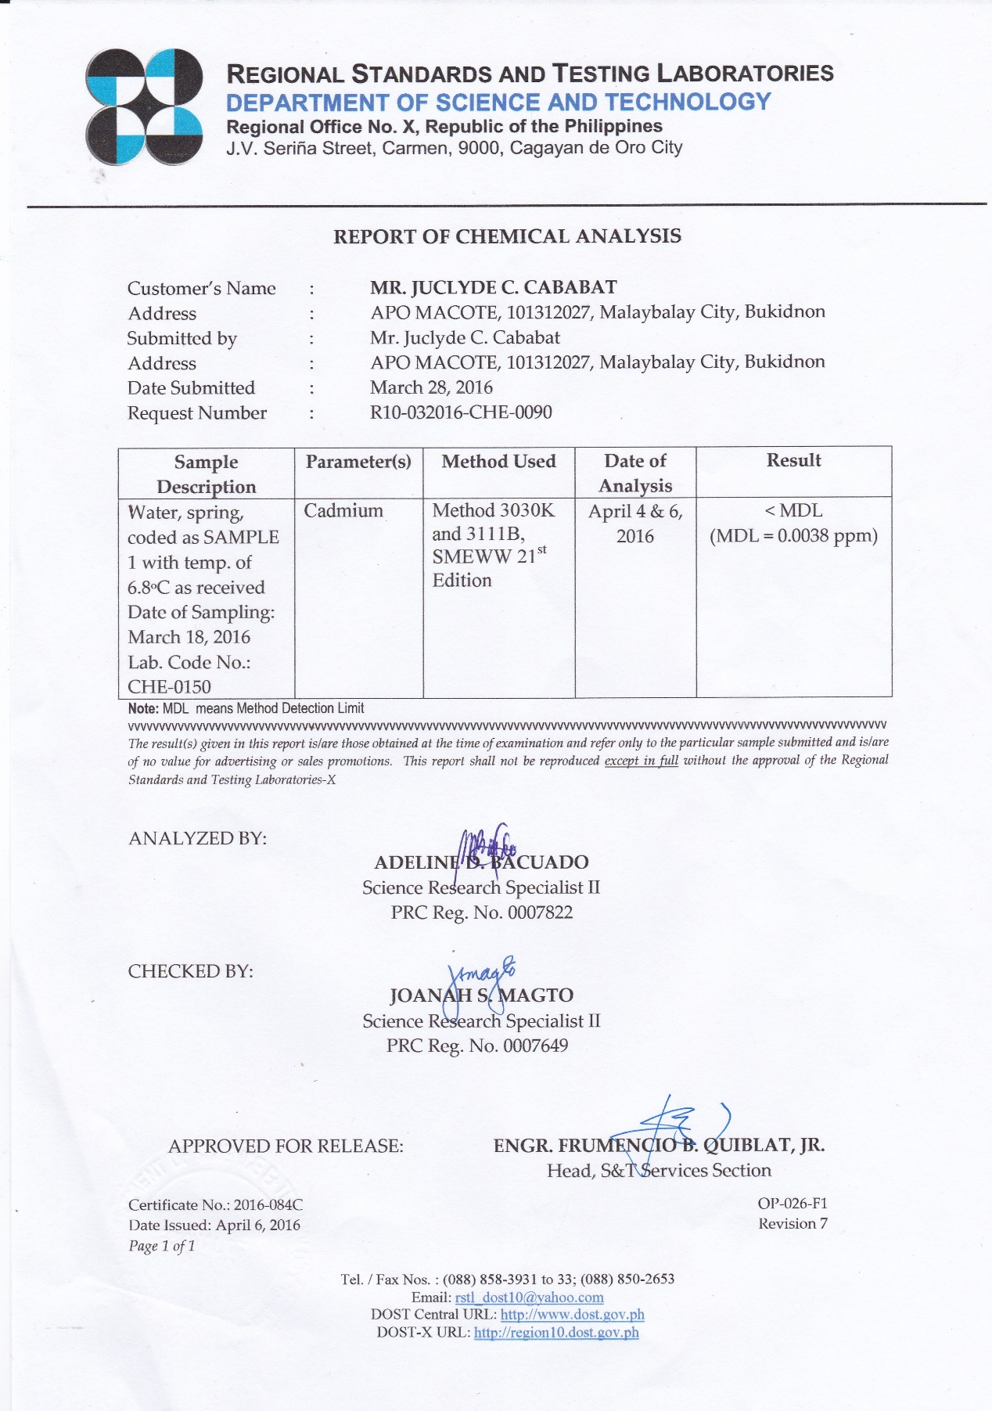
Appendix 1. Laboratory test result of cadmium in spring number 2 during ENSO 2015-2016(warm episode)
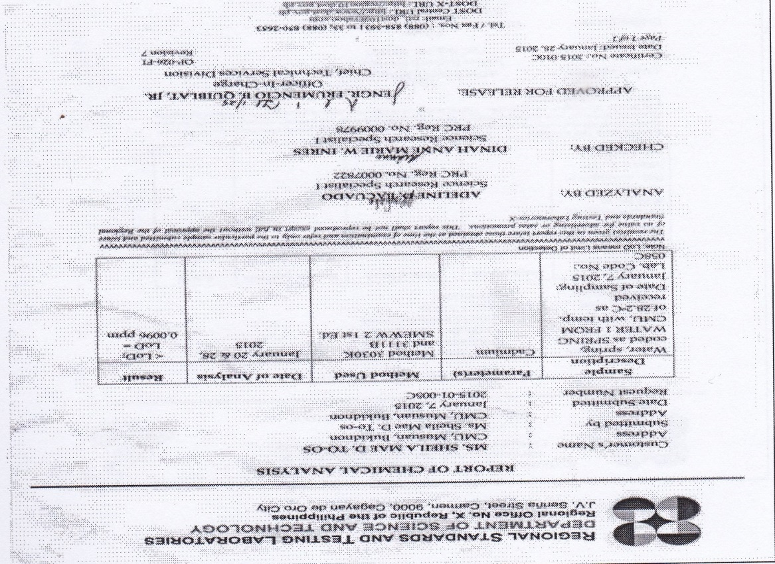
Appendix 2. Laboratory test result of cadmium in spring number 2 during wet season of 2014

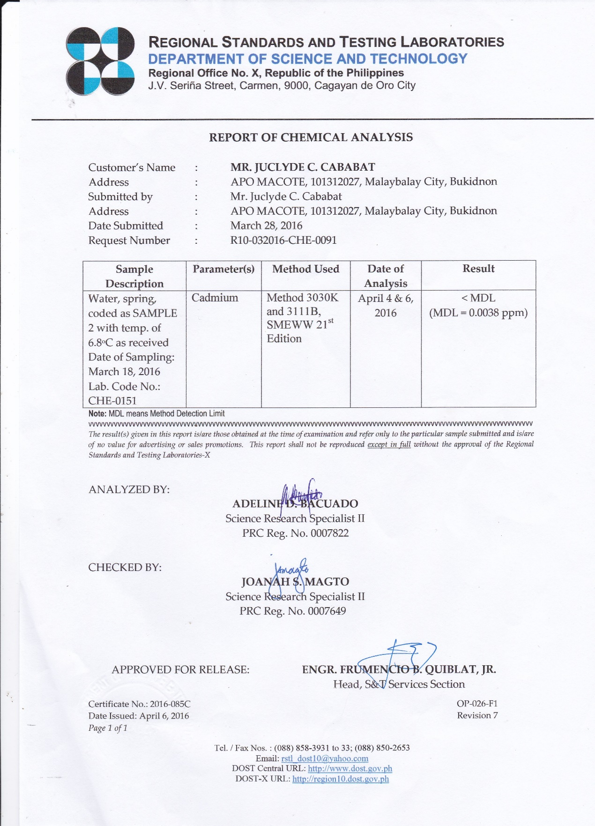
Appendix 3. Laboratory test result of cadmium in spring number 3 during ENSO 2015-2016(warm episode)

Appendix 4. Laboratory test result of cadmium in spring number 3 during wet season of 2014
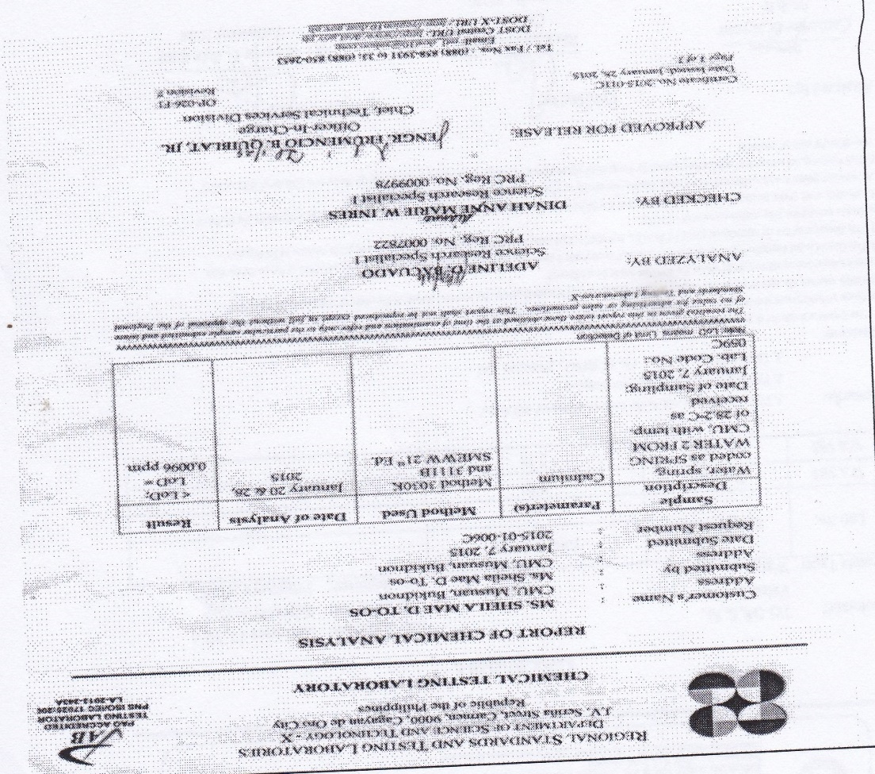

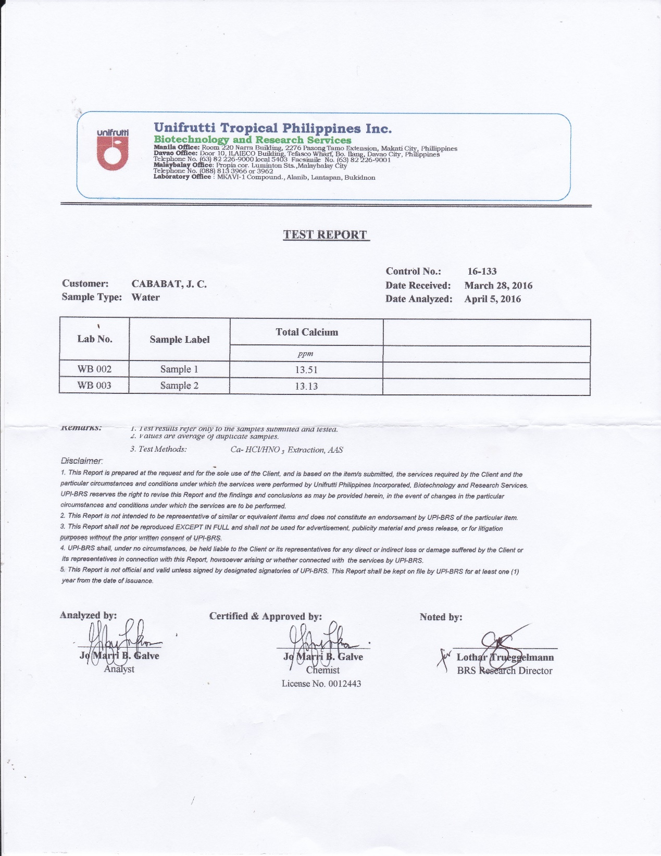
Appendix 5. Laboratory test result for calcium of spring number 2 and 3 during ENSO 2015-2016(warm episode)

Appendix 6. Laboratory test result for calcium of spring number 2 and 3 during wet season of 2014
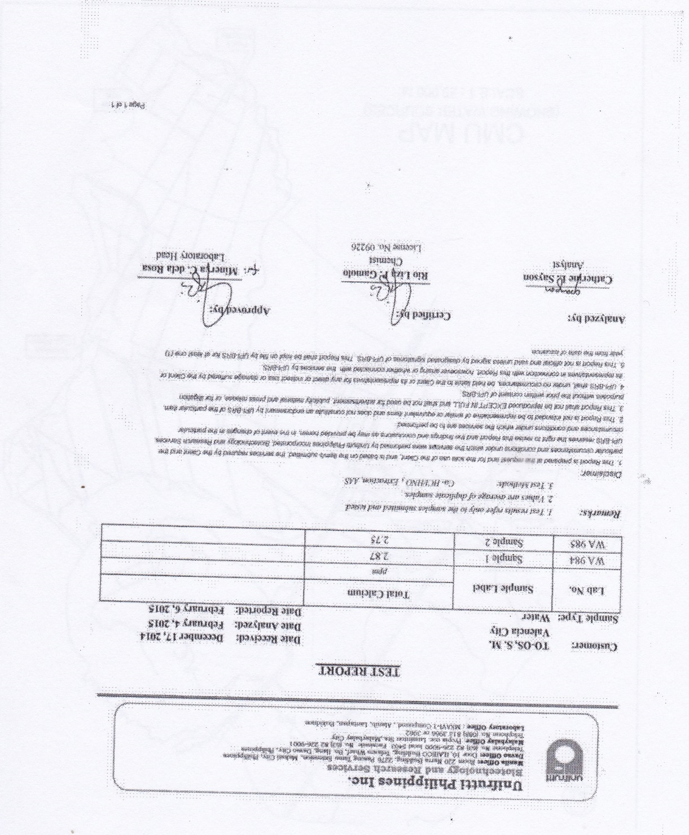

Appendix 7. Sample of Survey Questionnaire of the Farmers
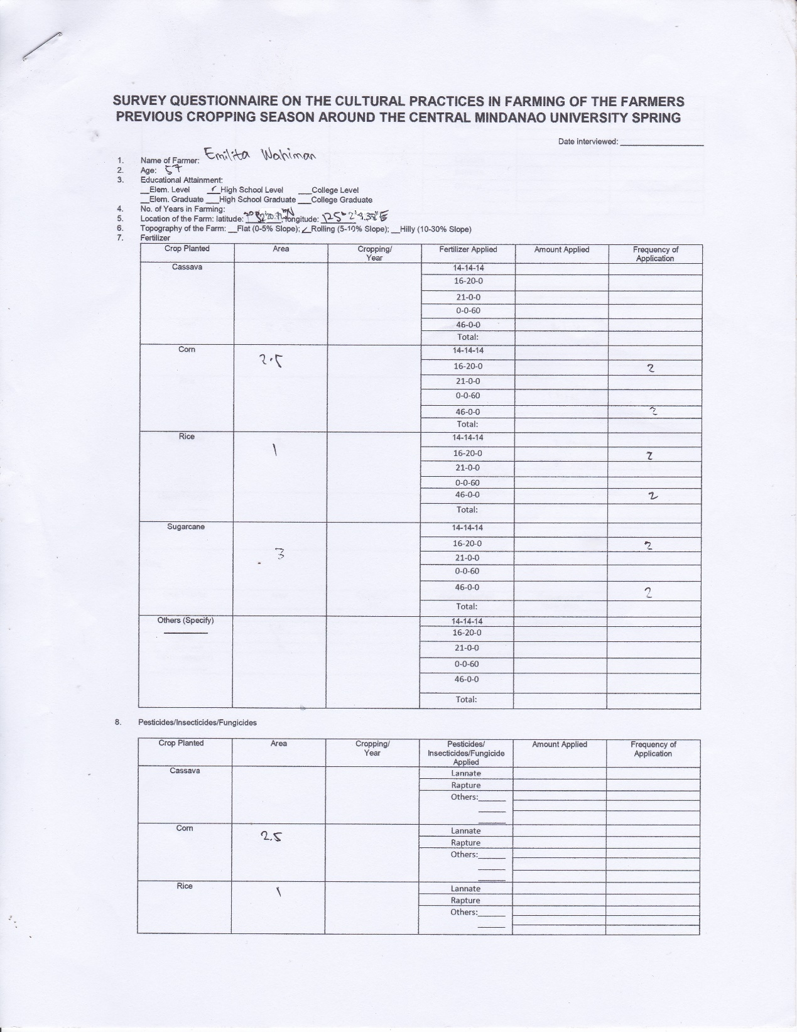

Appendix 7. Continued. . .
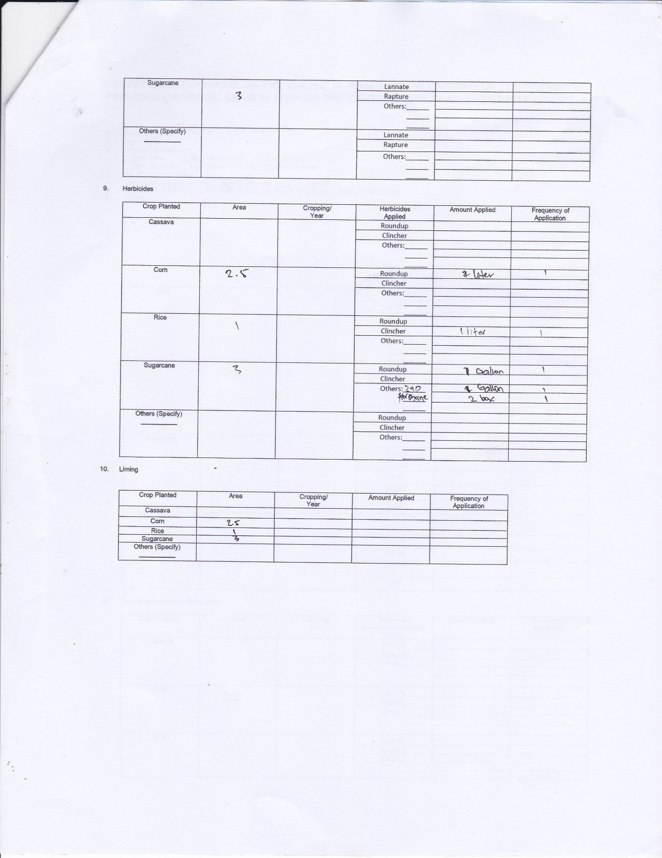

Appendix Table 1. Standard Values for Physical and Chemical Quality; Health Significance
CONSTITUENT | MAXIMUM LEVEL (MG/L)
Antimony  Arsenic  Barium  Boron  Cadmium  Calcium  Chromium  Cyanide  Fluoride  Lead  Nitrate NO₃  Nitrite NO₂  Mercury total  Selenium | 0.005  0.01  0.7  0.3  0.003  300  0.05  0.07  1.0  0.01  0.001  50  3  0.01
Source: Philippine National Standard for Drinking Water, 2007

