What type of meat will we eat in the future: still conventional meat from livestock, in vitro meat or meat analogues?
Jean-Francois Hocquette, INRA, UMR1213, Recherches sur les Herbivores, F-63122 Saint Genes Champanelle, France
Bonny Sarah Patricia Fairclough, School of Animal and Veterinary Sciences, the University of Adelaide, North Terrace, Adelaide, S.A., 5005, Australia
Gardner Graham E., School of Veterinary and Life Sciences, Murdoch University, 90 South St, Murdoch, W.A., 6150, Australia
Pethick David W, School of Veterinary and Life Sciences, Murdoch University, 90 South St, Murdoch, W.A., 6150, Australia

Abstract (300 word limit)
The global population is estimated to reach 9 billion by the year 2050, and the meat industry would need to increase its production by approximately 50-73% based on current consumption trends. In response, there are several different options that have the potential to satisfy demand and increase production. One of these options is the production of cultured meat, which regularly generates media interest because of the potential contribution to food production while also protecting the environment and respecting animal life. Proponents of artificial meat have been successful in engaging the interest of public media with an effective communication strategy.
Cell culture has been performed successfully in research laboratories, however there are significant technical difficulties limiting large-scale production including prohibitive cost and a lack of similarity of the obtained product with animal derived-meat. Other alternatives include selective breeding, animal cloning, genetic modification, agroecology systems and orientation towards bio-economy (those parts of the economy that use renewable biological resources). Furthermore, new protein sources from plants, fungi, algae or insects could also be used as a substitute for meat proteins. In the future, it is likely that meat substitutes will increase market share through competition with low-grade cuts of meat, cheap meat, ground meat and processed meat. To meet growing demands for protein, and in the face of growing competition from other protein sources, the conventional meat industry must adopt new farming systems. The traditional more extensive livestock systems (pasture based beef and lamb) is one option likely to satisfy consumers’ expectations for natural products. Grazing systems are also the best to convert low-grade cellulose from grass into high quality organoleptic and healthy products. Ultimately, consumer acceptance of artificial meat will depend on moral or ethical concerns about the technology, as well as the usual food product concerns such as price, quality, and providence..

Image
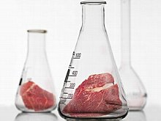
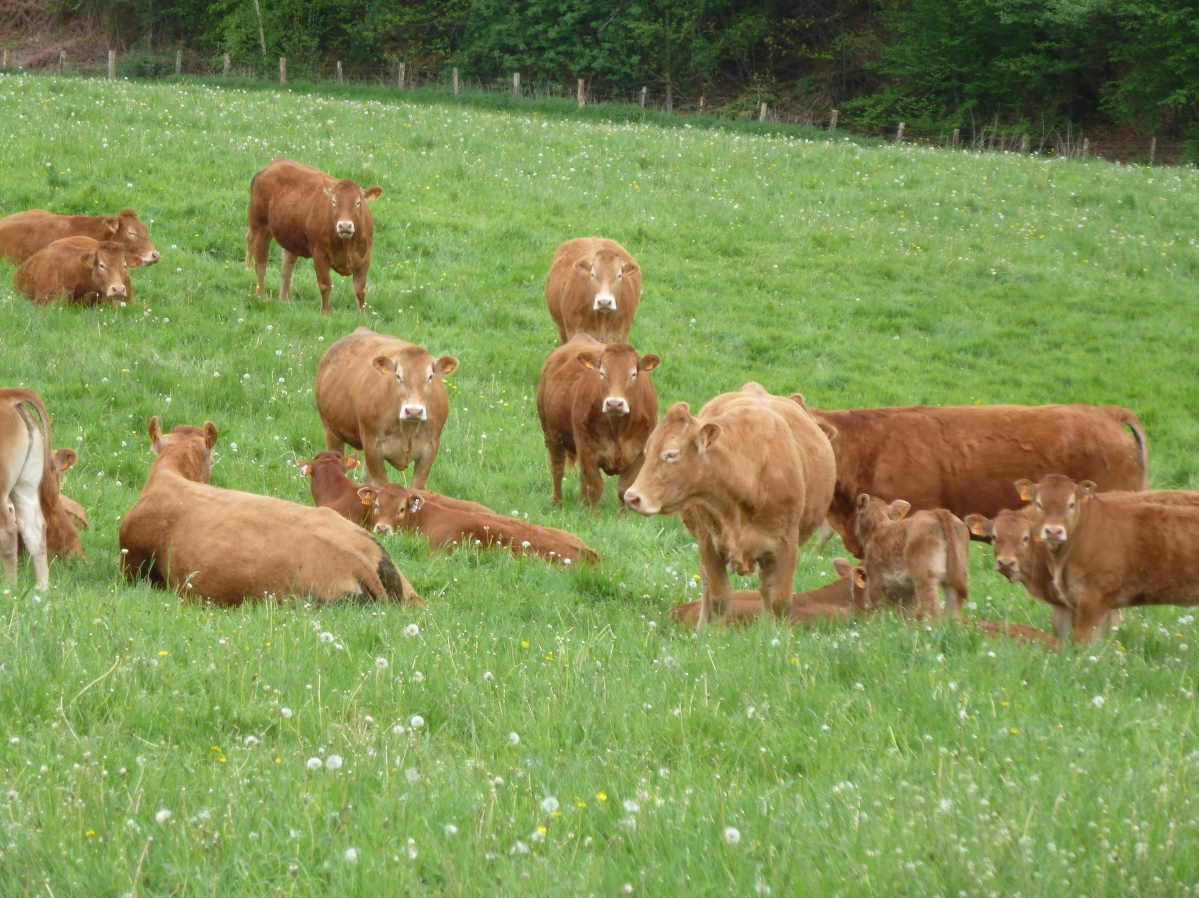
OR

Recent Publications (minimum 5)
- Bonny SPF, Gardner GE, Pethick DW, Hocquette JF (2015). What is Artificial Meat and what does it mean for the future of the meat industry?. Journal of Integrative Agriculture, 14(2), 255-263.
- Bonny SPF, Gardner GE, Pethick DW, Hocquette JF (2017). Artificial meat and the future of the meat industry. Animal Production Science, in press.
- Hocquette JF (2017). Is in vitro meat the solution for the future?. Meat Science 120:167–176.
- Hocquette JF, Botreau R, Legrand I, Polkinghorne R, Pethick DW, Lherm M, Picard ., Doreau M, Terlouw EMC (2014). Win-win strategies for high beef quality, consumer satisfaction, and farm efficiency, low environmental impacts and improved animal welfare. Animal Production science, 54 (10), 1537-1548.
- Pethick DW, Ball AJ, Banks RG, Hocquette JF (2011). Current and future issues facing red meat quality in a competitive market and how to manage continuous improvement. Animal Production Science, 51, 13–18.

Biography (150 word limit)
Since 1991, JF Hocquette has been scientist at INRA (the French National Institute of Agricultural Research). His research interest mainly concerns muscle biology as relevant to muscle growth and beef eating quality. His scientific activity resulted in 250 papers, 2 patents, over $7M in grants, mentorship (27 scholars), adjunctship (800 students) and 60 lectures worldwide. In 2014 and 2016, JF Hocquette organized the French Meat R&D congress (150 to 240 attendees). He was involved in EU-programs on meat. He was head of the Herbivore Research Unit (172 staff) and now works for the High Council for Evaluation of Research & Higher Education. JF Hocquette is involved in the activities of the EAAP (European Association for Animal Production) and of the French Meat Academy. JF Hocquette was associate editor of BMC Genomics, edited two EAAP books (#112 & #133) and is currently editor-in-chief of the French Meat R&D Journal (5600 subscribers).
Presenting author details
Full name: Hocquette Jean-François
Email: jean-francois.hocquette@inra.fr
Contact number:
Twitter account: https://twitter.com/jfhocquette?lang=fr
Linked In account: https://www.linkedin.com/in/jean-fran%C3%A7ois-hocquette-b8440680/
Session name/ number:
Category: Oral presentation
Notes/Comments:

