The law of the field crop performance (agrophytocenosis) productivity – the key to the future of agriculture
Petras Lazauskas, Prof. Habil. Dr., Aleksandras Stulginskis University, Lithuania

Abstract
The worldwide conventional deep soil tillage by annual ploughing has no proved theoretical fundamentals and is based only on the primitive sensual empirical experience. The greatest disadvantage of this method is its negative impact on the soil: its degradation, soil carbon material mineralization, rising emissions of carbon dioxide, and climate warming.

According to the geo-botany theory the typical field crops stands are natural field plant communities (agrophytocenosis). Their cognition productivity therefore should be evaluated from the theoretical point of view. The soil tillage and weed control can been proved by the novel law of crop and weed communities’ performance. This law can be defined as follows: Productivity of a typical field plant community (agrophytocoenosis), including overall dry mass of crop and weeds, growing under identical conditions is relatively constant. In general, this phenomenon can be described by the following equation: A = Y+ X b, where A signifies maximum productivity of the whole dry mass of the whole community; Y - crop dry mass yield under the existing growing conditions of the community; X - weed mass; b - yield depression rate, indicating the degree of yield increase or decrease when weed mass changes by one unit.

Based on this finding we can predict that this novel Field Crop Performance Productivity Law will theoretically and practically revolutionize the cognition of soil tillage and weed control. Consequently, in the nearest future, the soil tillage and weed control disciplines will adopt this theoretical background and modernize the traditional empirical basis of soil tillage technologies. New theoretical cognition will have to reject annual deep plough and apply shallow precise soil tillage. These means will mitigate soil degradation, reduce the amount of carbon dioxide emission into the environment, slow climate warming, and will save costs of the non-regenerative energy in agriculture.

Image

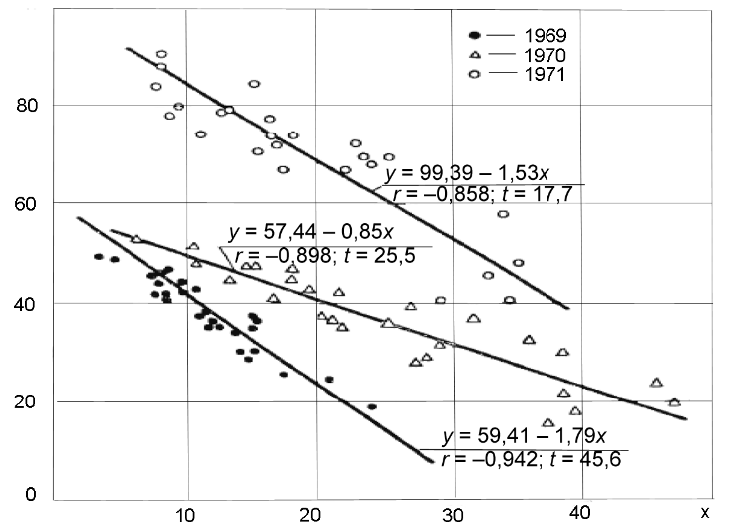
Y
Figure 1. Correlation between the spring barley grain and straw yield - y and the dry mass of field mustard (Sinapis arvensis L.) - x (increasing the number of barley plants in the pot-treatment: 3 ; 6; 9 ;12; 15; 18, and 6 plants of field mustard in all of the treatments (g⁻¹/pot)).

Recent Publications
- Lazauskas, P. 1990. Agrotechnika prieš piktžoles, Vilnius: Mokslas. p. 216. (Monograph in the Lithuanian language).
- Lazauskas, P. 1993. The law of crops performance as a theoretic basic of non-chemical weed control. Communications of the fourth l.F.O.A.M. Conference, Dijon, France, 5th-7th July, 1993. Pp. 59-63.
- Lazauskas, P. 1995. Strategy of non chemical weed control. 9th EWRS Syposium: “Challenges for Weed Science in a Changing Europe,” Budapest, Hungary. pp. 571-576.
- Lazauskas, P. 2013. The abstract theoretical cognition of productivity of agricultural plant communities instead of empirical cognition. Agricultural Sciences 20 (4), pp. 308-321.
- Lazauskas, P. 2016. The original law of field crop performance (agrophytocenosis) productivity for development of the theoretical cognition of weed control and soil tillage. 6th Workshop of the EWRS: “Weeds and Biodiversity,” Riga, Latvia. p. 30.
- Lazauskas, P., Sirvydas, A. 2002. Weed control with water steam in barely. Zeitschrift für Pflanzenkrankenheiten und Planzenschutz Sonderheft, XVIII, Studgart, pp. 633-638. ISSN 0938-9938.

Biography
Petras Lazauskas graduated from the Lithuanian Academy of Agriculture (Kaunas city). As a scientist, he started work on the problems of weed control applying a traditional empirical method of cognition. Subsequently he was involved in a non-chemical weed control using theoretic geo-botanic method of cognition. Studying field crop plant communities, he noticed a novel regular negative correlation between the yields of cultural plants and the mass of weeds that grew under identical conditions. This correlation as a novel law, discovered by Petras Lazauskas, was incorporated as a main thesis in his second doctoral dissertation. In 1990, it was published in the monograph Agronomical Practices against Weeds (in the Lithuanian language). He participated in organic farming and weed control events in Germany, France, the USA, Italy, Sweden, the Czech Republic, Hungary, Latvia, and Russia. In 1997, he won a bursary to attend the British Crop Protection Council Conference in Brighton.

Email: petras.lazauskas@asu.lt

