Water stress estimation system

Using thermography with a smartphone
Sosuke Mieno, National Institute of Technology, Toba College, Japan
Kazuaki Shiraishi, PhD, National Institute of Technology, Toba College, Japan
Takaharu Kameoka, PhD, Mie University, Japan
Shin Yoshida, PhD, National Institute of Technology, Anan College, Japan

Abstract (300 word limit)
Statement of the Problem: In recent years, plant water stress has often been used in agriculture to produce sweeter fruits and vegetables. However, this method is difficult. For example, in the case of fruit trees, if the plant water stress is too small, sweet fruits will not be produced, whereas too much water stress will damage trees, leading to a poor harvest the following year. Currently, estimates of plant water stress are often based on the judgements of experienced farmers. Therefore, less experienced agricultural workers require a different method. The proposed system visually expresses the plant water stress of an individual plant by using thermography with a smartphone so that anyone can easily estimate plant water stress. Methodology & Theoretical Orientation: It is well established that photosynthetic activity decreases due to increased plant water stress and that leaf temperature rises as transpiration decreases. In the proposed system, a portion of the leaves of a plant to be managed are photographed using a thermographic device connected to a smartphone and the plant water stress is visualized by comparing the temperature with that of a dummy leaf. (A dummy leaf is laminated layers of moistened paper that imitates a leaf without the photosynthetic activity.) Plant water stress is proportional to temperature difference, which is obtained by the following equation:
Temperature difference = dummy leaf temperature - target leaf temperature
Conclusion & Significance: Using the proposed system, plant water stress can be easily estimated by not only inexperienced agricultural workers but also home gardeners. Already, many farmers within Japan have requested to use the developed system and a patent application is also under investigation.

Image

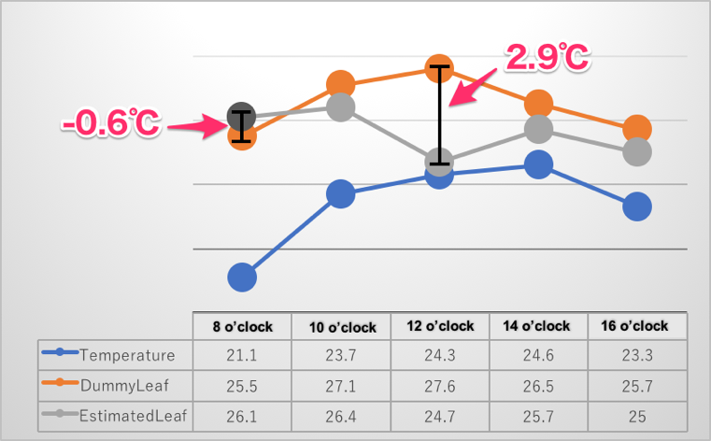
Figure 1: Comparison of temperatures before and after watering
Recent Publications (minimum 5)

Biography (150 word limit)
Mieno Sosuke has her expertise in evaluation and passion in improving the information technology. He engages in fusion of different fields of Agriculture and ICT.
He supports technology in National Institute of Technology, Toba College.
Email: sosuke.mieno@toba-cmt.ac.jp

Notes/Comments:

