Organic Mango in Bangladesh: an analysis of present and prospect to increase in market share
M.S. Islam, PhD Fellow, Kochi University, Japan.

Statement of the Problem: With few exceptions, organic farming in Bangladesh still occurs largely on an experimental basis. Total land area under organic cultivation in Bangladesh has been estimated at 0.177 million hectares, representing only 2% of the country’s total cultivable land. Since the introduction of organic farming in Bangladesh, by NGOs, the movement is still being largely being directed by these organizations’. This article presents an analysis of the current situation of the organic mango sector in Bangladesh with the aim is to provide recommendations about how to achieve a significant increase in market share of the organic mango sector. However, the increase in market share will not be an easy mission to achieve, but it should be possible with both, farmers and consumers' cooperation.
Methodology: The subject matter was prepared from previous studies and using dialogues with sector participants and focus groups to understand the relationships and the context in which it occurs.
Findings: There have been studied three different levels of the chain in the mango sector; production, processing and marketing level. To achieve the goal, conventional farmers need to be willing to convert to organic and consumers need to be convinced to buy more organic products. In order to convince the farmers, technical information has to be provided about organic farming. This can be done by giving workshops and providing examples of successful organic farms. The government could play an important role in this regard, such as, motivation through research and extension personnel, promote the establishment of farmers’ co-operatives and cold storage facilities, facilitate organic certification and provide subsidy to encourage to conversion.
Conclusion: Appropriate market policy will play a significant role and it can be recommended to evaluate how the organic system can be made more attractive in terms of economic sustainability.
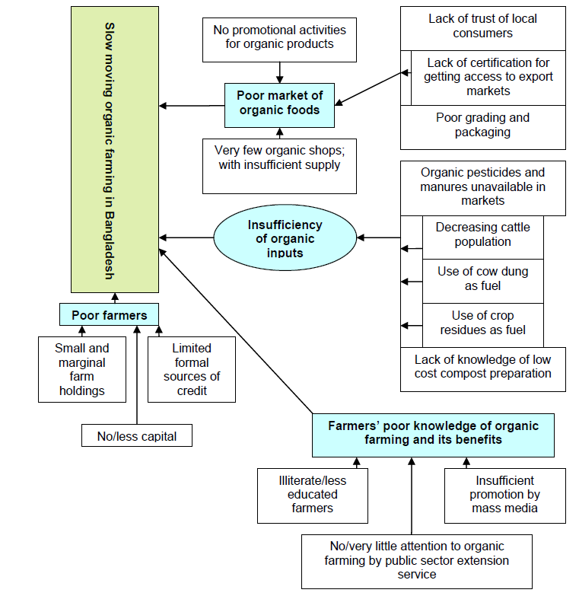
Fig 1. Analysis of key problems associated with the expansion of organic farming in Bangladesh

Recent Publications:
- Bangladesh Bureau of Statistics (BBS). 2006, Statistical Pocket Book of Bangladesh, 2004. Bangladesh Bureau of Statistics, Planning Division, Ministry of Planning, Government of the People’s Republic of Bangladesh.

- Bangladesh Economic Survey Report. 2007, Economic Division, Ministry of Finance, Government of the People’s Republic of Bangladesh.

- Department of Agricultural Marketing (DAM). 2005, Agricultural Marketing Division, Ministry of Agriculture, Government of the People’s Republic of Bangladesh.

- IFOAM. 2006, The World of Organic Agriculture, Statistics and Emerging Trends 2005, available at: http://www.soel.de/inhalte/publikationen/s/s_74_07.pdf [accessed on Nov. 02, 2006].

- Ministry of Agriculture (MOA). 2007, North-west Crop Diversification Project, Department of Agricultural Extension, Ministry of Agriculture, Government of the People’s Republic of Bangladesh, available at: http://www.dae.gov.bd/template/NCDP/about.htm [accessed on Dec. 20, 2007].

- Sarker, M. A. 2007, “Practice of organic farming technologies by the Bangladeshi farmers: evidence from farm operations in Tangail district”. An unpublished Master’s Thesis, submitted to the Department of Bio-resources science, the Graduate School of Agriculture, Yamaguchi University, Japan in July, 2007.
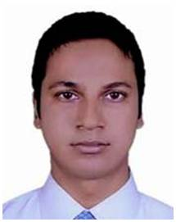 Biography
M. S. Islam has expertise in plant sciences, particularly in horticultural crops for production, physiology, breeding, micropropagation, post-harvest management and the value chain. This open and contextual evaluation based on responsive constructivists creates new corridors for improving the crops, marketing channel and farmer’s wellbeing. He made these recommendations after years of experience in research, evaluation, teaching and administration both in research and education institutions. This approach is responsive to all participants in the market and has a different way of focusing.
E-mail: saiful1236@gmail.com

