CONVERT TO ORGANIC POTATO PRODUCTION TO NOURISH THE EARTH

C. Jeffrey Bragg, Everything Potatoes, Inc., Donnelly, Idaho, USA

Abstract
Potatoes are the most nutritious vegetable offering in the world. It is the number one food source for developed and developing countries. History and civilization has kept continents and people whole because of the consumption of potatoes. The crop returns more yield of calories, nutrients, protein, and countless other ingredients to the human than any other crop worldwide. It’s attachment to the soil, however, is crucial to maintain their integrity for human consumption. Because of the current system of transferring even a small bit of adhering soil on seed potatoes, to another soil, diseases can be transmitted readily in soil and plants. Too many chemicals have been used in potato production globally, and now resistance to soil and plant diseases are out of control. Because of globalization many growing areas are being forced to GMO crops to attempt to gain market shares in different countries. In addition, the chemicals used in potato production have threatened

bee populations to upwards of 74% according to different organizations. Potato growers worldwide should be working together to lessen the impact on soils, plants, and humans by more diligently taking care of Mother Earth. This talk today will be from the perspective of an Idaho born ,USA citizen, that has been hands on from an early age with a shovel-to a potato idea person that recognizes the health issues that afflict humans with improper channeling of resources. Because of its huge impact globally on rising populations more information needs to be transferred to people hands on, if you will, to foster human health. The talk is designed to give a timeline from organic production in the 1950’s and human health versus where we are today on human health issues around potato consumption. This author has done all of the steps, including fumigation, and growing of GMO crops.

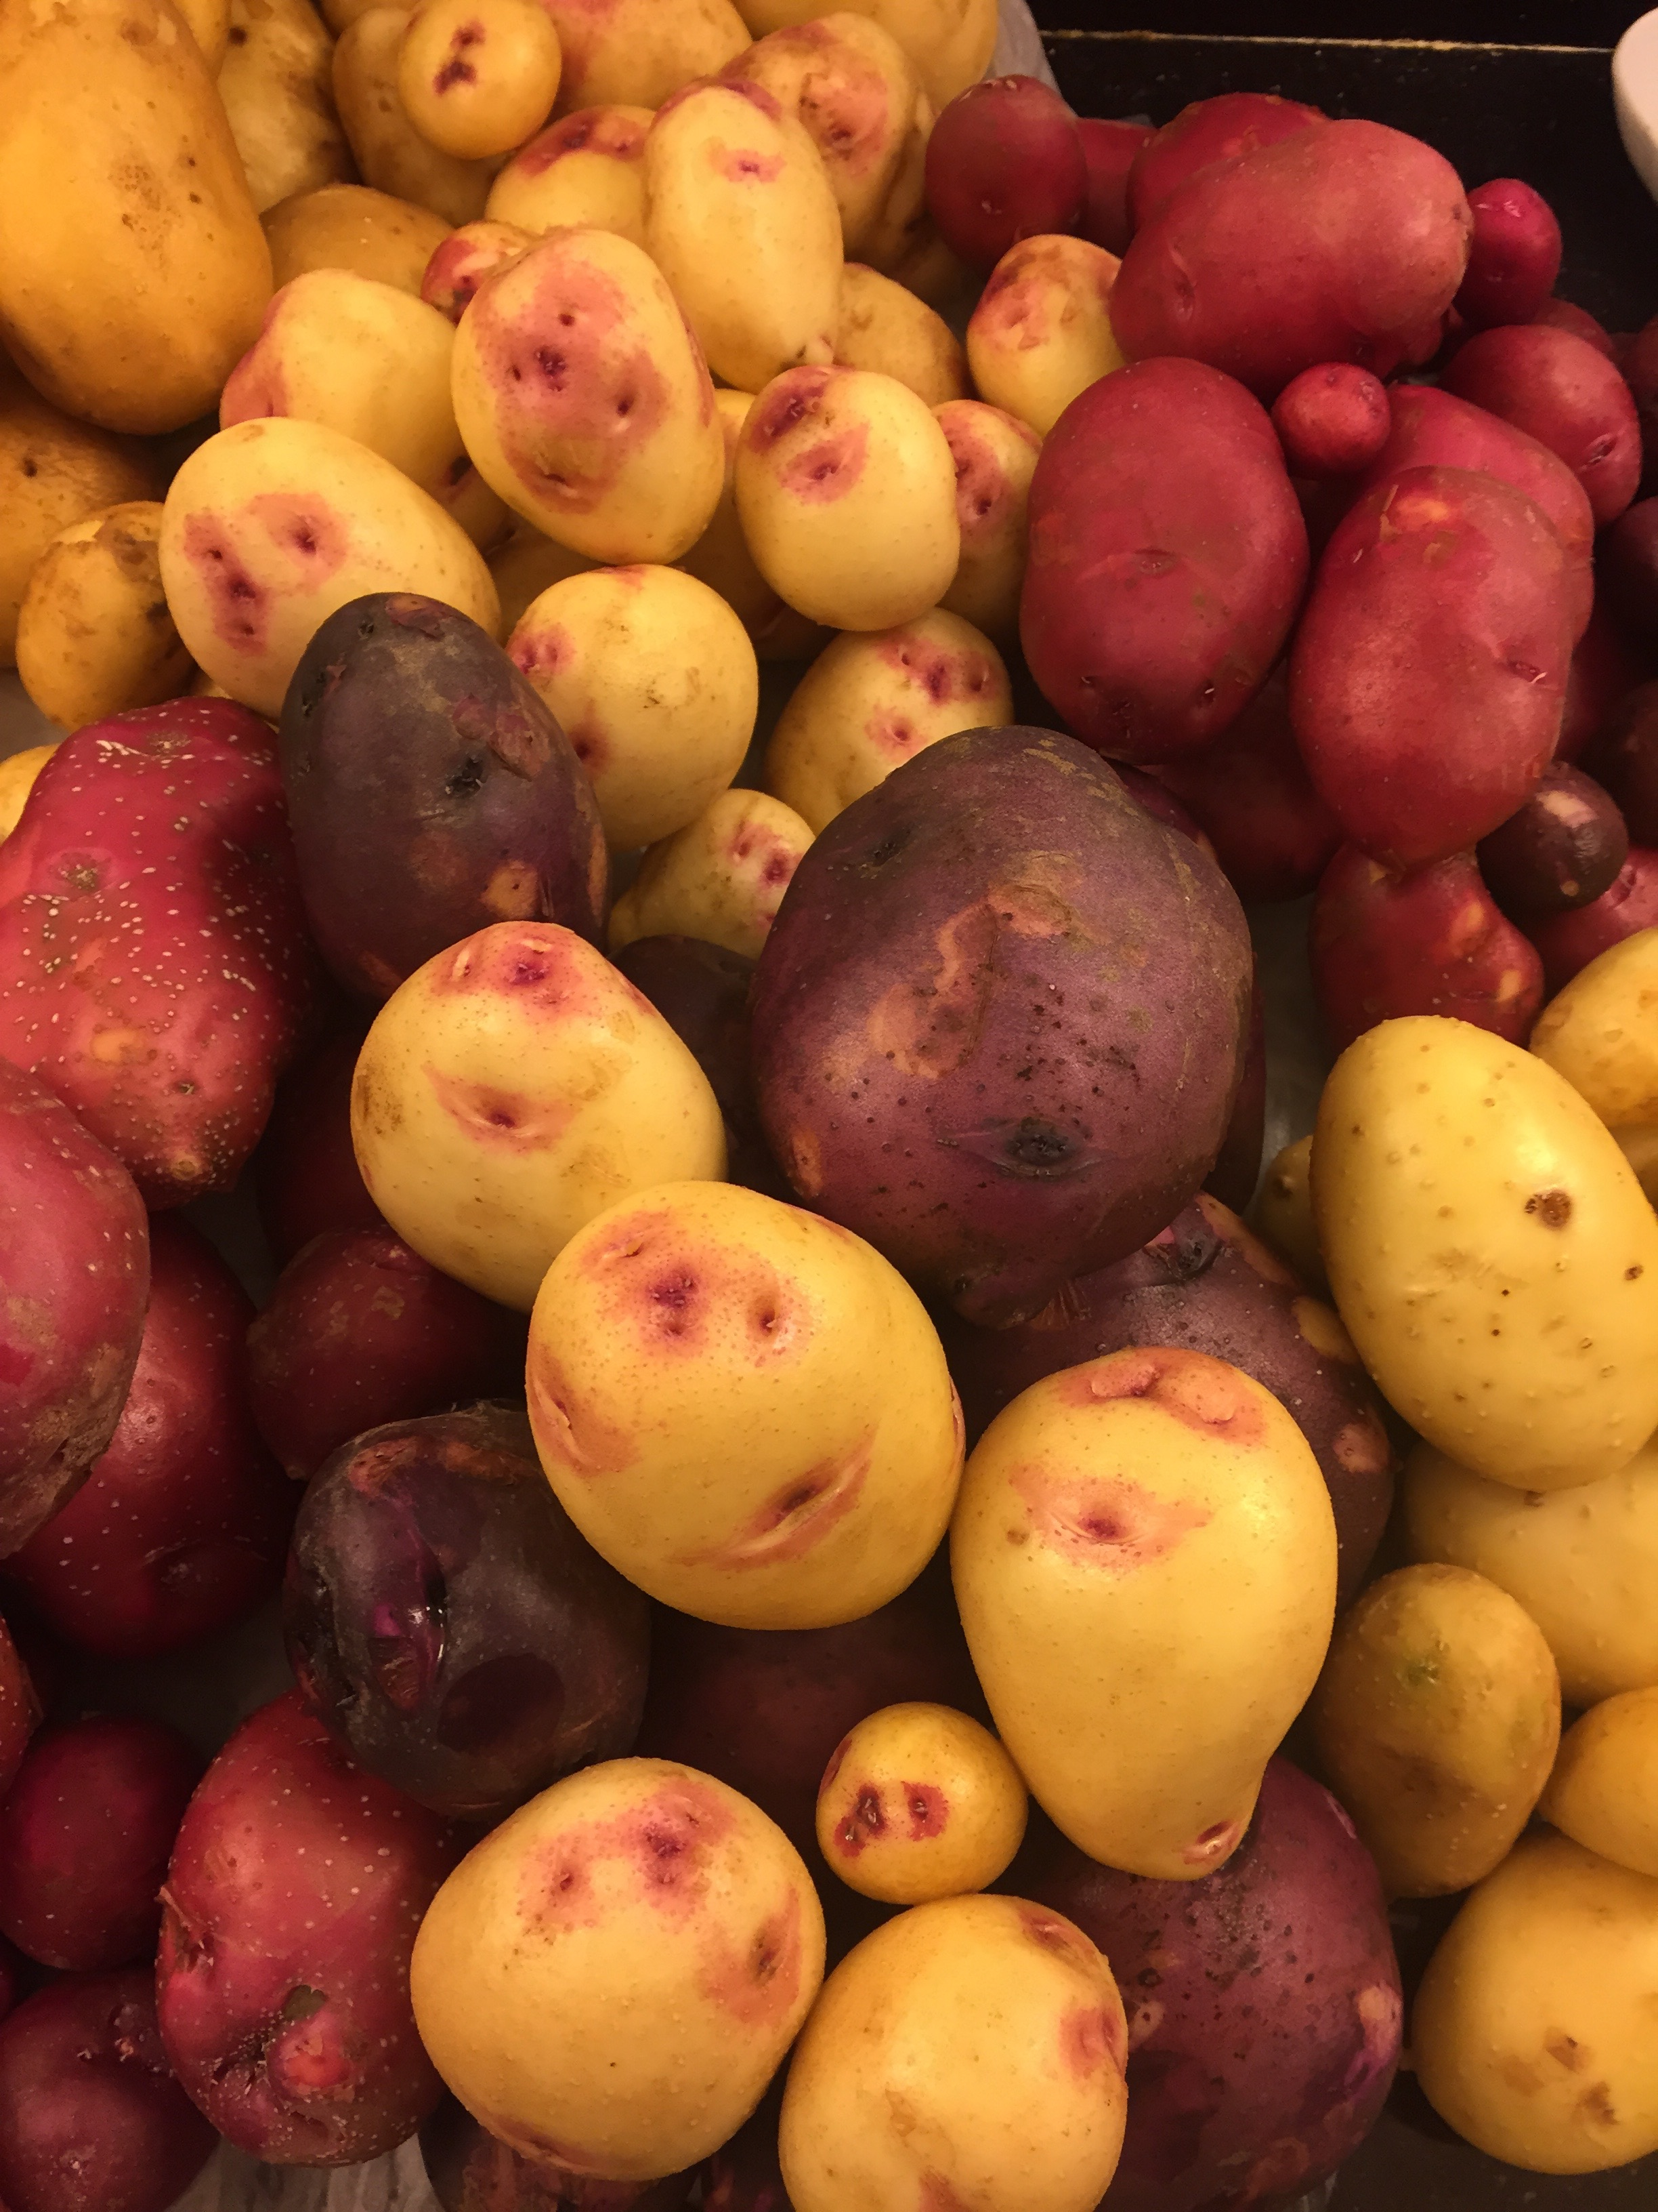

Jeff Bragg is the most hands on potato scientist and grower globally. He started in Idaho as a young man toiling with his parent’s family farm. Not intending to get involved with agriculture he became a agronomist, IPM and Conventional grower of a multitude of cropping structures in North America. He has consulted in North America as well as Siberia. Many markets have been developed under his watch with various large entities he has worked with. The knowledge of how potatoes feed the world will be evident in his passion for potatoes.
Email: everythingpotatoes@me.com

Notes/Comments:

