Light control on cutting propagation of Chrysanthemum induces the reduction of flowering time
Won Jun Hwang, Chan Saem Kil, You Jin Lim, Seok Hyun Eom*
Department of Horticultural Biotechnology, College of Life Sciences, Kyung Hee University, Yongin 17104, Republic of Korea
This study was conducted to reduce flowering time by the application of light irradiations on the cuttings of a spray type chrysanthemum, named ‘Haydal’, for the purpose of reduction of flowering time. Two types of cuttings, terminal cutting and axillary bud cutting, were used. Light qualities and intensities were applied to the cuttings at the initial growth periods. The periods of light treatments were 10, 20, and 30 days with 16 h daylight in a day, respectively. After the light treatments, the cuttings were moved into a growth facility set to 8 hour short-day period (SDP) and maintained until flowering. Experimental data collected were the time of flowering initiation, the length, weight, and thickness of shoots, and the qualities of flowers. In conventional methods for flowering from cuttings and our non-treated control, it generally took about 110 days for flowering from cuttings. SDP treatment right after cutting establishment reduced flowering time, exhibiting 73 days for flowering. Regardless of light quality, initial 10-day light supplement to cuttings induced flowering at 49 days. Low intensity of light treatment to terminal cuttings reduced flowering time while high intensity of light treatment to axillary bud cuttings shorten flowering time. Initial 20-day light supplement also reduced flowering time, presenting 59 days for flowering. Although 20-day light supplement showed less effect for flowering time, the treatment was better for growth qualities like shoot length and flower size than 10-day light supplement. The 30-day light supplement was less effective to the production of chrysanthemum flowers.

- Mortensen LM, Strømme E (1987) Effects of light quality on some greenhouse crops. Scientia horticulturae 33:27-36.
- Oyaert E, Volckaert E, Debergh PC (1999) Growth of chrysanthemum under coloured plastic films with different light qualities and quantities. Scientia horticulturae 79:195-205.
- Cockshull KE, Hughes AP (1971) The effects of light intensity at different stages in flower initiation and development of chrysanthemum morifolium. Annals of Botany 35:915-926.
- Kim SJ, Hahn EJ, Heo JW, Paek KY (2004) Effects of LEDs on net photosynthetic rate, growth and leaf stomata of chrysanthemum plantlets in vitro. Scientia Horticulturae 101:143-151.
- Carvalho SMP, Heuvelink E, Kooten O (2002) Effect of light intensity, plant density, and flower bud removal on the flower size and number in cut chrysanthemum. Acta horticulturae 593

Fluorescent light

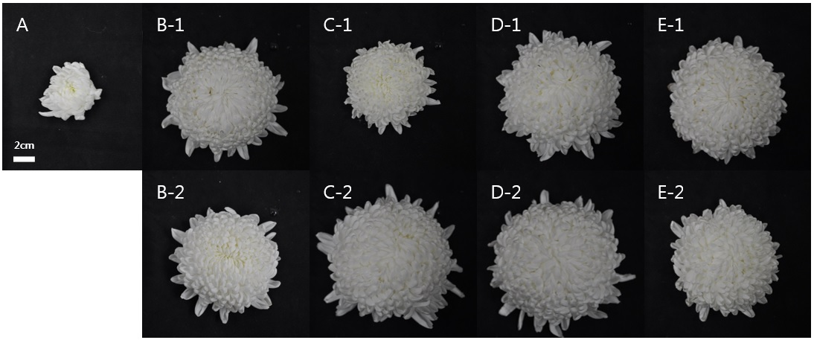
Figure 1. The flower quality of initial 20-day light supplement to axillary bud cuttings. (A) Fluorescent light (B-1) high intensity of red light, (C-1) high intensity of blue light, (D-1) high intensity of red and blue light, (E-1) high intensity of red, blue and light, (B-2) low intensity of red light, (C-2) low intensity of blue light, (D-2) low intensity of red and blue light, (E-2) low intensity of red, blue and green light.

