Refining and bran grinding levels of wheat flours, besides baking properties, affect tensile characteristics of derived bioplastics
Debora Puglia, Dr. PhD, University of Perugia, Italy
Franco Dominici. Mr, University of Perugia, Italy
Paolo Benincasa, Prof. PhD, University of Perugia, Italy

Abstract
Statement of the Problem: There is recent literature on the use of wheat flours to obtain bioplastics as an energetically and economically cheap alternative to purified starch (1). Previous researches from our group (2-3) demonstrated that the tensile properties of thermoplastic films depended on wheat grain hardness and baking properties of refined flours, expressed as Chopin’s alveograph parameters (P, L, P/L, W) (4). No research, however, has considered the use of wholegrain flours, while this could be of relevance because the bran could work as reinforcement (5) instead of being a by-product to get rid of when exceeding the need for livestock feeding. The purpose of this study is to describe the mechanical performance of thermoplastics obtained from wheat flours differing for grain hardness, alveographic parameters, and refining and bran grinding level. Methodology: Grains of four common wheat (Triticum aestivum L.) cultivars (Altamira, Aubusson, Blasco, Bologna) were milled separately with a laboratory mill in order to produce single-cultivar refined (R) or wholegrain flour with fine (F) or gross (G) bran grinding. Grain hardness and alveographic parameters for R flours are reported in Benincasa et al (2). The flours were then plasticized, filmed and tested for tensile properties (strength, σ; elongation at break, ε) according to Puglia et al (3). Findings: The bran reduced ε but increased σ for the films derived from any of the four cultivars. The σ was higher and ε was lower in films from F than G flours. The reasons for the effect of refining and bran grinding levels are discussed based also on SEM microscopy of films, which revealed that bran and its texture affected starch granules exposure to plasticizer. Conclusion & Significance: Both the alveographic parameters and the refining and bran grinding levels of wheat flours represent novel choice factors to consider for tailoring manufactures according to requirements and uses.
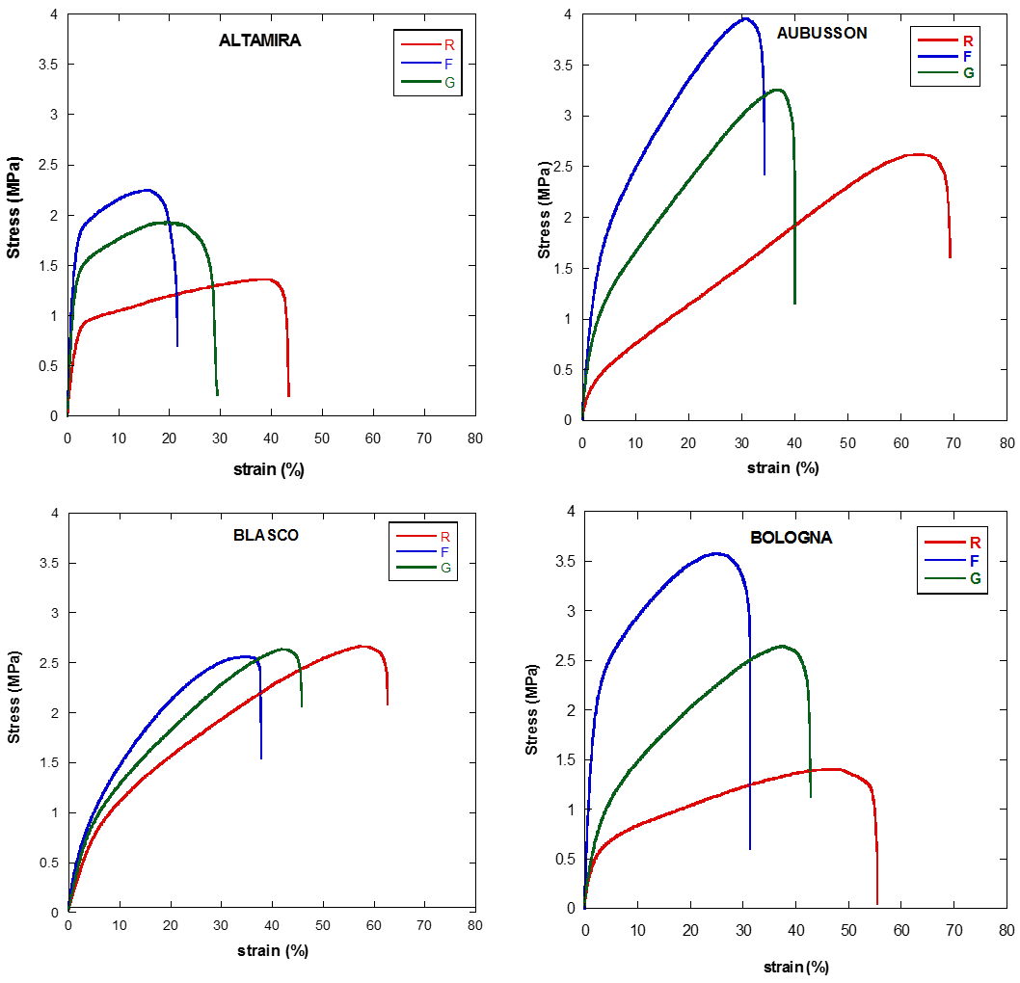
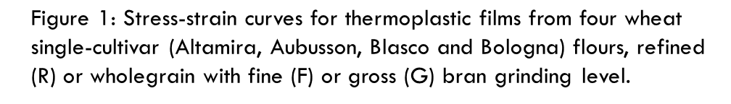

- Leblanc N, Saiah R, Beucher E, Gattin R, Castandet M, Saiter J-M (2008). Structural investigation and thermal stability of new extruded wheat flour based polymeric materials. Carbohyd Polym 73: 548-557
- Benincasa P, Dominici F, Bocci L, Governatori C, Panfili I, Tosti G, Torre L, Puglia D. Relationships between wheat flour baking properties and tensile characteristics of derived thermoplastic films. Ind Crops Prod, submitted, under revision.
- Puglia D, Dominici F, Kenny JM, Santulli C, Governatori C, Tosti, G, Benincasa P (2016). Tensile behavior of thermoplastic films from wheat flours as function of raw material baking properties. J. Polym Environ 24: 37-47
- Prabhasankar P, Sudha ML, Haridas Rao P (2000). Quality characteristics of wheat flour milled streams. Food Res Int 33: 381-386
- Reddy N, Yang Y (2011). Biocomposites developed using water-plasticized wheat gluten as matrix and jute fibers as reinforcement, Polym. Int. 60: 711-716

Biography
Paolo Benincasa is Associate Professor at the Dept. of Agricultural, Food and Environmental Sciences of the University of Perugia. He has 25-year expertise in Crop Science and Technology. His research activity focused on the evaluation of agronomic aspects affecting crop yield and quality and on the management of crop residues and soil fertility in conventional and organic farming systems. Recently, together with his colleagues of the Materials Engineering group, he has started working on biobased materials looking at the factors (cultivar, environment, cultivation practices, post-harvest manipulation) that may affect the mechanical properties of derived manufactures. Novel findings are reported in articles published or under consideration in high ranked journals.
Email: paolo.benincasa@unipg.it

