Analysis of Yield and Yield Attributing Traits of Maize Genotypes in Chitwan, Nepal

Abstract:
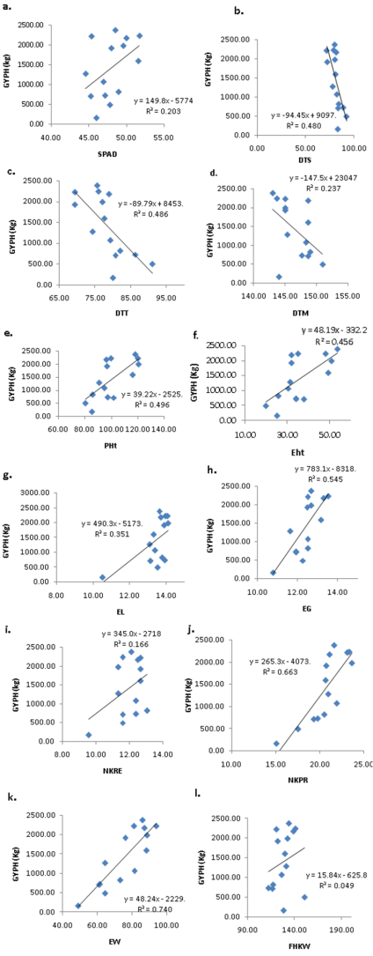
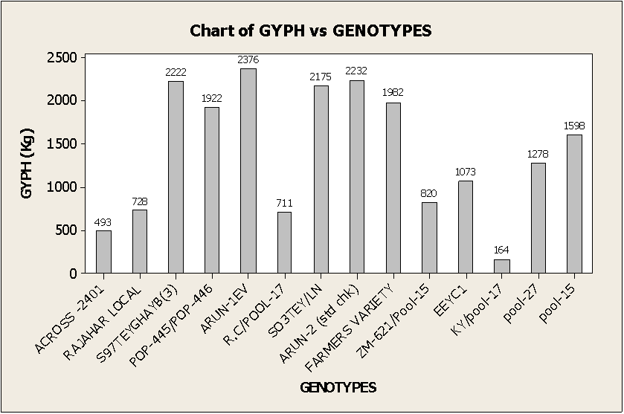
Fourteen maize genotypes were evaluated at National Maize Research Program (NMRP), Rampur, Chitwan, Nepal with objective was to explore genetic variability and investigate yield and yield attributing traits from 22nd October, 2014 to 12th April, 2015. The experiment was designed in randomized complete block with three replication. Phenotypic observation was taken for important quantitative traits viz. Soil Plant Analysis Development (SPAD) reading, days to 50% tasseling, days to 50% silking, ear height, plant height, days to physiological maturity, ear length, ear girth, ear weight, number of kernel row ear-1, number of kernel row-1, five hundred kernel weight. The result showed that traits plant height, ear height, ear length, ear girth, ear weight, no. of kernel row per ear, no. of kernel per row exhibited positive and highly significant correlation with grain yield per hectare while SPAD reading and five hundred kernel weight given significant correlation. The analysis also indicated that days to 50% tasseling and days to 50% silking explained negative and highly significant correlation with grain yield per hectare. Similarly, days to maturity showed negative and non significant correlation with grain yield per hectare. The result also reflected that genotype ARUN-1EV has been found comparatively superior to ARUN-2 for major yield components. The genetic study revealed that days to silking, days to tasseling and grain yield per hectare were highly heritable (>0.6). Higher GCV and high GAM indicated efficient indirect selection for higher grain yield per hectare based on these traits. Thus, high GAM and GCV was observed in ear weight, grain yield per hectare and ear height. Correlation analysis revealed that the traits plant height, ear length, ear girth, number of kernel per row, ear weight were most yield determinative traits and hence, simultaneous selection for these traits might bring an improvement in grain yield. The research gave the finding that use of ARUN-1EV can be reliable for further research and breeding programs.
Figure 2 Estimated liner correlation. (a) between SPAD reading and grain yield ha-1 (GYPH), (b) between DTS (days to 50% silking) and grain yield ha-1 (GYPH), (c) between DTT (days to 50% tasseling) and grain yield ha-1 (GYPH), (d) between DTM (days to physiolog
Figure 2 Grain Yield of fourteen genotypes of maize

Recent Publications:
1. Ghimire, B. , & Timsina, D. (2015). Analysis of Yield and Yield Attributing Traits of Maize Genotypes in Chitwan, Nepal. World Journal of Agricultural Research, 3(5), 153-162.
2. Ghimire, B., Timsina, D., & Nepal, J. (2015). Analysis of chlorophyll content and its correlation with yield attributing traits on early varieties of maize (Zea mays L.). Journal of Maize Research and Development, 1 (1), 134-145
3. Report on "Cremation Toxicity and Roles of Trees at Pashupatinath, Nepal" published on online portal Climate Wednesday, ( http://www.climatewed.org/2015/08/cremation-toxicity-and-roles-of-trees.html)

Biography:

Bikal Ghimire is an Erasmus Mundus Scholar pursuing his Masters Degree in Erasmus Mundus Joint Master Degree in Plant Health In Sustainable Cropping System. Currently, he is studying his first year of degree in University of Goettingen, Germany and will study his second year in University of Italy, Padova. This work was from his Bachelor's study research program where he studied about the yield attributing traits in maize as his major. Mr. Ghimire is an innovative person with keen interest in research works. He is a gentle and diligent person with strong will power. He always goes for excellence and wishes to contribute to the nation through his hard work.

email: bikalghim@gmail.com

