THE EFFECTS OF BIOPREPARATION ANTIBAC-UZ ON HELICOVERPA ARMIGERA HB.
Khujamshukurov N., PhD, TACI, Uzbekistan

Abstract:
Cotton - one of the most important, including export sectors of agriculture of Uzbekistan. For stable producing the required amount of raw cotton, along with high agro-technical, utmost importance gets science-based protection against pests of cotton, including one of the main pests of this crop is cotton bollworm (Helicoverpa armigera Hb.). During the grown season cotton scoop develops in large quantities in the cotton fields, causing serious damage to crops of cotton, reducing the technological parameters of cotton fiber and worsen the quality of the seed.
A lot of work was conducted for the implementation of the integrated plant protection system in the Republic of Uzbekistan, the main element of which was the biological control. This method is the most effective element that allows to save the environment from pollution by pesticides and increase yields of agricultural crops. This article presents the results of experiments on cotton held in the field service system selection method during the years 2013-2014.
On the basis of obtained results of the microbiological product manufactured on the basis of a strain of Bacillus thuringiensis var. thuringiensis against younger ages of cotton bollworm in the application of 5.0 l/ha, with the working fluid flow rate of 200 l/ha of treated areas biological efficacy against I generation was found -79 8%, II generation-80,4%, III generation-83.6%. This drug proved to be quite an effective tool in the fight against cotton bollworm in cotton younger ages. In conducted two-year studies provide us such grounds to believe that the biological product Antibac-Uz of bacterial origin, as well as its producents can be used in the fight against cotton bollworm.
Antibac-Uz of biopreparation in rates of 4.5-5.0 l/ha have been never negative effect on the number of natural population entomophages on cotton crops.

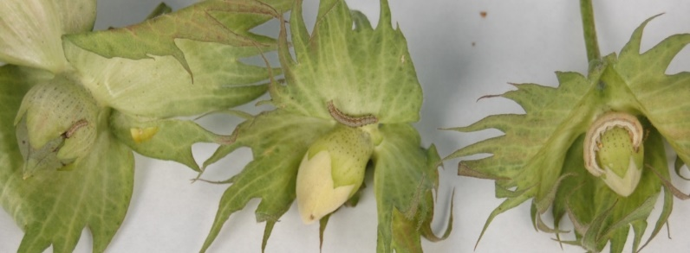
Fig. Damage to cotton boll worm boxes
References
- Khujamshukurov N.A. 2011. Production of microbiological preparations for plant protection problems and prospects (Overview). Chemistry and Chemical Technology. 3(33): 66-75.
- Pogue M. 2004. A new synonym of Helicoverpa zea (Boddie) and differentiation of adult males of H.zea and H.armigera (Hübner) (Lepidoptera: Noctuidae: Heliothinae). Annals of the Entomological Society of America 97(6): 1222-1226.
- Fitt GP. 1989. The ecology of Heliothis species in relation to agroecosystems. Annual Review of Entomology 34: 17-52.
- Fitt GP., Wilson LJ. 2000. Genetic engineering in IPM: Bt cotton. In: Kennedy GG, Sutton TB (Eds.). Emerging technologies in integrated pest management: concepts, research and implementation. APS Press, St Paul, MN, USA. Pp: 108- 125.
- Yang Y., Li Y., Wu Y. 2013. Current status of insecticide resistance in Helicoverpa armigera after 15 years of Bt cotton planting in China. Journal of Economic Entomology 106: 375-381.


Biography

Khujamshukurov Nortoji, Born in 1976 in Uzbekistan. Doctor of Philosophy, docent. Vice rector of Tashkent Institute of Architecture and Civil engineering. Research interests: insecticides, biopreparation, plant protection, entomopathogens.

E-mail: nkhujamshukurov@mail.ru
Notes/Comments:

