Marker-trait association analysis for grain calcium content in global collection of finger millet genotypes
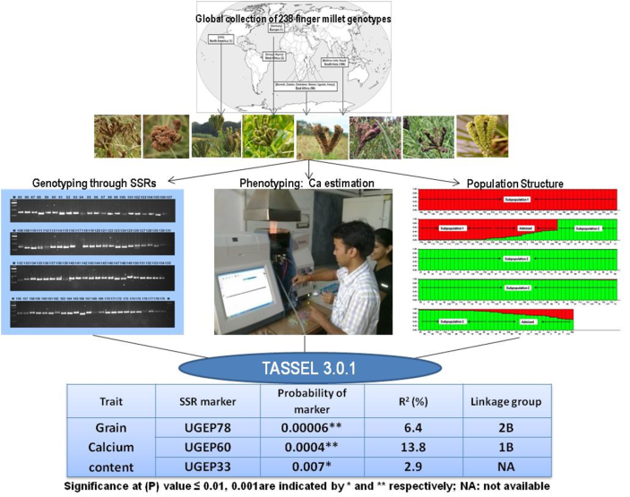
Shambhavi Yadav^{1,2}, Anil Kumar², Ajay Thakur¹
¹ Forest Research Institute, Dehradun, India
²G.B. Pant University of Agriculture and Technology, US Nagar, India

Abstract
Statement of the Problem: Increased calcium content in cereals could result in biofortification for combating mineral deficiencies. Finger millet (Eleusine coracana) is one such crop with grains highly rich in calcium. Understanding the genetic basis of grain calcium content (GCC) is critical for improvement of finger millet. In present study marker-trait association for GCC in finger millet was explored using association mapping.
Methodology & Theoretical Orientation: A global collection of 238 genotypes was taken for present study and genotyped using 85 genic and non-genic simple sequence repeats (SSR) markers. Phenotyping for GCC was done using atomic absorption spectrophotometry. Association analysis of SSR allelic data with GCC was carried out using TASSEL 3.0.1 software.
Findings: The 85 SSRs yielded 160 scorable alleles, of which 62 were polymorphic with polymorphic information content ranging from 0.143 to 0.781 at an average of 0.359. GCC across 238 genotypes ranged from 0.07% to 0.45%. Association analysis revealed two genomic SSRs UGEP78 and UGEP60 to be significantly associated to GCC quantitative trait loci (QTL) at threshold (P) value ≤0.001 and exhibiting phenotypic variance (R²) of 6.4 to 13.8% respectively. Genotypes GPHCPB45 and GPHCPB44 from North-West Himalayan region of India and exotic genotypes IE2957 and IE6537 were found to possess highest GCC. These may be effectively used as parents in genetic improvement programs.
Conclusion & Significance: In present study, marker UGEP60 found linked to QTL for GCC belongs to linkage-group 1B of finger millet which shows colineraity with rice chromosome 1 harboring a calcium content QTL and thus fine mapping around QTL on finger millet linkage-group 1B could lead to identification of potential genes affecting this trait. Moreover identified markers could be used in map based cloning and marker assisted introgression. The present study therefore provides a basis for genetic improvement of calcium content in finger millet.

Figure1: Determination of marker-trait association for grain calcium content in finger millet
Recent Publications
- Bradbury PJ, Zhang Z, Kroon DE, Casstevens TM, Ramdoss Y, Buckler ES (2007) TASSEL: Soft ware for association mapping of complex traits in diverse samples. Bioinformatics 23: 2633–2635
- Dida MM, Srinivasachary RS, Bennetzen JL, Gale MD and Devos KM (2007) The genetic map of finger millet, Eleusine coracana. Theoretical & Applied Genetics 114: 321–332.
- Garcia-Oliveira AL, Tan LB, Fu YC, Sun CQ (2009) Genetic identification of quantitative trait loci for contents of mineral nutrients in rice grain. Journal of Integrative Plant Biology 51:84–92
- Panwar P, Nath M, Yadav VK, Kumar A (2010) Comparative evaluation of genetic diversity using RAPD, SSR and cytochrome P450 gene based markers with respect to calcium content in finger millet (Eleusine coracana L. Gaertn.). Journal of Genet 89(2):121-33
- Srinivasachary DMM, Gale MD, Devos KM (2007) Comparative analyses reveal high levels of conserved colinearity between the finger millet and rice genomes. Theoretical & Applied Genetics 115: 489–499

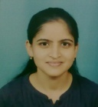 Biography
Shambhavi Yadav has her expertise in molecular plant breeding. Her work has been focused on use of molecular genetics and transcriptomics approaches in understanding calcium accumulation in finger millet. She has done genetic diversity and population structure analyses in diverse finger millet germplasm and carried out linkage and association mapping to reveal quantitative trait loci for calcium content trait. Her work also include in silico mining of simple sequence repeats in finger millet developing-seed transcriptome thereby generating rich SSR resource in finger millet. Currently she is working in the area of genetics and propagation of important forest trees and medicinal plants and also involved in in vitro conservation of forest genetic resources.
Email: shambhaviyadav@gmail.com
Notes/Comment

