Comparison of Allelopathic Activity of Some Edible Mushroom and Wild Mushroom in Japan
Osivand A. PhD Student, Tokyo University of Agriculture and Technology, Japan
Mardani H. PhD Student, TUAT, Japan
Araya H. Associate Professor, Meiji University, Japan
Fujii Y. Professor, TUAT, Japan

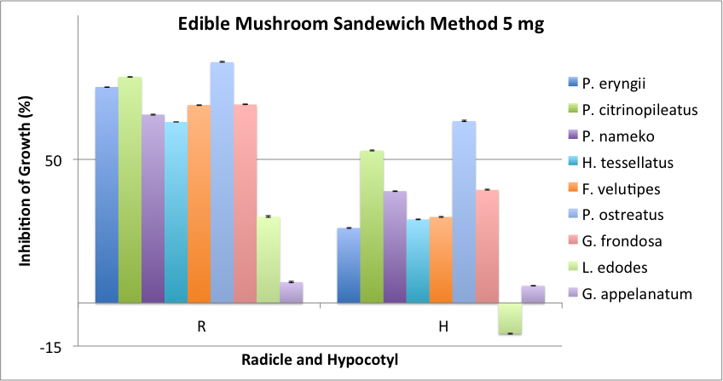
Abstract
Wild mushrooms have been always considered as valuable source of bioactive compounds, while edible mushrooms have been known for their importance as food source. However, their interaction with plants through chemicals that could lead to find new biochemical has not been well undertaken.
A
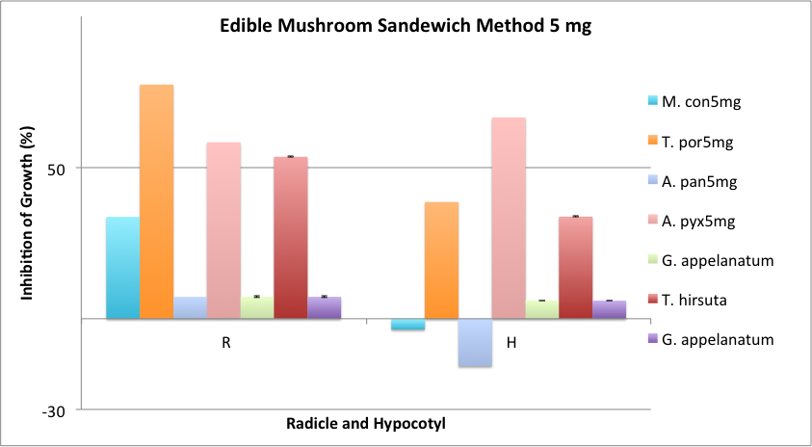
A special bioassay method (Sandwich method) was applied to compare eight common edible mushrooms (Pleurotus eryngii, Pleurotus citrinopileatus, Pleurotus ostreatus, Lentinula edodes, Grifola frondosa, Flammulina velutipes, Hypsizygus tessellatus and Pholiota namako) with some wild species (Ganoderma appelanatum, Amanita pantherina, Artomyces pyxidatus, Morchella conica, Tricholosporum porphyrophyllum, Trametes hirsuta) for their phytotoxicity against lettuce.
B
Among all tested edible mushrooms, application of 5 mg of P. ostreatus showed stronger allelopathic activity by inhibiting the growth of radicle and hypocotyl of lettuce by 84% and 63% respectively. Moreover, same amount of T. porphyrophyllum exerted 77% and 67% growth inhibition on radicle and hypocotyl of lettuce.
In general biochemicals contributed in tested mushrooms could be the main cause for their inhibitory activity and could lead to find new allelochemicals.

Image
Figure1: A) 5mg sandwich method of edible mushrooms have shown. B) The sandwich method of 5mg wild mushrooms have illustrated.
Recent Publications
- FujiiY, HiradateS (2007) editors. Allelopathy: new concepts & methodology. CRC Press. Pp 382.
- ElskusAA, SmallingKL, HladikML, KuivilaKM (2016) Effects of two fungicide formulations on microbial and macroinvertebrate leaf decomposition under laboratory conditions. Environ Toxicol Chem 35: 2834–2844.
- ArayaH, HiradateS, FujiiY (2003) Allelopathic activity of fruiting bodies of higher fungi. J Weed Sci Tech. 49(s): 176-177.
- OsivandA, MardaniH, ArayaH, FujiiY (2015) Evaluation of allelopathic potentials of some common edible mushrooms in Japan, 56th Weed Science Society of Japan proceeding, p 105.
- AkiyamaH, EndoM, MatsuiT, KatsudaI, EmiN, KawamotoY, KoikeT, BeppuH (2011) Agaritine from Agaricus blazei Murrill induces apoptosis in the leukemic cell line U937. Biochim Biophys Acta. 1810(5): 519-25.

Biography
Asma Osivand successfully conducted her MSc thesis on “Investigating the possibility of producing hybrids with single-spore isolates of Pleurotus florida” in the result she found 17 new hybrids which extra studies are conducting on one of them as vigorous hybrid in continues in her former University, Ferdowsi university of Mshhad, Iran. She started her PhD in bio-regulation science at Tokyo University of Agriculture and Technology from October 2015 on “allelopathy of edible and wild mushroom” to aim of finding new biochemical to use it as safe herbicide. In the Prof. Fujii laboratory at TUAT, she is going to focusing on her aim to finding the promising mushroom(s) and new allelopathic compound afterward.
Email: s157313w@st.go.tuat.ac.jp

Notes/Comments:

