Enhancing Onion Production and Productivity through Introduction of Seed Production Techniques in Central Zone of Tigray Region, Ethiopia
Yemane Kahsay, M.Sc., Adigrat University, Ethiopia

Abstract
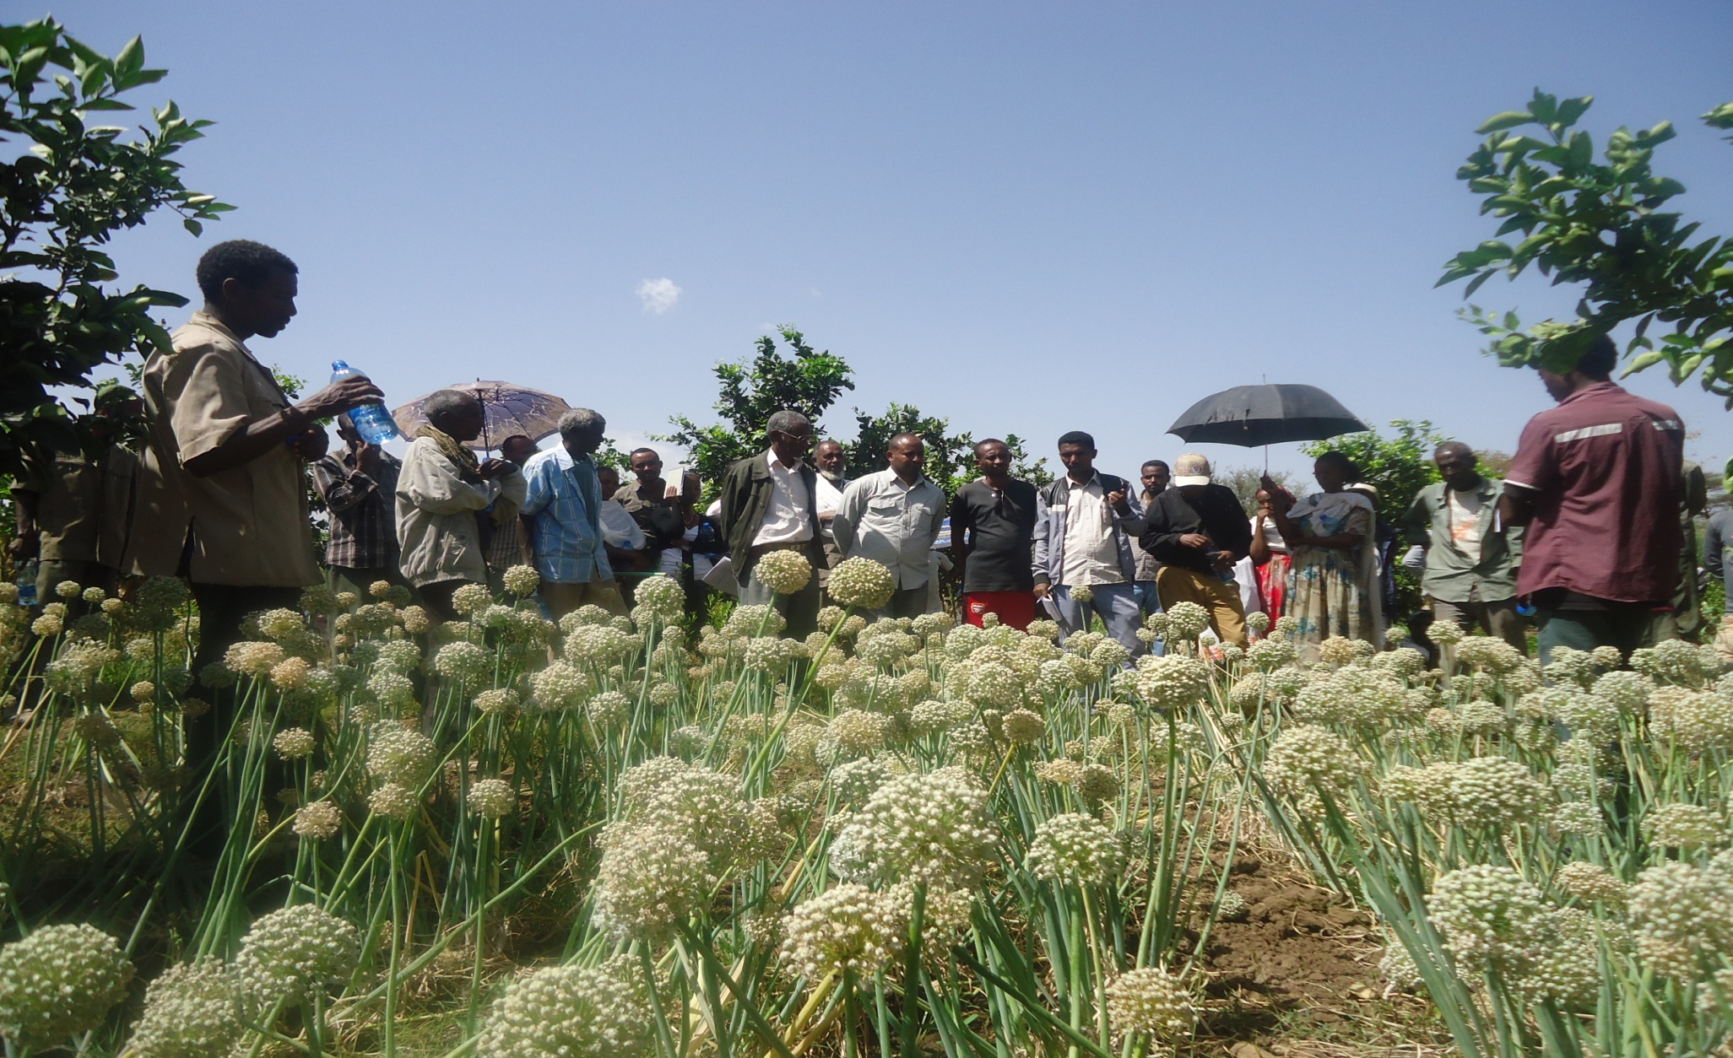
The main reason of low production and productivity is restricted use of inputs, notably improved seeds and fertilizers. Different vegetable seeds are imported which results in different problems like disease outbreak, timely unavailability, costly and so on. The demand of vegetable seed is increasing from time to time. Though vegetable seed production is difficult, there are attempts and efforts to produce at local level. Strengthening of community based seed multiplication is a means to develop the vegetable seed production techniques and business. In order to bring this to practical, demonstration and scaling up activities conducted since 2009 to 2014. Farmers Research Group (FRG) approach was used to implement the research. In 2013 an average yield of 7q/ha of onion seed was recorded while the maximum was 10 q/ha. While in 2014 a maximum yield 16 q/ha was recorded at farmers field. The yield increment might be due to skill development by the farmers. Farmers could get gross income of 24, 000 thousand from a parcel of 300 m² land. Thus local seed production practice is technically possible and economically feasible and should be encouraged and promoted by all stakeholders so as to enhance the income and livelihood of farmers.

Image

Figure 1. Stakeholders evaluation of the technologies at M.lekhe 2012 at field day
Recent Publications (minimum 5)
- Yemane, et al. 2013. Intra row spacing effect on shelf life of onion varieties (Allium cepa L.) at Aksum, Northern Ethiopia. Journal of Plant Breeding and Crop Science Vol. 5(6), pp. 127-136, June 2013
- Yemane, et al. 2013. Intra row spacing effect on growth and yield of onion varieties (Allium cepa L.) at Aksum, Northern Ethiopia. Journal of Agricultural Research. Sep. 2013
- Yemane, et al. 2013. Intra row spacing effect on yield and quality of onion varieties (Allium cepa L.) at Aksum, Northern Ethiopia. African Journal of Plant Science. Vol. 7(12), pp. 613-622, December 2013
- Yemane, et al. 2016. Determination of Optimum Rates of N and P Fertilizer forTomato at Mereb-lekhe District, Northern Ethiopia. Journal of Agriculture and Crops, Vol. 2, No. 3, pp:24-30, 2016
- Yemane, et al. 2016. Enhancing Onion Production and Productivity Through Introduction of Seed Production Techniques in Central Zone of Tigray Region, Ethiopia. Academia Journal of Agricultural Research 4(4): 188-192, April 2016
- Yemane, K..2016. Scope and Status of Vegetable Seed Production in Ethiopia. Journal of Nature and Natural Sciences (JNNSci) (2016) 1:13,1-15

Biography
Yemane Kahsay has his expertise in the area of horticulture. He had been research in horticulture for 8 years and did many researches in vegetable variety studies, vegetable seed production technologies, vegetable agronomy and coordinated different technology transfer activities and he is well experienced farmers participatory research approach. Currently as lecturer of horticulture and director of cactus research institute, he is engaged in lectures, teaching material preparation, consultancy leading research projects and institute.
Email: yemi2am@yahoo.com

Notes/Comments: This article is concerned with the critical value chain interventions in vegetable development for food security and income generation

