Development of a system for controlled and leveled puddling
Kusuma Guturu¹, Manohar Jesudas D²
- Assistant Professor – Vignan’s University, Vadlamudi, Andhra Pradesh, India
- Professor- Tamil Nadu Agricultural University, Coimbatore, India
Abstract:
Statement of the problem:
Rice is one of the staple foods for almost half of the world’s population and consumes ample amount of water per unit yield, which results from highly water consuming system of seed bed preparation called puddling. Puddling is done to reduce percolation of water in the rice cultivation. But the process of puddling itself takes mush amount of water. A system is developed to reduce amount of water required for puddling by limiting the depth of puddling to required level, to reduce percolation of water by achieving harder hard pan and to obtain good leveled field which affects final yield of the crop.
Methodology and theoretical orientation: A rotavator was laser controlled while it is used for puddling operation. The depth of puddling was set to 20 cm depth which is optimum for rice cultivation. Modifications were done in the hydraulic system of tractor to supply hydraulic oil at high pressure to the cylinder of laser attachment. The field was tested for level variations after puddling with laser puddler and compared with level variations of the conventionally puddled field.
Findings: The average depth of puddling when puddling with laser puddler was 17.3 ± 0.4 cm, while that of conventional puddler (rotavator) was 15.2 ± 0.3 cm at 95% confidence interval. The penetration resistance of the laser puddled and conventionally puddled fields were 197 k Pa and 186 k pa respectively at 180 mm depth of puddle. Wire frame for laser puddled field is shown in the Fig.1.
Conclusion and significance: The variations observed were significant and it revealed that, systematic level of puddling will contribute to the energy and resource conservation in paddy cultivation.
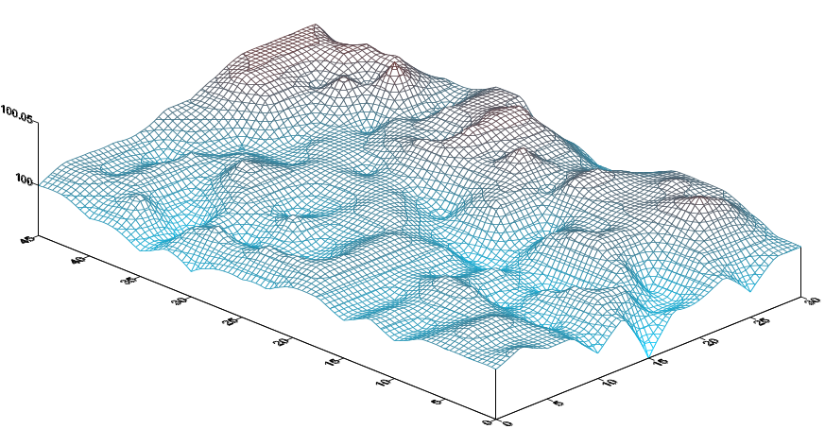
Fig. 1: Wire frame for surface of the field
Recent publications:
- Kusuma Guturu, K.sahitya, V. Naga komali, B. Raj kiran, Ch. V.V. satyanarayana (2015). Design and Fabrication of raising platform for harvesting oil palm fresh fruit bunches. Indian Journal of Science and Technology. Vol 8(17) ISSN (Print) : 0974-6846, ISSN (Online) : 0974-5645.

- Kusuma Guturu, T. Vadhan singh (2015). “Harvesting of oil palm- An ambitious task for Ag. Engineers” International Journal For Research In Emerging Science and Technology, Volume-2, Issue-7, E-ISSN: 2349-7610

- Kusuma G, Lavanya P, Naresh N, Anitha G, Radha S A, Naveen A (2015). Comparitive Evaluation of percolation rates in conventionally puddled wet rice fields of Sangareddy, Telangana State. International Journal of Tropical Agriculture, Vol 33 (4) : 3683-3686.

- Kusuma G, Kranthi kumar Ch, Balachand Ch. (2015). Comparitive evaluation of low and high pressure biomass briquettes. International Journal of Tropical Agriculture, Vol 33 (4) : 3687-3690.

- Kusuma Guturu, Manohar Jesudas. D and Surendra Kumar. A (2016). Variation in Surface and Hardpan Levels of Wet Rice Fields. Indian Journal of Ecology, Vol 43(Special issue):132-135.

- Kusuma G, Lavanya P, Naveen A , Naresh N, Anitha G, Radha S A. (2016) Quantification of Water Loss Due to Unleveled Surface of Conventionally Puddled Wet Rice Fields , Indian Journal of Ecology, Vol 43(1): 65-69.

- Kusuma.G, Lavanya.P, Naresh.N, Anitha.G, Radha.S.A., Naveen.A. (2016). Effect of Puddling on Surface Levels of The Conventionally Puddled Wet Rice Fields. Environment, Ecology and Conservation (Yet to be published in December 2016, only accepted)
Biography:

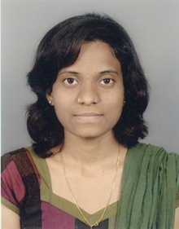
Ms. Kusuma Guturu is currently working as Assistant Professor in Vignan’s University. She has conducted this research as a part of her M.Tech. degree under the guidance of Dr. Manohar Jesudas at Tamil Nadu Agricultural University, Coimbatore, India, where they have developed a seed bed preparation system for puddling to obtain controlled and leveled puddling for paddy fields to conserve the water. She has received best presentation award for this project from Indian Society of Agricultural Engineers.
E-mail: kusumaguturu.10@gmail.com

