Performance of the Warehouse Receipt System (WRS) Program

to Support Agricultural Financing in Indonesia

Endro Gunawan¹⁾ and Yuli Edi Subagio²⁾
¹⁾ Indonesian Center for Agricultural Socio Economic and Policy Study
²⁾ Commodity Future Trading Regulation Agency, Indonesia
¹⁾ Asian Institute of Technology, Thailand
e-mail : st119285@ait.asia

Abstract

The common problem in agricultural commodity in Indonesia is price volatility. The warehouse receipt system (WRS) is one of the means by which the farmers can manage the price volatility and finance their production activities. The warehouse receipt system has been implemented in Indonesia in 2006 based on Law No. 9 of 2006. As a new financial system, warehouse receipt system is not well known and not fully understood by stakeholders. This study examined the performance and benefit of the warehouse receipt system support the agricultural financing in Indonesia. The performance indicators measured in this study are number of volume and value of commodity deposit in the WRS, the number of warehouse receipt, and the number of financial funding from the WRS from 2008-2016. The method of analysis is narrative and descriptive statistic.

The result revealed that since the WRS was introduced in 2006 in West Java and East Java province, until 2016 the WRS has been adopted in 76 districts/cities in 21 provinces. The warehouse receipt issued reached 2,423 receipts in 2016 with total volume of commodity of 87,868.77 tons valued at Rp. 493.2 billion, and Rp 291.3 billion was financed by the various financial institutions. The volumes of commodities stored in the warehouses over the period 2008 – 2016 were as follows: 73,026.16 tons of paddy rice valued at Rp 372.8 billion, 7,922.10 tons of rice (Rp 60 billion), 5,699.07 tons of corn (Rp 19.2 billion), 631.57 tons of coffee (Rp 36.6 billion), 555.57 tons of seaweeds (Rp 4.3 billion), 3.14 tons of cocoa (Rp 78.5 Million), 31.16 tons of rattan (Rp 264.5 Million). Total financing by the financial institutions as of 30th December 2016 was Rp. 291.3 Billion. The number of the warehouse receipts that had been issued was 2,124 for paddy rice, 135 for rice, 108 for corn, 36 for coffee,16 for seaweed, 3 for rattan and 1 for cocoa. The total number of warehouse receipts issued was 2,423.

The benefit of the WRS is provides easy access to credit, controlling and stabilizing the commodity prices. For the banks, the WRS will create a market for banks’ credit. The processor of agricultural products will ensure the availability of raw materials. The WRS is an alternative for the agricultural financing with the guarantee of warehouse receipt for credit collateral.

Keywords : warehouse receipt system, agricultural financing, Indonesia

1. Introduction

Agriculture is a strategic sector for Indonesia. The strategic roles of the Indonesian agricultural sector include the provision of food, industrial raw materials, foreign exchange, and employment (Ministry of Agriculture, 2016). During the period 2010-2014, the Indonesian agricultural sector’s contribution to GDP reached an average of 10.26%, with annual growth of about 3.9% during that period (BPS-Statistics, 2017). In 2014, the agricultural sector employed approximately 35.76 million people (about 30.2% of Indonesia’s total labour force). From 2010-2014, investments in the primary agricultural sector, from both domestic and foreign sources, increased by 4.2% and 18.6% per year, respectively. The export growth rate reached 7.4%, and import growth was 13.1% per year over the same period. Agriculture has long been and remains a top priority in development plans in Indonesia (Cummings et al., 2006).

Key problems in the agricultural sector in Indonesia relate to financing, marketing, and marketing infrastructure. The perishability and seasonality of agricultural products has increased price volatility in the market (Coulter & Onumah, 2002). At harvest time, the price of agricultural commodities falls, otherwise, outside the harvest season, the price remains high. Price fluctuations are a disadvantage for both producers and consumers. Theoretically, to avoid losses due to falling prices during harvesting period, farmers could delay their sales (Ashari, 2012). However, most farmers do not have a strong bargaining position to hold back their harvested products because they need cash flow for their next farming investment (Coulter & Onumah, 2002). This situation occurs every harvesting season, although the Indonesian government has issued a policy to set the basic price for some agricultural products. Prevailing instruments such as crop insurance and futures markets have been employed to manage the price risk, nevertheless, this strategy has not proven effective (Galtier, 2011). Governments in some African countries have also been unable to successfully intervene on the issue of price instability (Poulton, 2006). Price instability leads to agricultural market volatility for poor farmers and increases in food imports in low-income countries (Schneider, 2011). The warehouse receipt financing has been applied in the Ethiopian Commodity Exchange to enhance social capital in the agricultural value chain (Meijerink et al., 2014).

Theoretically, to avoid income losses due to falling prices during the harvesting period, farmers could delay sales of their produce (Ashari, 2012). However, most farmers do not have a strong bargaining power to withhold their harvested produce because they require cash flow to support their next farming investment (Coulter and Onumah, 2002). Price volatility in agriculture commodities has an impact on decreasing farmers’ incomes. Without government intervention, this problem would continue every harvesting season. Governments have intervened by implementing policies to set the basic price (i.e. government purchase price) for some agricultural products, such as paddy rice, maize, and soybeans. However, the reach and effectiveness such programs has been limited, so the problem of price volatility often remains (Poulton et al., 2006; Ministry of Agriculture, 2016). Governments should carefully consider the causes of price instability, and apply a combination of public and private instruments to help address the problem (Galtier, 2011).

Price volatility for agricultural commodities has driven the government of Indonesia, through the Ministry of Trade, to issue a Warehouse Receipt System (WRS) policy based on Law No. 9/2006. The policy was seen as essential to assist farmers in overcoming product marketing issues during the harvest season and help them gain access to credit financing from banks and other financial institutions (Erawan, 2008). The WRS is a strategy to substitute the Minimum Support Price scheme and cash transfers with a more targeted public distribution system for poor households (McCorriston & MacLaren, 2016). This study will assess the performance and benefit of the WRS in Indonesia, based on the secondary data from 2008-2016.

2. Method of Analysis

The method of analysis is narrative and descriptive statistic.

3. Result and Discussion

3.1 Current status of the WRS in Indonesia

Since the WRS was introduce in 2008 in West Java and East Java province, now the WRS has been adopted in 76 districts/cities of 21 provinces (CoFTRA, 2017). Data from CoFTRA Annual Report 2017, the warehouse receipt issued reached by 2,423 receipts in 2016 with total volume of commodity 87,868.77 tons or equivalent with Rp. 493.2 billion, and Rp 291, 3 billion had been financed by the various financial institution (Table 1).

Table 1: Warehouse receipt, commodity volume, and warehouse receipt value: 2008 – 2016

 | Warehouse Receipt |  | Value of Receipt | Funding
Year | Amount | Vol (Ton) | (Rp) |  | (Rp)
2008 | 16 | 508.83 | 1,431,616.200 |  | 313,900.000
2009 | 13 | 214.11 | 552,962.240 |  | 136,800.000
2010 | 57 | 2,299.94 | 8,678,733.500 |  | 4,216,023.850
2011 | 271 | 8,895.62 | 40,067,723.608 |  | 24,049,719.530
2012 | 379 | 18,144.16 | 93,183,187.979 |  | 58,653,918.633
2013 | 532 | 20,796.23 | 108,948,556.100 |  | 66,993,206.000
2014 | 605 | 21,649.27 | 116,514,391.200 |  | 75,795,102.000
2015 | 300 | 8,931.92 | 81,171,788.490 |  | 45,597,684.680
2016 | 250 | 6,428.69 | 42,644,699.900 |  | 15,591,922.000
Total | 2,423 | 87,868.77 | 493,193,659.217 |  | 291,348,276.693
Source: CoFTRA Annual Report (2017)

Figure 1: Number of warehouse receipt, 2008-2016

Figure 2: The Value of commodity and funding by WRS, 2008-2016

Based on the commodity, the volume of commodity that stored in the warehouse are 73,026.16 tons of paddy rice (Rp 372.8 billion), 7,922.10 tons of rice (Rp 60 billion), 5,699.07 tons of corn (Rp 19.2 billion), 631.57 tons of coffee (Rp 36.6 billion), 555.57 tons of seaweeds (Rp 4.3 billion), 3.14 tons of cocoa (Rp 78.5 Million), 31.16 tons of rattan (Rp 264.5 Million). Total financing funneled per 30 December was Rp. 291.3 Billion (Table 2). The number of the warehouse receipt that have been issued was 2,124 from paddy rice, 135 from rice, 108 from corn, 36 from,16 from seaweed, 3 rattan and 1 from cocoa. The total number of the warehouse receipt issued until 2016 is 2,423 WR.

Table 2: The number of receipt, volume and value of the warehouse receipt by commodities: 2008 – 2016
Commodity | Number of | Volume | Value | Fund
 | Receipt | (ton) | (Rp) | (Rp)
Paddy Rice | 2,124 | 73,026.16 | 372,775,506.336 | 224,813,412.230
Rice | 135 | 7,922.10 | 60,011,466.500 | 33,351,580.300
Corn | 108 | 5,699.07 | 19,247,609.194 | 11,286,883.100
Coffee | 36 | 631.57 | 36,565,089.187 | 20,805,801.063
Seaweed | 16 | 555.57 | 4,250,940.000 | 1,090,600.000
Rattan | 3 | 31.16 | 264,548.000 | -
Cocoa | 1 | 3.14 | 78,500.000 | -
Total | 2,423 | 87,868.77 | 493,193,659.217 | 291,348,276.693
Source: CoFTRA Annual Report (2017)

3.2. Warehouse receipt issued process

Based on the Regulation of the Minister of Trade Number 26/2007, the types of commodities stored in the WRS especially was export’s commodities and food crop. The requirement for this commodity were: (1) have a long life storability at least three months; (2) the price is fluctuates; (3) have certain quality standards, (4) have a clear market and pricing information; and (5) have an added value as a potential commodity. There were ten types of commodities: paddy rice, rice, corn, coffee, cocoa, pepper, rubber, seaweed, rattan, and salt. Other commodities could also be stored in warehouses taking into account recommendations from local governments, relevant agencies, or commodity associations with due regard to the commodity requirements set out in the regulation.

Before issuing the WR, the goods must follow the standard quality that fixed by the warehouse manager (Ministry of Trade, 2016). The WRS document would be issued by warehouse manager after all requirements were completed. All data related to WR issued will sent into the WR information system (IS-WARE) at the Registration Centre. The process of issuing a warehouse receipt was described in Figure 2.1.

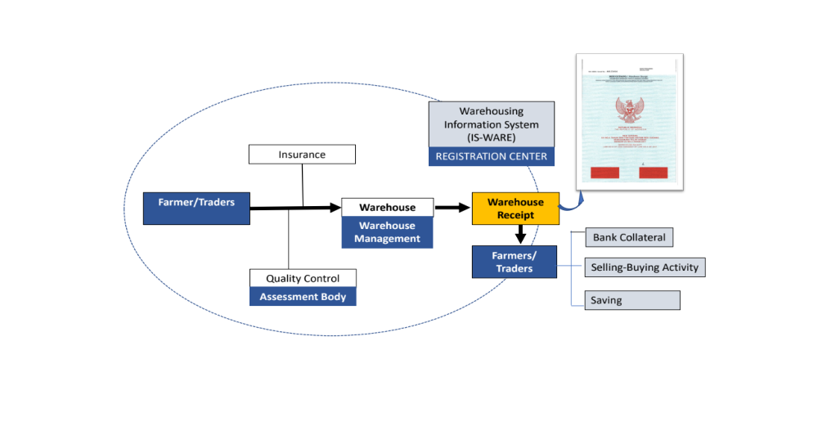
The farmers will deposit the commodity in the warehouse after obtain the approval from the warehouse manager. The agricultural commodity that will be store in the warehouse must qualify with the quality standard of the product. If the condition of the goods appropriate with the term of condition, the goods will be deposit in the warehouse, and the owner will obtain a warehouse receipt. The warehouse receipt could be used as credit guarantee in the bank, selling in the auction market or stored as proof of ownership of the goods. The commodity that stored in the warehouse will be insured. By WRS, agricultural commodities could be traded with high prices through the improvement of product quality, and at the same time can be guarantee as credit collateral in the bank.

Figure 1: Process of issuing a warehouse receipt

Source: CoFTRA (2015)

3.3 The Benefits of the Warehouse Receipt System.

The main goal of the WRS policy was to increase the welfare of farmers, cooperatives, and small and medium enterprises. This objective could be achieved through government-provided financing schemes that could be accessed by the community with agricultural commodities resulting from farming as collateral. Through WRS, farmers, cooperatives, and the small and medium enterprises could be increase the productivity which leads the competitiveness. Furthermore, the implementation of the WRS was useful in controlling and stabilizing the commodity prices. For the banks, the existence of the WRS will create a market for bank’s credit. The agricultural processor also became the benefits from the WRS through ensuring the availability of raw materials.

The research by Ashari (2012) stated that implementation of the WRS will increased agriculture production, economic turnover, absorb the labor and reduce unemployment. The WRS has significant contribution on the economic growth of the small medium enterprise’s. The implementation of the WRS was prospective to increase the farming income. Warehouse receipts can be guaranteed for the credit collateral, farmers will obtain cash money for the farming and buying their daily needs.

According Anugrah & Suryani (2015), the WRS is an alternative for the agricultural financing with the support from the bank. The possible reasons were: 1) the volume of agricultural commodity was abundant, 2) the period of WRS credit was relatively short, 3) implemented by assessment institution, warehouse manager, and insurance, and, 5) the bank only deals with the warehouse receipt document.

Study by Ashari (2012) concluded that, the income structure of the paddy rice farmers’ who participated in the WRS was higher than non-participants. Moreover, Yudisaputro (2013) also showed that, WRS was capable and have benefits to the farmers. The cost for issuing the WR was lower than the revenue that received by WRS participants.

Erwidodo et al. (2014) showed that the implementation of the WRS could increase the farmer's income of the WRS participants. In general, the essence of the implementation of the WRS were: 1) increased farmer's income, 2) as a financial resources, 3) improvement of product quality and standardization, and 4) as a warehousing revolution.

WRS was one of the policy to increased farmer’s income through a delayed sale system where farmers can deposit their products during harvest time, and sell at high prices. The WRS also as a source of financing by the principle of collateral. WRS can be creating a more efficient and modern marketing system, through the auction market system. With the WRS, the product no need to be carried or transported by people during the sales or marketing process. Even with this pattern, the marketing of the product can be done up to the commodity exchanges.

The WRS will encourage the improvement of the product quality and standardization. Farmers were motivated to standardize their products when they were to be incorporated into the WRS (Nathaniel et al., 2013). This was very important to face the global market competition. WRS will encourage the warehousing revolution, through the development of a warehousing system, that was an important part of supporting modern marketing patterns.

Conclusion

Reference

