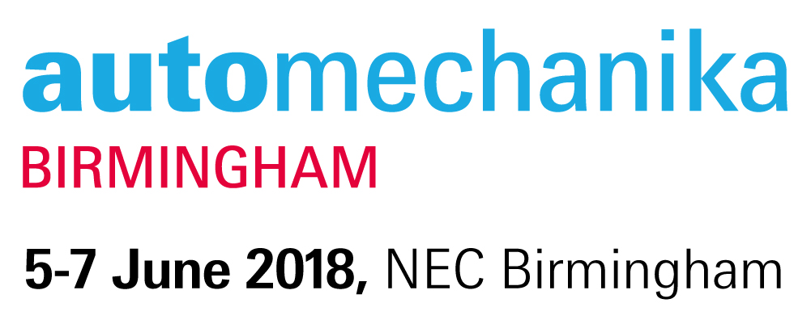
- Summary
- Information

Summary
Review your registration details

Your Badge
Congratulations, you're registered to attend Automechanika Birmingham 2018!
Please print your badge and bring it with you:

Registration Details
Mr JOHN EKOW BONDZIE
isaacboateng895@gmail.com
AUTO PUMP MECHANIC
ST JOHN FUEL PUMP WORK SHOP

Venue Details
National Exhibition Centre,
Halls 6, 19 and 20,
Marston Green,
Birmingham
B40 1NT
Visit Website

Opening Hours
Tuesday 5 June | 9.30am - 4.30pm
Wednesday 6 June | 9.30am - 4.30pm
(Garage Quarter, Hall 19 open until 7pm)
Thursday 7 June | 9.30am - 4.00pm

Meetings programme
Pre-plan your visit to maximise your time at the event. Save time and use our meetings tool to pre-arrange meetings with the most relevant suppliers onsite, build and print a daily agenda. Look out for the email for your profile!

Held in association with SMMT 

More information
Head to www.automechanika-birmingham.com.

Recommend another person from the automotive industry for the chance to get a free breakfast, courtesy of 
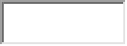

Tell people you're coming

