STORY TELLING
BENEFITS OF CONSERVATION AGRICULTURE (MULCHING) IN TANZANIA: A CASE OF KIBONDO DISTRICT, KIGOMA REGION, TANZANIA
Mohamed Semdoe: District Environmental Management Officer,
Chemba District Council,
Dodoma Region
Tanzania
Email: mohamedsemdoe@gmail.com
- Introduction
Kibondo District is among of six districts in Kigoma region. It is situated 250km North-East from Kigoma region headquarters. The District covers an area of 7715.05 square kilometers, lies between 3.9⁰ –5.0⁰ S, and 30.2⁰ –31.50⁰ E with an average altitude, that ranges between 500m and 2300m ASL. As regard to climatic condition, temperature ranges between 15⁰ C and 22⁰ C; while rainfalls range between 800 mm to 1900 mm. The rain start at the end of October to May; March and April are normally the wettest months.
Kibondo district has about 1,285.84 square kilometer of land suitable for agricultural production, including about 200 square kilometer of rangelands suitable for livestock grazing. The district has 3 agro-ecological zones.

2.0 Success story
In the year 2004, the government of Tanzania has launched and implements District Agricultural Sector Investment Project in all districts which ended in year 2012. The project aimed at increase crops productivity through facilitation of agricultural inputs, extension services, storage facilities, and market linkage. One of the districts benefited was Kibondo district in Kigoma region of which project activities conducted and reached at village level. At Kitahana Village where, one of resident known as Mr Christopher Ntaziha adopted and practices skills provided by facilitators. He adopted conservation agriculture practice (Mulching), through mulching practice, his farm plots of 10 acres with mixed clay-loam soils and climatic condition of temperature range between 15⁰C and 22⁰C and Rainfall range between 800mm-1900mm produced banana bunch per one banana tree with about 3000 pieces of banana. Also his farm plots produced five bags (100kg each) of beans per one acre; and 10 bags (100kg each) of maize per one acre. He used to sell his crops to both local market and nearby regions. He communicated with his customers through mobile phone, the customers collected crops from the farm plots.
3.0 Conclusion
Agriculture sector is the key contributor to the national economy by accounting 25.88% of the national economy, contributed by crops subsector (18.93%); livestock subsector (4.70%) and fisheries subsector (2.25%), respectively. About 90% of Tanzanians are engaged in agriculture as economic base. However, majority are not practices sustainable agriculture such mulching, contours farming, intercropping and a few to mention. Therefore, more efforts should be done by Public-Private Partnerships to change farmer attitude on agriculture practices so as to increase crops productivity and attain Sustainable Development Goals.
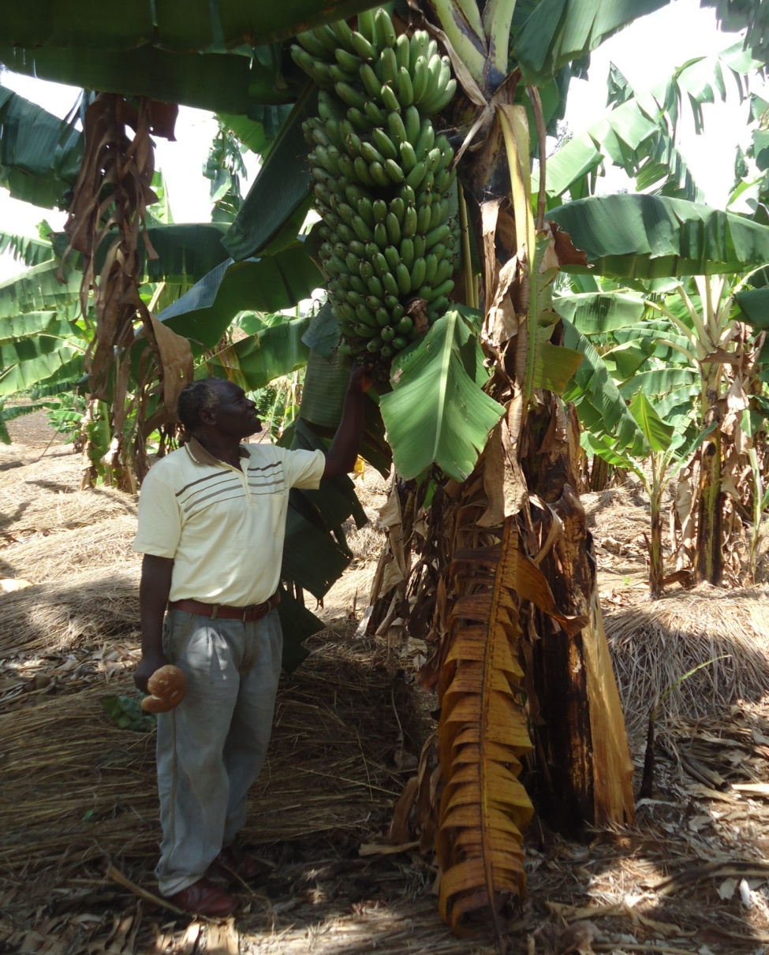
Figure 1: A farmer (Mr Christopher Ntaziha) of Kitahana Village in Kibondo District, Kigoma Region, Tanzania has showed banana product cultivated in his farm under conservation agriculture practices (Mulching): Photo: Mohamed Semdoe, 2017
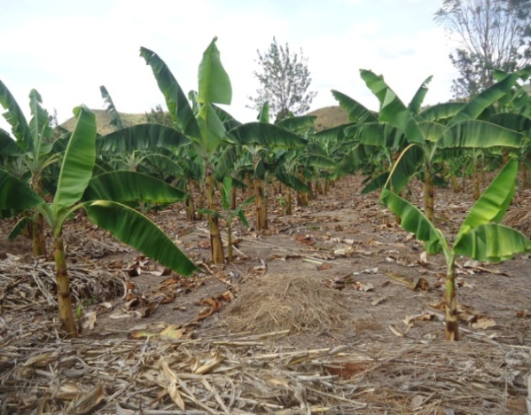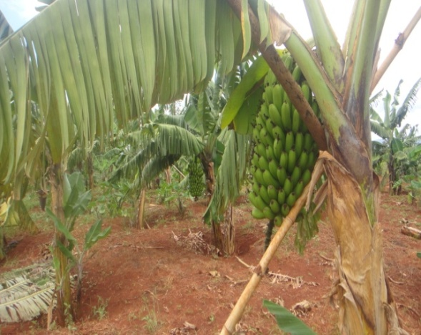
Figure 2: Banana farms under conservation agriculture practices (Mulching) own by Mr Christopher Ntaziha in Kibondo District, Kigoma Region, Tanzania. Photo: Mohamed Semdoe, 2017

