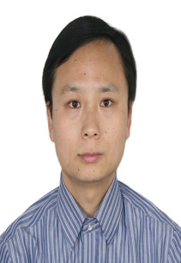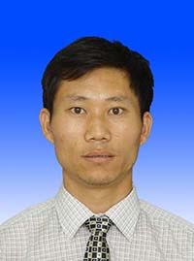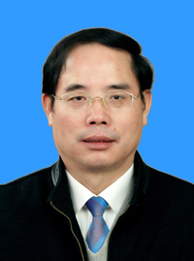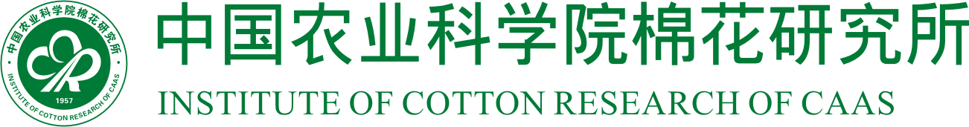
Title: Genome-wide association mapping for malondialdehyde and proline contents in semi-wild accessions of Gossypium hirsutum races under drought stress

Kiflom Weldu Okubazghi, Wang Xingxing, Liu Fang, Wang Kunbo
State Key Laboratory of Cotton Biology, Institute of Cotton Research of Chinese Academy of Agricultural Sciences, Anyang, Henan, 455000, China

Gossypium hirsutum is the most important source of fiber for textile industry worldwide. To meet the demand of the world’s growing population and rising income, cotton production has to be improved. However, crop production, in general, is under threat due to human-mediated climate change, which has left farmers and crop breeders with almost no choice but to contend with frequent and long-term droughts, among other abiotic stress. Semi-wild accessions of Gossypium hirsutum races are repositories of desirable alleles for several economically important traits, such as tolerance to drought stress. Thus, uncovering the molecular basis of drought related traits in the accessions may play a key role in developing new drought tolerant cotton varieties. In this study, to detect single nucleotide polymorphisms (SNPs) significantly associated with drought tolerance related physiological responses, genome-wide association study (GWAS) was conducted in 189 semi-wild accessions of Gossypium hirsutum races using 80K Illumina Infinium SNP array. We performed GWAS using mixed linear model implemented in TASSEL 5 software, and detected 1 and 2 SNPs significantly associated with malondialdehyde and proline, respectively, on 2 of the 26 cotton chromosomes, explaining 9.80-11.61% of the total phenotypic variation. In addition, we identified 7 and 59 candidate genes related to malondialdehyde and proline, respectively. The identified SNPs and genes not only further advance our understanding of the genetic architecture of drought tolerance but also could be utilized in future drought tolerance improvement programs though marker assisted selection in cotton.

Biography
Kiflom Weldu Okubazghi has completed his MSc in Crop Genetics and Breeding from Graduate School of Chinese Academy of Agricultural Sciences. Currently, he is a PhD scholar at Graduate School of Chinese Academy of Agricultural Sciences. He is a lecturer at Hamelmalo Agricultural College, Keren, Eritrea. He has published a paper in a reputed journal named Journal of Integrative Agriculture and his other papers are ready for submission to other reputed journals.

Wang Xingxing has completed his PhD from Huazhong Agricultural University. He is an Assistant Researcher at the Institute of Cotton Research of Chinese Academy of Agricultural Sciences. He has published more than 10 scientific papers in various reputed journals.

Liu Fang has completed his PhD from Southwest University in China. He is a professor at the Institute of Cotton Research of Chinese Academy of Agricultural Sciences. He has more than 10 invention patents and won the second prize of National Science and Technology Progress. He has published more than 30 scientific papers in various reputed journals.

Wang Kunbo has completed his PhD from Graduate School of Chinese Academy of Agricultural Sciences. He is the leader of innovative team of Cotton Germplasm Innovation and Utilization at the Institute of Cotton Research of Chinese Academy of Agricultural Sciences. He developed about 700 accessions and distributed them to cotton breeders in China which resulted in 172 novel upland cultivars. He won the second prize of National Science and Technology Progress. He has published more than 160 scientific papers in various reputed journals, including one paper titled “The draft genome of a diploid cotton Gossypium raimondii” in Nature Genetics and has been serving as an academic editor in PLOS ONE.

Presenting author details
Full name: Kiflom Weldu Okubazghi
Contact number: 0086-18317306117
Email: wediweldu81@yahoo.com
Session name/ number: Agricultural Biotechnology
Category: Oral presentation

