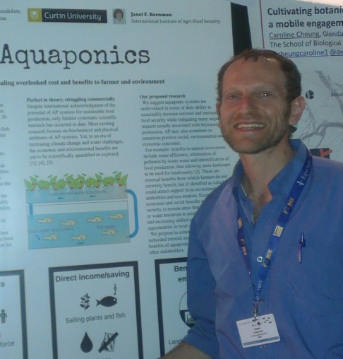
Economically Viable Aquaponics: Mapping the Gap between Promising Potential and Current Uncertainties
Name: Asael Greenfeld^{1,2}
Co-aouthers: Nir Becker², Jennifer McIlwain¹, Janet F. Bornman³.

¹ - Department of Environment and Agriculture. Curtin University, WA.
² -Faculty of Social and sciences and Humanities. Tel-Hai College, Israel
³ -International Institute of Agri-Food Security. Curtin University, WA.

Aquaponics, or integrated farming of fish and plants, has potential for sustainably producing high quality food, but has not become a commercial success in most places. In recent years, aquaponics has been receiving growing attention from the scientific community, and the current literature covers many aspects of aquaponics production. We reviewed the current literature and classified the specific areas covered by each paper and its contribution to cost reduction or benefit enhancement. Regardless of contradicting views of current profitability, there seems to be a consensus that 1) bigger systems are economically superior to smaller ones; 2) profitability is sensitive to retail prices; and perhaps most importantly, most authors agree that commercial aquaponics can become more profitable by improving business plans. We identified three under-studied aspects that could each be a “game changer” for commercial aquaponics: 1) Grower considerations such as financial planning and risk management that may affect potential growers’ initial engagement in aquaponics; 2) Consumer perception of aquaponics products including willingness to pay more for the added value; 3) The economic value of environmental benefits of aquaponic systems, and ways to internalise them. We present some results from our study on growers’ and consumers’ perception of aquaponics that highlight the importance of case specific business planning and market research. Further study of each of these three aspects will support ongoing attempts to establish large-scale aquaponics as an economically sustainable practice.

Biography

Asael Greenfeld has an MSc in dryland Ecology from BGU Israel and following years of enviromental education is Israel and Australia, has taken on a PhD course in Environmental Economics at Curtin University WA, in conjunction with the Tel-Hai academic college in Israel.
Presenting author details
Full name: Asael Greenfeld
Contact number: +972-54-7138372
Twitter account:
Linked In account: https://www.linkedin.com/in/asael-greenfeld
Session name/ number: Agricultural Production Systems & Agribusiness / Organic farming / Agriculture and Environment
Category: Oral presentation

