Electromembrane extraction combined with capillary electrophoresis for the determination of Organophosphorus in wastewater and food samples
Ehsan sadeghi, Shahid Beheshti University, Tehran, Iran

Abstract

Electromembrane extraction (EME) is a sample preparation technique in pharmaceutical, chemical, clinical and environmental analysis. This technique uses electromigration across artificial liquid membranes for selective extraction of analytes and sample enrichment from complex matrices. This method has many advantages such as simplicity, rapid, low-cost, low LOD, high preconcentration factor and high recovery.
In the present work, simultaneous preconcentration and determination of Organophosphorus such as Glyphosate (GLP), Malathion (MAT), Ethion (ETH), Dimethoate (DMT) were studied using EME as a suitable extraction method, followed with capillary electrophoresis (CE) using ultraviolet (UV) detection as separation technique. The Organophosphorus were extracted from 4 ml sample solutions, through a supported liquid membrane (SLM) consisting 2-nitrophenyloctylether (NPOE) impregnated in the walls of a polypropylene hollow fiber, and into a 20 μL acidic aqueous acceptor solution resent inside the lumen of the hollow fiber with a potential difference applied over the SLM. The variables of interest, such as chemical composition of the organic liquid membrane, stirring speed, extraction time and voltage, pH of donor and acceptor phases and salt effect in the EME process were investigated and optimized. Under optimal conditions NPOE as SLM, stirring rate of 1000 rpm, 200 V potential differences, 20 min as the extraction time, acceptor phase HCl (pH 1.0) and donor phase HCl (pH 1.5).
After the microextraction process, the extracts were analyzed by CE with optimum conditions phosphate running buffer (pH 2.0), applied voltage of 20 kV and 25°C. Under the optimum conditions, limits of detection (LOD) and quantification (LOQ) for GLP and MAT and ETH and DMT were 2.31-2.68-2.48-2-91 and 7.72-8.91-8.43-7.95 ng mL⁻¹ respectively. Preconcentration factor and RSD for five replicates of each Organophosphorus were calculated to be 200 and 4.06-3.93-4.32-3.65 respectively.

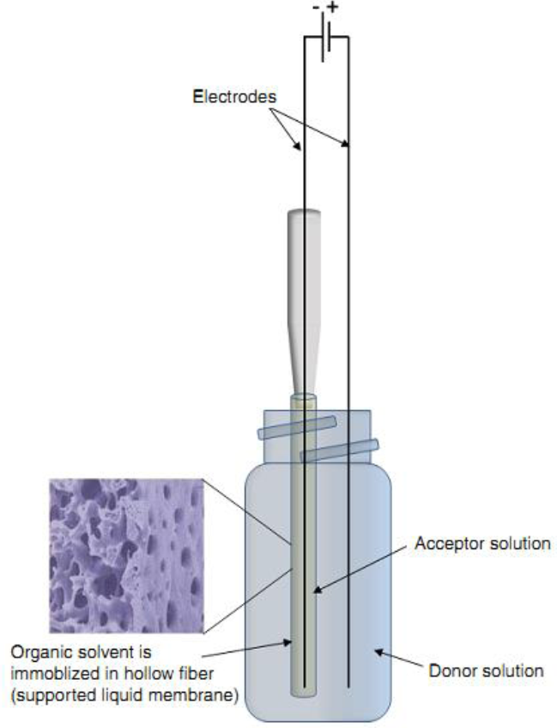

Figure 1. Schematic illustration of the electromembrane extraction
(EME) set-up.

Recent Publications
- Tabani, H., Fakhari, A.R. and Shahsavani, A., 2013. Simultaneous determination of acidic and basic drugs using dual hollow fibre electromembrane extraction combined with CE. Electrophoresis, 34(2), pp.269-276.
- Hasheminasab, K.S. and Fakhari, A.R., 2013. Development and application of carbon nanotubes assisted electromembrane extraction (CNTs/EME) for the determination of buprenorphine as a model of basic drugs from urine samples. Analytica chimica acta, 767, pp.75-80.
- Middelthon‐Bruer, T.M., Gjelstad, A., Rasmussen, K.E. and Pedersen‐Bjergaard, S., 2008. Parameters affecting electro membrane extraction of basic drugs. Journal of separation science, 31(4), pp.753-759.
- Nojavan, S. and Fakhari, A.R., 2010. Electromembrane extraction combined with capillary electrophoresis for the determination of amlodipine enantiomers in biological samples. Journal of separation science, 33(20), pp.3231-3238.
- Kjelsen, I.J.Ø., Gjelstad, A., Rasmussen, K.E. and Pedersen-Bjergaard, S., 2008. Low-voltage electromembrane extraction of basic drugs from biological samples. Journal of Chromatography A, 1180(1), pp.1-9.
- Rezazadeh, M., Yamini, Y. and Seidi, S., 2011. Electromembrane extraction of trace amounts of naltrexone and nalmefene from untreated biological fluids. Journal of Chromatography B, 879(15), pp.1143-1148.
- Kiplagat, I.K., Doan, T.K.O., Kubáň, P. and Boček, P., 2011. Trace determination of perchlorate using electromembrane extraction and capillary electrophoresis with capacitively coupled contactless conductivity detection. Electrophoresis, 32(21), pp.3008-3015.

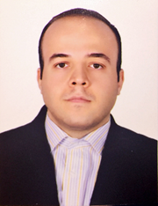 Biography

Biography

He received the B.S. degree in applied chemistry from Khajeh Nasir Toosi University of Technology and was started analytical chemistry at Shahid Beheshti University in 2015. Ehsan has experiences in the field of several extraction and purification techniques such as electromembrane extraction, Headspace solid-phase and dispersive liquid–liquid microextraction in real samples such as urine and plasma and wastewater. His current research interests include evaluation and separation of achiral and chiral drug by variety chiral selector such as cyclodextrin, maltodextrin, antibiotic compounds and so on as additive to background electrolyte in CE-based analysis.
Email: esad14274@gmail.com

Name: Ehsan sadeghi
Email: esad14274@gmail.com
Contact number: +989192978066
Category: poster

