Exposure brassinosteroid and brassinosteroid mimics continually improve photosynthesis in rice subject to heat stress
Weerasin Sonjaroon, Department of Botany, Faculty of Science, Kasetsart University, Thailand
Jutiporn thussagunpanit, Department of Applied Biological Chemistry, Graduate School of Agricultural and Life Science,University of Tokyo, Japan
Kanapol Jutamanee, Department of Botany, Faculty of Science, Kasetsart University, Thailand
Ornusa Khamsuk, Department of Botany, Faculty of Science, Kasetsart University, Thailand
Apichart Suksamrarn, Department of Chemistry and Center of Excellence for Innovation in Chemistry, Faculty of Science, Ramkhamhaeng University, Thailand

Abstract
The epibrassinolide (EBR) are a steroids plant growth regulator. The 7,8-dihydro-8α-20-hydroxyecdysone (DHECD) and 7,8-dihydro-5α,8α-20-hydroxyecdysone (αDHECD)-a brassinosteroid mimics which has a chemical structure similar to natural BRs and functions like a BR on the physiological responses of rice under heat stress. In this experiment, we continually applied water, EBR, DHECD and αDHECD on rice leaves every other day for 4 times. Rice was exposed to two differences the temperature in a greenhouse where the temperature were controlled at 30/26 ºC day/night (normal temperature) and 40/30 ºC day/night (high temperature) for 7days. The treatments consisted of: control plants; control plants treated with EBR, DEHCD and αDHECD; heat-stressed control plants; heat-stressed plants treated with EBR, DEHCD and αDHECD foliar application at the reproductive growth stage. EBR, DHECD and αDHECD were effective in increasing the net photosynthetic rate, stomatal conductance, Intercellular CO₂ concentration and transpiration rate at normal temperature. Under heat stress, EBR, DHECD and αDHECD steadily enhanced the net photosynthetic rate, stomatal conductance, Intercellular CO₂ concentration and transpiration rate. The results indicated that the foliar application of EBR, DHECD and αDHECD continually during reproductive growth could enhance heat tolerance in rice by increasing photosynthetic performance under high temperature stress.

Image
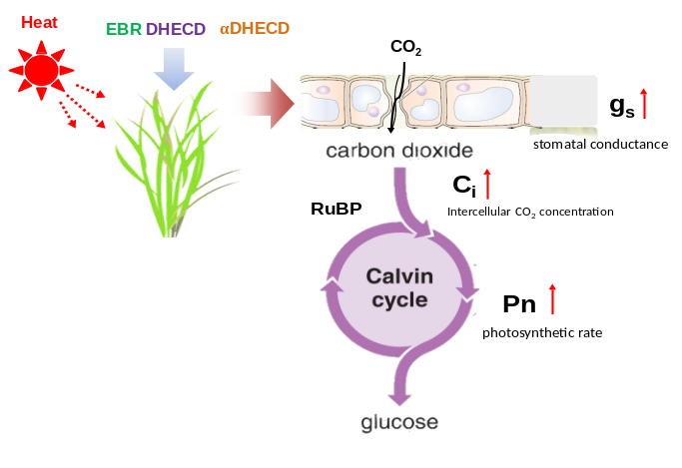
Figure 1. Effect of EBR, DEHCD and αDHECD on photosynthetic gas exchange in rice under heat stress. (: increase or improve; :decrease or reduce)
Recent Publications
- Thussagunpanit, J., Jutamanee, K., Sonjaroon, W., Chai-arree, W., Kaveeta, L., Pankean, P., Suksamrarn, A., 2015. Effects of brassinosteroid and brassinosteroid mimic on photosynthetic efficiency and rice yield under heat stress. Photosynthetica 53, 312–320.
- Sonjaroon, W. Kaveeta, L. Chai-arree, W. Klinsakorn, S. Suksamrarn, A. Jutamanee, K., 2016. Exogenous 7,8-dihydro-8α-20-hydroxyecdysone application improves antioxidative enzyme system, photosynthesis, and yield in rice under high-temperature condition. Acta Physiol Plant. 38:202.



Biography

Weerasin Sonjaroon, I am studying Ph.D. program at Department of Botany, Kasetsart Univeristy. I am interested in plant hormone and plant physiology. Recently, global warming predictions suggest an increase in the temperature by 0.3°C to 0.7°C from 2016 to 2035 (IPCC, 2013). High temperature affects normal plant growth and productivity (Havaux 1993). Brassinosteroids (BRs) can act as a plant growth regulator. BRs has been applied to increase the crop yield as well as to mitigate the effects of biotic and abiotic stresses in plant (Yu et al., 2004). Currently, there are efforts to utilize EBR substances in agriculture. Nevertheless, the extraction of natural BRs from explants has been generally low, and too expensive for large-scale applications (Grove et al. 1979: Serna et al. 2012). Therefore, I offer brassinosteroid mimics which can increase photosynthesis in rice under heat stress similar to natural BRs.

Email: weerasin-kim@hotmail.com

