Weed Control Methods in Wheat Fields – Example Diyarbakir
Pala F, Assist. Prof., University of Siirt, Turkey
Mennan M, Prof., University of Ondokuz Mayis, Turkey

Abstract
In this study, a survey with 15 questions was given to 75 wheat farmers. The questionnaire was conducted in wheat fields of Diyarbakir located in South Eastern Anatolia Region of Turkey in order to evaluate weed control tactics prefered in 2016. Farmers stated that most common weeds were wild oat (Avena spp.), wild mustard (Sinapis arvensis L.), 4% catchweed (Galium aparine L.), 3% ball mustard (Neslia paniculata L.), 3% bluegrass (Poa spp.), and the others (3.3%). All of the farmers indicated that they applied herbicides as a mixture to control grass and broadleaf weed control as post-emergence herbicide; 14.7% pyroxsulam + 2,4-D amin, 14.7% clodinafop-propargyl + 2,4-D EHE+florasulam, 13.3% pinoxaden + 2,4-D EHE+florasulam, 8.0% mesosulfuron-methyl+iodosulfuron-methyl-sodium, 6.7% pinoxaden + tribenuron methyl, 5.3% clodinafop-propargyl + tribenuron methyl,5.3% mesosulfuron-methyl + MCPA, 5% mesosulfuron-methyl + 2,4-D EHE+florasulam, 5.3% pinoxaden + tritosulfuron+dicamba, 4.0% mesosulfuron-methyl + tribenuron methyl, 14.7% the others. As understood growers considered to choose herbicides respectively the price (38.7%), herbicide resistance (34,7%), weeds (20.0 %) and crop rotation (6.6%). Growers stated they applied crop rotation (28.0%), late sowing (13.3%) and deep tillage (6.7%), but 52.0% of them did not take any preventions, also rotating crops for wheat were wheat (61.3%), lentil (13.3%), cotton (10.7%), corn (6.7%) and barley (6.7%), and growers just had 22.7% of the herbicide rotation. As a result, it has been seen that the investigation of weed control methods in wheat production of this area, the determination of herbicide compatability and the development of crop and herbicide rotations are important.

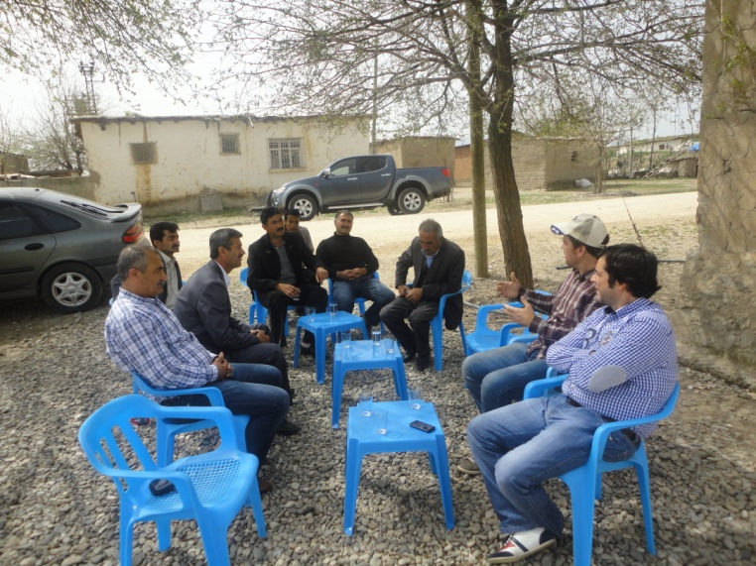
Figure 1: The most important problem of wheat farmers are wild oat and wild mustard
Recent Publications
- Mennan H, Isik D, (2003) Germination ability and densities of weed seeds contamination in wheat seeds. Türkiye Herboloji Dergisi 6(1):8-15.
- Ozturk A, Bulut S, Yildiz N, Karaoglu MM (1012) Effects of organic manures and non-chemical weed control on wheat: I-Plant growth and grain yield. Tarım Bilimleri Dergisi 2012,18(1):9-20.
- Vrbnicanin S, Stevanivic ZD, Radovanov KJ, Uludag A (2009) Weed vegetation of small grain crops in Serbia: environmental and human impacts. Turkish Journal of Agriculture and Forestry, 33(4):325-337 Ref: 48.
- Özbek FS, Fidan H (2014) The analysis of consumer behaviours affecting the preference of pesticides in wheat production. Anadolu Tarım Bilimleri Dergisi 29(3):211-216.
5. Mallory-Smith C, Ball D, Hulting A (2009) The OSU Weed Science Group: Developing Weed Management Solutions for Oregon's Wheat Growers. Oregon Wheat Vol. 61 Issue 4, p11-13.

 Biography
Dr. Firat Pala is a scientist at University of Siirt, Plant Protection Department where he does research on weed control. He has a PhD in weed science from University of Ondokuz Mayis and has done research in Southeast of Turkey, especially on weeds and herbicides using cereal, pulse and cotton fields. He researched mode of action herbicidesw and herbicide resistance weeds, also nowadays on cover crops to control weeds.
Email: firatpala@siirt.edu.tr Contact No: +90484212111

Notes/Comments:

