CLONING OF CENH3 GENE IN DIVERSE PLANT FAMILIES
Niranjana M., Ramesh B., Sreejith A., Mohit R., Maruthachalam R.
Abstract
Centromere is determined by the presence of the centromere-specific histone variant, CenH3 in plants. This is ubiquitously and constitutively found at nearly all eukaryotic centromeres with the notable exception of the parasitic trypanosome protozoa. CenH3 replaces canonical histone H3 in centromeric nucleosomes. The localization of centromere is determined by the presence of CENH3 rather than the underlying centromeric DNA sequence. Hence CenH3 is regarded as the epigenetic “mark” of the centromere. Manipulation of CENH3 results in uniparental genome elimination and is utilized as a tool for haploid induction in Arabidopsis, maize and mustard. CenH3 protein is encoded by a single-copy gene in most diploid species while some diploids and polyploids are exception to this. Contrary to histone H3, which is nearly invariant across eukaryotes, CenH3 shows a high degree of sequence variability. The C-terminal domain of CenH3 consists of a histone fold domain (HFD), which is similar in all eukaryotes and shares significant similarity with H3. While the N-terminal tail is highly diverse both in length and sequence, even among closely related species, and lacks similarity between distantly related species. The role of wide variation in the N-terminal tail domain of CenH3 even among closely related species has been hypothesized to be involved in speciation. In the current study plant species from diverse families viz., Orchidaceae, Araceae, Moringaceae, Anacardiaceae, Poaceae, Amaranthaceae and Lamiaceae were considered. Based on CENH3 sequence information available in model plant species primers were developed. CENH3 gene insert was cloned into pET20 vector by blunt end cloning. Positive colonies carrying different inserts from each species were detected.
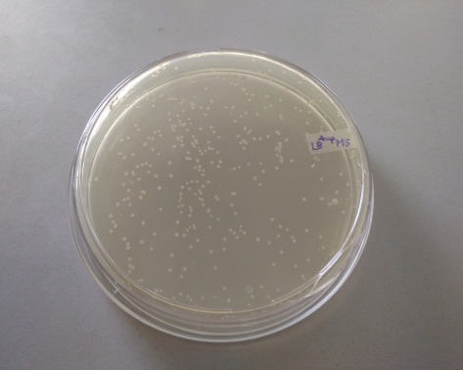
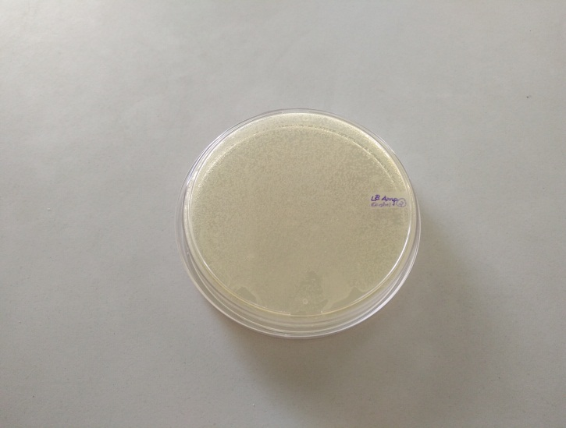

Fig. 1: (a) Negtive control- Only cut vector leading to self- ligated colonies (b) Positive vector containing the Cenh3 insert of Moringa oleifera.
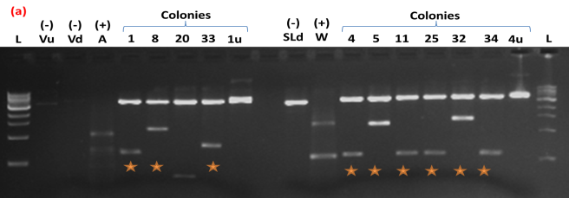
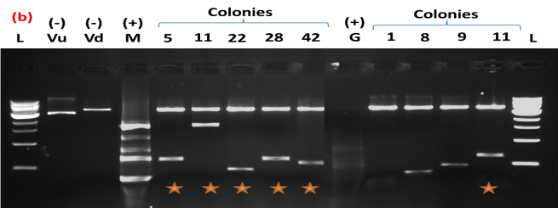
Fig. 2: Confirmation of positive colonies by restriction digestion using two enzymes viz., BamH1 and NcoI, which are adjacent to EcoRV. If the plasmid contains the insert the two enzymes will release the insert during digestion and can be visualized in agarose gel (1.2%). (a) Colonies carrying the insert from Anthurium (F. Araceae) and Triticum aestivum (F. Poaceae). (b) Colonies carrying the insert from Moringa oleifera (F. Moringaceae) and Gomphrena globosa (F. Amaranthaceae). Abbreviations: L-1 Kb Ladder; (-) Vd- Negative control - Vector digested; (-) Vu- Neagtive control- Vector undigested; (+) W- Positive control - Insert from Triticum aestivum, (+) M- Positive control - Insert from Moringa oleifera, (+) G- Positive control- Insert from Gomphrena globosa.
Bibliography
- Maheshwari, S., Tan, E. H., West, A., Franklin, F. C. H., Comai, L., and Chan, S. W. L. (2015). Naturally occurring differences in CENH3 affect chromosome segregation in zygotic mitosis of hybrids. PLoS Genet. 11:e1004970. doi: 10.1371/journal.pgen.1004970.
- Masonbrink R. E., Gallagher J. P., Jareczek J. J., Renny-Byfield S., Grover C. E., Gong L.,Wendel J. F. (2014). CenH3 evolution in diploids and polyploids of three angiosperm genera. BMC Plant Biology, 14: 383. doi: 10.1186/s12870-014-0383-3
- Ravi, M., and Chan, S. W. L. (2010). Haploid plants produced by centromere-mediated genome elimination. Nature 464, 615–618. doi: 10.1038/nature08842.
- Talbert P. B., Bayes J. J., Henikoff S. (2008). Evolution of centromeres and kinetochores: A two-part fugue. P. De Wulf, W.C. Earnshaw (Eds.), The Kinetochore, Springer, Berlin.
- Watts A., Kumar V., Bhat S. R. (2016). Centromeric histone H3 protein: from basic study to plant breeding applications. J. of Plant Biochemistry and Biotechnology. doi: 10.1007/s13562-016-0368-4.

