Silage Corn Response to Sulfur in Some Calcareous Soils
Hosein Besharati1 Associ. Prof. Soil Biology Department of Soil and Water Research InstituteBesharati1350@yahoo.com
Houshang Khosravi. Assistant Prof. Soil Biology Department of Soil and Water Research Institute khosravi_1971@yahoo.com
Mahmoud Solhi, Assistant Prof. Soil and Water Research Institute, Isfahan Agricultural Research Center, msolhi@yahoo.com
Abdolhossein Ziaiyan, Associ. Prof. Soil and Water Research Institute, Fars Agricultural Research Center, ziaeian@yahoo.com
Arash Sabbah, Assistant. Prof. Soil and Water Research Institute, Jiroft Agricultural Research Center, arash14492@yahoo.com

Abstract
Sulfur is a byproduct of gas and oil refineries, that is produced in Iran more than two million tons annually. In this research, the effects of bentonite- sulfur which has been produced with a new process, was tested on corn (SC 704) at Isfahan, Shiraz and Jiroft sites in research farms as a factorial experiment. 0, 0.5, 1 and 2 t ha⁻¹ elemental sulfur and also 0, 65 and 100% recommended phosphorous were applied. The results indicated that sulfur phosphorous and their co-application significantly increased corn shoot dry and wet weight, only in Shiraz site. Zinc and iron uptake in shoots increased in Shiraz and Jiroft sites respectively because of sulfur usage. The highest Fe uptake was observed in 2,000 kg S ha⁻¹. In any site the treatments had on significant effect on shoot phosphorus uptake.

Key words: Sulfur, Phosphorous, Thiobacillus, Silage Corn, Calcareous soil

Image
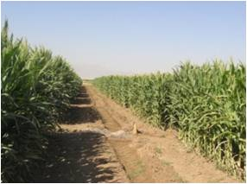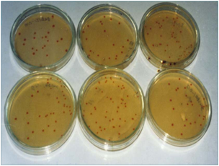
Photos of the corn-sulfur project sites in Fars (left) Thiobacillus bacterial colonies on the Postgate specific culture medium(right)
Recent Publications
- Besharati, H. 2016. Effects of Sulfur Application and Thiobacillus Inoculation on Soil Nutrient Availability, Wheat Yield and Plant Nutrient Concentration in Calcareous Soils with Different Calcium Carbonate Content. DOI:10.1080/01904167.2016.1245326.
- Ghavami . Alikhani, Pourbabaei, Besharati. 2016. Effects of two new siderophore producing rhizobacteria on growth and iron content of maize and canola plants. Journal of Plant Nutrition. DOI:10.1080/01904167.2016.1262409.
- Saffari, Pourbabaee Asgharzadeh, Besharati.2016. Isolation and identification of effective cellulolytic bacteria in composting process from different sources. Archives of Agronomy and Soil Science. Vol 4 No. 12.
- Moradi, Besharati, Bahrami, Karimi. 2013. A 2-year study of soil tillage and cattle manure application effects on soil fauna population under zea mays cultivation, in western Iran (Sanandaj). Environ. Earth. Sci. Vol 70, No. 2.
- Ghasem, Pustini, Besharati, Mohammadi, Abouei, Gatfred . 2012. Pre-inoculation of Sinorhizobium meliloti with luteolin, methyl jasmunate and genistein affecting alfalfa( medicago sativa) growth, nodulation and nitrogen fixation under salt stress. JAST. Vol. 14. 1255-1264.

Short Biography:
Besharati, Hossein is researcher at the Soil and Water Research Institute for soil microbiology of Iran. He is associate professor of soil biology department of the Institute as well as member of the Iranian Soil Science Society. His main research interests are sulfur oxidation and soil microbiology especially sulfur oxidizing bacteria. He is one of the laureate of the 28th Khwarizmi International Award.

