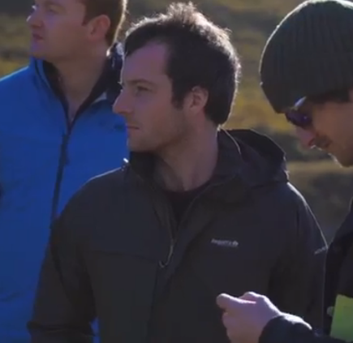

Title: Microplastics in aquatic systems – genuine threat or over exaggeration?
Eoghan M. Cunningham – ecunningham18@qub.ac.uk
Queen’s University Belfast, School of Biological Sciences, BT9 5AH, UK

Microplastics (synthetic polymers; <5 mm) are ubiquitous, in the environment and in the news. The associated effects of microplastics on flora and fauna are currently only established through laboratory-based exposure trials; however, such studies have come under scrutiny for employing excessive concentrations with little environmental relevance. A meta-analysis of results from published experimental (n = 128) and environmental (n = 180) studies allowed us to compare the reported impacts on organisms, and the concentrations of microplastics found in the wild. The results of this meta-analysis highlight three issues that should be modified in future work (1) use of extreme dosages, (2) incompatible and incomparable units, and (3) the problem of establishing truly informative experimental controls. We found that 5 % of exposure trials examined did not use any control treatment, and 82% use dramatically elevated dosages without reference to environmental concentrations. Early studies in this field may have been motivated to produce unequivocal impacts on organisms, rather than creating a robust, environmentally relevant framework. The existing literature on the extent of plastic pollution also has limited utility for accurately synthesizing broader trends; environmental extraction studies use many different units, among which only 76% (139/180) could be plausibly converted for comparison. Future researcher should adopt the units of microparticles/kg (of sediment) or mp/L (of fluid) to improve comparability. Now that the global presence of microplastic pollution is well established, with more than a decade of research, new studies should focus on comparative aspects rather than the presence of microplastics.

Biography
After completion of his Master’s thesis in fisheries sustainability, Eoghan was awarded a prestigious scholarship in 2018 to undertake his PhD in marine plastic pollution at Queen’s University Belfast. As a young researcher in the Department of Biological Sciences, Eoghan already has a number of co-authored published articles in marine and environmental science and currently has two journal articles submitted for review from his PhD program.
Presenting author details
Eoghan M. Cunningham
Contact: (+44)7545870408
Twitter: @manuscunningham
Session: Track 11 - Aquaculture and Fisheries Science
Category: Poster Presentation

