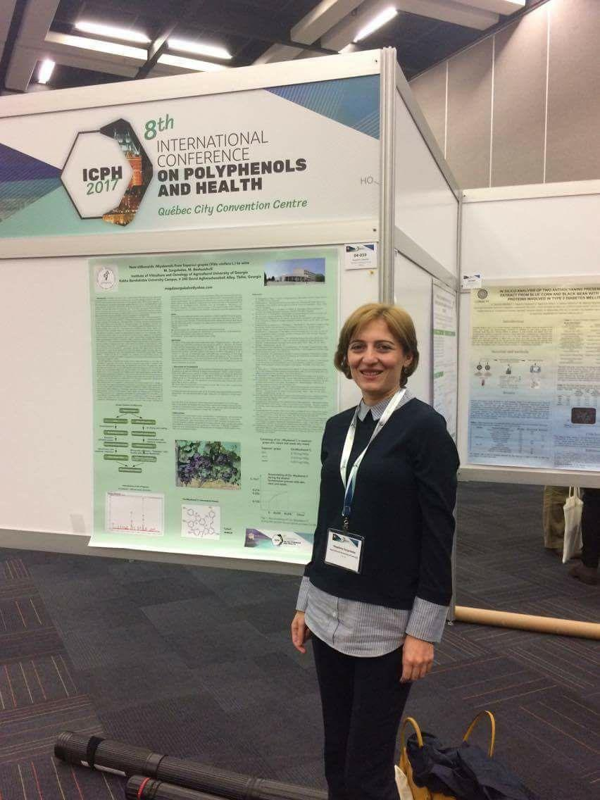
The stress-metabolite stilbenoids of grape skin saperavi variety (Vitis vinifera L.) in condition of Powdery mildew
M.Bezhuashvili¹, L.Bavaresco², L. Tskhvedadze, M.Surguladze¹, G.Shoshiashvili¹,L.Elanidze,¹P.Vashakidze¹ 1. Institute of Viticulture and Oenology of the Agricultural University of Georgia, Kakha Bendukidze University Campus, # 240 David Aghmashenebeli Alley, Tbilisi, Georgia m.bezhuashvili@agruni.edu.ge 2. DI.PRO.VE.S., Università Cattolica del Sacro Cuore, Via E. Parmense 84, 29122 Piacenza, Italia luigi.bavaresco@unicatt.it

A B S T R A C T
The stress-metabolite stilbenoids of grape skin saperavi variety (Vitis vinifera L.) have been investigated in condition of Powdery mildew(Uncinula nec.). The study was carried on healthy and infected grapes skins from the vineyard cultivated in eastern Georgia (Telavi). Vine age is 15 old year, soil type- cinnamonic .Study samples were taken at the end of July. The stress metabolite stilbenoids and their quantitative variability are determined by HPLC/MS method . Specifically, an increase the concentrations of the following stilbenoids were identified: for trans-resveratrol 30,52mg/kg-55,70mg/kg, for trans-epsilon-viniferin 9,23mg/kg 31,35mg/kg, for trans-piceid 4,31mg/kg-8,75mg/kg , for trans-astringin 3,22mg/kg-5,75mg/kg, for cis-piceid 4,67mg/kg - 5,78mg/kg and for trans-piceatannol 2,73mg/kg -7,83mg/kg. Obtained results are important for the determination of Saperavi grape variety immunity with phytoalexin stilbenoids.
This work was supported by Shota Rustaveli National Science Foundation of Georgia(SRNSFG)[grant number FR 17_486].

Key words: saperavi; stilbenoids; powdery mildew.

Biography
1.Wine making technologist, master degree-2002. 2.PHD student in Agricultural University of Georgia-2019. 3.Reaserch issue is study of Biologically active stilbenoids in vine and wine. 4. Participation in International conferences:
1. M.A. Surguladze, M.G.Bezhuashvili , Change correlation of saperavi (Vitisvinifera L.) stilbenoides to wine type, 7th Imternational Conference on Polyphenols and Health, Congress center Tours, France, 2015, October 27-30.
2.Surguladze M., Bezhuashvili M.,New stilbenoids - Miyabenols from saperavi grapes( Vitis vinifera L.) to wine. / 8 th international conference on polyphenols and health. 2017. October 3-6, Quebec, Canada,Abstract Book, p. 52
3.Surguladze, M., Bezhuashvili, M. Biological activity of some stilbenoids from grape saperavi (Vitis vinifera L.) ICP+TC 2018 XXIX International Conference on Polyphenols 9th Tannin Conference. 2018 , July 16-20. Madison, USA
4. M.Surguladze, M.Bezhuashvili, M.Djaparidze , TRANSFORMATION OF BIOLOGICALY ACTIVE STILBENOIDS FROM SAPERAVI(Vitis vinifera L.) GRAPE TO WINE, 42 nd OIVworld congress of Vine and Wine, Geneva, Switzerland, July 15-19, 2019
Presenting author details
Full name: Magdana Surguladze
Contact number:( +995 ) 577 75 09 39
Twitter account:
Linked In account:
Session name/ number:
Category: Video Presentation

