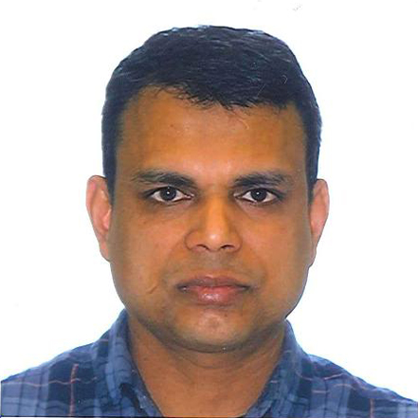

Title: Strip planting increases yield and water productivity of wheat (Triticum aestivum) in Northwest Bangladesh

Mir Nurul Hasan Mahmud, Richard W Bell, Wendy Vance
School of Veterinary and Life Sciences, Murdoch University, 90 South Street, Murdoch, WA-6150, Australia.

Minimum tillage is proposed for saving water or increasing water productivity of crops. Here we compare the yield, irrigation water use and water productivity of wheat in strip planting (SP), bed planting (BP) and conventional tillage (CT). SP and BP were carried out using a Versatile multi-crop planter mounted on a 2-wheel tractor. Residue treatments were 20 or 50 % of rice straw retained. The study was carried out on long-term replicated plots at Rajshahi, Bangladesh (silty clay loam soil), which were established in 2010. The current experiment was conducted in cool dry seasons of 2015-2017. In 2015, the yield of wheat under SP (5.10 t ha⁻¹) and BP (5.03 t ha⁻¹) were significantly higher (P<0.05) than under CT (4.34 t ha⁻¹). Over the three years, SP saved 11-33 % water compared to CT; while water input was 16-27 % lower in BP. Water productivity of wheat was higher in SP and BP compared to CT in three years. In 2015, water productivity of wheat was 2.06, 2.01 and 1.25 g grain kg⁻¹ water for SP, BP and CT respectively. Similarly, water productivity of wheat in 2016 and 2017 was highest (2.32 and 1.95 g grain kg⁻¹ water respectively) in SP. Water productivity of wheat in 2016 and 2017 was intermediate for BP between SP and CT. Minimum tillage approaches have the potential to increase production and water productivity in the northwest region of Bangladesh; however, the challenge will be to apply them in the annual crop rotations on smallholder-farms.

Biography

Mir Nurul Hasan Mahmud is currently a PhD student in School of veterinary and life sciences, Murdoch University, 90 South Street, Murdoch, WA-6150, Australia. His PhD research project is titled “Evaluation of Minimum Tillage Systems for Rice-Based Rotations in Northwest Bangladesh: Effects on Plough Pan and Water Balance”. He graduated from Bangladesh Agricultural University at Mymensing with a Bachelor of Science in Agricultural Engineering in 2004 and he completed his Master of Science in Irrigation and Water Management from the same university in 2012. He is a senior scientific officer of Irrigation and Water management Division at Bangladesh Rice Research Institute. He has published more than 15 papers in reputed journals.

Presenting author details
Full name: Mir Nurul Hasan Mahmud
Contact number: 61469767836
Twitter account:
Linked In account: Mir Nurul Hasan Mahmud
Session name/ number: Seeding Tillage and Harvesting
Category: Oral presentation

