Attractiveness of yeast species and strains to Drosophila suzukii in laboratory and field assays.
Rory Jones, University of Lincoln and NIAB EMR, UK
Catrin Günther, PhD, University of Lincoln, UK
Paul Eady, PhD, University of Lincoln, UK
Michelle Fountain, PhD, NIAB EMR, UK
Matthew Goddard, PhD, University of Lincoln, UK

Abstract

Drosophila suzukii (Matsumra) is a highly polyphagous pest that has recently spread around the globe. Originating in southeast Asia, it is now present in most northern temperate regions where it causes economic losses to soft- and stone-fruit crops. D. suzukii has a morphologically modified ovipositor which facilitates oviposition in ripening fruit, as opposed to rotting or overripe fruit where most other Drosophila species lay their eggs. Drosophila are dependent on microbes for nutrition; yeasts are important for both oviposition and larval development. As with other Drosophila species D. suzukii is attracted to yeast and this attraction varies with yeast species. D. suzukii is known to be associated with the yeast species Hanseniaspora uvarum.

Two-way choice test experiments using T-mazes were used to ascertain the attractiveness of different yeast species and strains fermented in strawberry juice. Four species were significantly attractive to D. suzukii including H. uvarum, yeasts coded 218, 164 and 190. Additionally, six out of eight strains of H. uvarum also proved to be significantly attractive. Attraction of single yeast species was similar in the field, with both stains of H. uvarum tested proving to be significantly attractive including a coded yeast, 190. However, coded yeast 218 proved indifferent in the field, contrary to laboratory findings.

Four candidate D. suzukii attractive yeast species (six strains of H. uvarum) have been identified. Overall there was reasonable correlation of attractiveness between laboratory and field assays suggesting that two-way choice tests with T-maze give a good indication of yeast attractiveness in the field, However, the attraction of yeast 164 varied between field and lab assays highlighting the need for field-based assays to confirm attraction. More research is needed to test the viability of yeast identified for use in attract-and-kill strategies.

Image
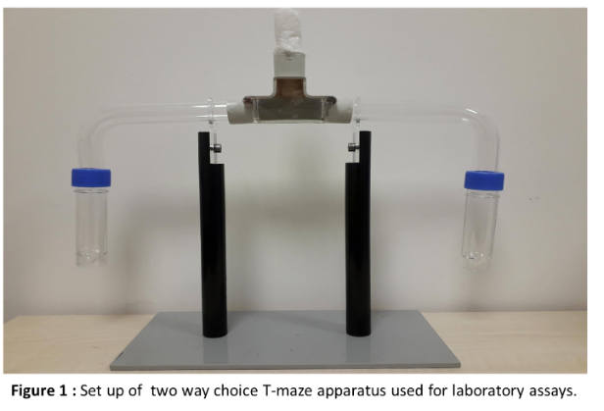
Recent Publications
- Buser CC, Newcomb RD, Gaskett AC and Goddard, MR (2014). Niche construction initiates the evolution of mutualistic interactions. Ecology Letters, 17:1257-1264.
- Hamby KA and Becher PG (2016). Current knowledge of interactions between Drosophila suzukii and microbes, and their potential utility for pest management. Journal of Pest Science, 89:621-630.
- Hamby KA, Hernández A, Boundy-Mills K and Zalom FG (2012). Associations of yeasts with spotted-wing Drosophila (Drosophila suzukii; Diptera: Drosophilidae) in cherries and raspberries. Applied and Environmental Microbiology, 78:4869-4873.
- Mori BA, Whitener AB, Leinweber, Y, Revadi, S, Beers, E.H, Witzgall P and Becher PG (2017). Enhanced yeast feeding following mating facilitates control of the invasive fruit pest Drosophila suzukii. Journal of Applied Ecology, 54:170-177.5.
- Scheidler NH, Liu C, Hamby KA, Zalom FG and Syed Z (2015). Volatile codes: correlation of olfactory signals and reception in Drosophila-yeast chemical communication. Scientific Reports, 5:14059.
- Noble R, Dobrovin-Pennington A, Phillips A, Cannon MFL, Shaw B and Fountain MF (in press) Improved insecticidal control of spotted wing drosophila (Drosophila suzukii) using yeast and fermented strawberry juice baits. Crop Protection.

Biography
Rory Jones is a 2nd year PhD student working with the University of Lincoln and NIAB EMR on a project, funded by the AHDB, looking at controlling Drosophila suzukii using yeast. This project involves investigating the interactions between Drosophila and yeast and exploiting them in control strategies for this pest. Additionally, yeast communities on ripening fruit will also be investigated with the aim of developing a highly attractive and selective yeast bait that can be used in control strategies.
Email: roryjones@lincoln.ac.uk

Notes/Comments:

