Review on species selection in Agroforestry of the Asia-Pacific Region: opportunities and challenges

Qing Wang, PhD, The University of British Columbia, Vancouver, Canada
& Asia-Pacific Network for Sustainable Forest Management and Rehabilitation, Beijing, P.R. China

Agroforestry systems play a vital role in sustainable forest management as they balance livelihood improvement and forest conservation, particularly in the Asia-Pacific Region, where poverty, intensive lands use, deforestation, and forest degradation are common. Species selection is an essential key factor in agroforestry establishment. Here, we explored agroforestry patterns with their intrinsic connections affecting the Asia-Pacific Region economy. We reviewed the literatures across 12 Asia-Pacific Region economies and determined that a total of 108 species belonging to 95 genus and 49 families formed this region agroforestry engine, and conducted Rule and Maptree analyses to unravel the various employed agroforestry patterns. Our results show: 1) on the species-family level, species selection significantly differed among economies, while the most common family-species combination were identified for each economy; 2) on the species-genera level, the studied economies, according to their most common used species, can be divided into three similar groups: a) Thailand, Vietnam, Papua New Guinea and Fiji with Hevea, Oryza, Eucalyptus, Acacia, and Zea; b) Nepal and China (Yunnan) with Zea, Leucaena, Morus, and Hevea; and c) Indonesia and the Philippines with Oryza, Hevea, Zea, and Brassica. In conclusion, the observed different agroforestry patterns among the studied economies indicated the need for a significant information sharing within the region. The Agroforestry systems need to be extend to Cambodia, Malaysia, Myanmar and Lao PDR. We conclude that the most common species combination should be widely adopted within each economy, while lessons learnt from existing genera-level agroforestry models should be duplicated and tested within each similar economy group. Although, this study focused on high-level taxonomy classification (family and genera), the results would shed light on the opportunities and challenges for future cooperation in agroforestry.

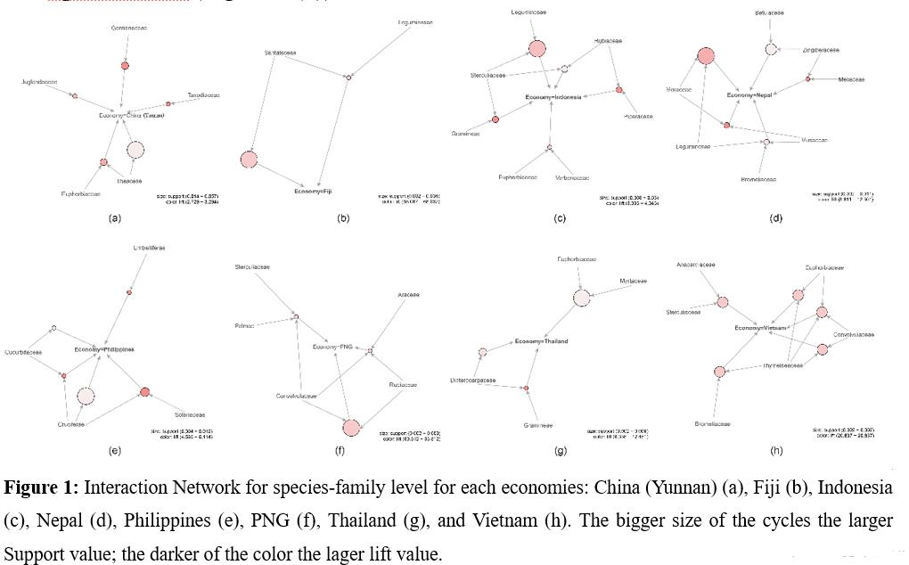

Publications
- Q Wang, R Zhu, J Cheng, Z Deng, W Guan, YA El-Kassaby 2018. Species association in Xanthoceras sorbifolium Bunge communities and species combination selection in establishing agroforestry. Agrofor. Sys. 1-13.
- Q Wang, L Yang, S Ranjitkar, J-J Wang, X-R Wang, D-X Zhang, Z-Y Wang, Y-Z Huang, Y-M Zhou, Z-X Deng, L Yi, X-F Luan, YA El-Kassaby, W-B Guan 2017. Distribution and in situ conservation of a relic oil woody species yellowhorn (Xanthoceras sorbifolium) Bunge base on China’s National Nature Reserves. Can. J. For. Res. 47:1450-1456.
- Q Wang, Y Huang, Z Wang, YA El-Kassaby, W Guan 2017. Fruit shape and reproductive self and cross compatibility for the performance of fruit set reproductive self-cross compatibility of an andromonoecious species Xanthoceras sorbifolium Bunge. Tree Genet. Genomes 13:116
- Q Wang, W-B Guan, MHG Wong, S Ranjitkar, W-N Sun, Y Pan, YA El-Kassaby, L-X Shen 2017. Tree size predicts vascular epiphytic richness of traditional cultivated tea plantations in southwestern China. Global Ecol. Conserv. 10:147-153.
- R Zhu, Q Wang, YA El-Kassaby, W Guan, Y Mao, B Tian, J Cheng. 2019 Genetic diversity hotspots identification of the high valued relic tree species yellowhorn (Xanthoceras sorbifolium). Ecol Evol. 9(6):3251-3263
- YA El-Kassaby, Q Wang, T Wang, B Ratcliffe, Q-X Bi, Z Wang, J-F Mao, W Guan 2018. Pairwise Kinship Coefficient Based Conservation Strategy for the Endangered Chinese Yellowhorn, Xanthoceras sorbifolium. For. Ecol. Manage. 423:976-982.
- RS Sujakhu, Y Lu, Q Wang, M Wang, J He, P Mortimer, J Xu, R Kindt, R Zomer 2016. Climate modelling for agroforestry species selection in Yunnan Province, China. Environ. Model. Software 75:263-272.
- XG Hu, SS Zhou, Y Yang, H Liu, S Anil, Q Wang, W Zhao, Q Gao, YA El-Kassaby, T Wang, Y Li 2020. Transcriptome-wide identification and profiling of miRNAs in a stress-tolerant conifer Sabina chinensis. J. Biosci. 45(1):41.
- Q Wang, MHG Wong, J Wang, Y Pan, P Song, L-X Shen 2014. The species association of parasitic/epiphytic plants of ancient cultivated tea plantation in Jingmai-Mangjing. J. West China For. Sci. 43(3):45-50. (in Chinese)
- Q Wang, Y Zhang, J Chen, S Ranjitkar, L-X Shen 2015. The effects of major factors on the distribution of Viscum articulatum Burm in ancient cultivated tea plantation. J. Beijing For. Univ. 37(10):117-124. (in Chinese)
- JH Xu, DX Zhang, K Sun, XR Wang, QH Xiang, Q Wang, WB Guan 2019. The complete chloroplast genome sequences of Pistacia chinensis Bunge, a potential bioenergy tree. Mitochondrial DNA Part B. 4(1):1774-5.
- D Zhang, K Sun, Q Xiang, X Wang, J Xu, Q Wang, W Guan 2019. The complete chloroplast genome sequence of Aesculus Chinensis Bunge, a major street tree. Mitochondrial DNA Part B. 4(1):1686-7.
- QH Xiang, DX Zhang, Q Wang, XR Wang, WB Guan 2019. The complete chloroplast genome sequence of Pyrus phaeocarpa Rehd. Mitochondrial DNA Part B. 4(1):1370-1.
- Contribute two chapters (7&8) in “Resources utilization of Traditional Arbor Tea Eco-system Among Bulang Ethnic Communities” 2017.12. (in Chinese).

Biography
Dr. Qing Wang is an ecologist with ten years research experience. Her educational includes B.S. in Computer Sciences and M.S. and Ph.D. in Forest Conservation Science. Since Jan 2019, she holds a Project Management Officer position at Asia-Pacific Network for Sustainable Forest Management and Rehabilitation (APFNet). She continues her research as a Postdoctoral Fellow at The University of British Columbia (2019-present). Her studies aiming at livelihood improvement and forest conservation, more recently focusing on human activity effects of agriculture land extend, forest degradation and deforestation, ecosystem services, and climate change. Her research has spanned multiple inter-disciplines to meet sustainable forest management goals, covering agroforestry establishment, yield improvement and genetic conservation of bioenergy tree species. Dr. Qing published over 10 peer-reviewed journal articles and book chapters.
Email: qing.wang@ubc.ca or wangqing@apfnet.cn Contact No: +86-13811308962

