Screening the extraction performance of aprotic polar and non-polar solvents on the proportional variances of saturated fatty acids in cassava cell cultures and their cytotoxicity assessment.

Name: Nermeen M. Arafa

Department of Plant Biotechnology, Genetic Engineering and Biotechnology Division, National Research Center, El‐Buhouth St., (P.O. Box 12622), Dokki, Cairo, Egypt.

Cassava plant is one of the major economical crops, involved in lots of industrial applications and therapeutic purposes as suppression of cancer cells activity. Present work targeted to assess saturated fatty acids and their derivatives in cassava cell cultures. The extraction adequacy of aprotic polar (ethylacetate) and non-polar (chloroform, n-hexane) solvents was evaluated. Stem explants of in vitro growing plantlets were induced calli on MS-medium+1mg/l NAA+0.5mg/l BA. Medium containing 5 mg/l 2.4-D and 0.2 mg/l BA was selected for callus productivity.Chloroform callus extract contained mostly fatty acid methyl esters (FAMEs) and fatty acid propyl esters (FAPEs). In contrast n-hexane extract contained higher amounts of fatty acid constituents in free form such as palmitic acid (23.55%). However ethylacetate extract included the highest value of lauric acid (28.34%) in free form as well other fatty acids such as caprylic acid (14.525%), capric acid (2.53%) and enanthic acid (6.41%). Ethylacetate extract conferred the optimal efficiency to suppress the breast cancer cells prevalence (2.63 ug IC50), followed by hexanoic extract (3.44 ug IC50) then chloroformic extract (6 ug IC50) recording the least value for cancer cells propagation. In conclusion, stem calli of cassava plantlets possess essential saturated fatty acids for considerable effectiveness against breast cancer prevalence.

Image.

For callus induction, stem explants of in vitro growing plantlets were cultured on MS-medium supplemented with 1mg/l NAA+0.5mg/l BA. Stem derived calli were sub-cultured on MS-medium contained 8 mg/l 2,4-D for callus production (Fig. 1). Using 5 mg/l 2.4-D + 0.2 mg/l BA visually observed to be the best treatment in callus proliferation after 30 days of cultivation as shown in Fig. (2).

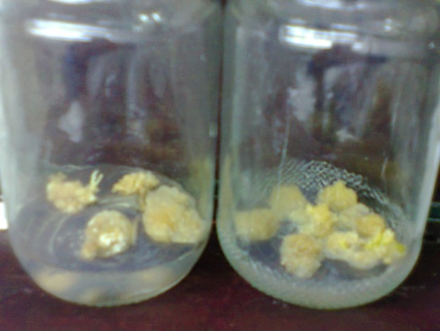

Figure (1): Callus induction of stem explants cultured on MS-medium containing 1mg/l NAA+0.5mg/l BA
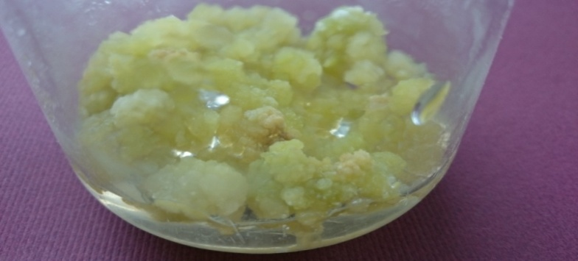

Figure (2): Stem calli grown on MS-medium supplemented with 5mg/l 2.4-D +0.2mg/l BA, after 30 days of cultivation.
Recent Publications.

- Alves A AC (2002) Cassava Botany and Physiology. In: Hillocks, R.J., Thresh, J.M. and Bellotti, A.C. (eds.) Cassava Biology, Production and Utilization. CAB International, Wallingford. 67-89
- Arafa, Nermeen, Moawad M, El-Shabrawi HM (2016) Comparison the organic and inorganic solvents effect on phenolic compounds extraction and the activity against breast carcinoma cell lines from callus cultures of Manihot esculenta. Interational Journal of PharmTech Research 9(12): 380-396
- Arjuna RA, Somal P (2013) Effect of Extraction Methods on Lipid and Fatty Acid Composition by Mortierella. International Journal of Scientific and Research Publications. 3(3): 2250-3153
- Balat M, Balat H (2009) Recent trends in global production and utilization of bio-ethanol fuel. Appl. Energ. 86: 2273–2282
- Mancini A, Imperlin, E, Nigro E, Montagnese C, Daniele A, Orrù S, Buono P (2015) Biological and Nutritional Properties of Palm Oil and PalmiticAcid: Effects on Health. Molecules. 20: 17339-17361
- Marigi EN, Masanga JO, Munga TL, Karanja LS, Ngugi MP, Thagana WM, Kirubi D, Mwangi M, Githunguri CM, Muiru MW, Miano DW, Alakonya AE Oduor RO (2016) Optimization of a somatic embryogenesis and transformation protocol for farmer-preferred cassava cultivars in Kenya. African Crop Science Journal. 24(s1): 35 – 44.
Biography
Nermeen M. Arafa has been completed PhD thesis at the age of 33 years from Biochemistry Department, Agriculture Faculty, Cairo University.
Postdoctoral studies have been completed from Plant Biotechnology Department, Genetic Engineering and Biotechnology Division, National Research Center.
Number of Publications: 10 papers have been published in reputed journals International cooperation: serving as a reviewer member in African Journal of Biotechnology. Research Work Presented at Conference: - Participating as organizer in [The First Egyptian Conference of Plant Biotechnology]. 2016. -Presenting a lecture in the symposium entitled [Plant Biotechnology], 2015.
Email: nermeenfouad78@yahoo.com
Presenting author details
Full name: Nermeen Mohammad Fouad Sayed Mahmoud Arafa
Contact Number: (+2)01221787862
Twitter account: @NermeenMohamma9
Linked In account: nermeenfouad78@yahoo.com
Track Name: Agricultural Biotechnology

