Response of soil application of biochar on growth, dry matter yield and nutrition of corn (Zea mays L.) grown on sandy loam soils of Gujarat, India

P.C.Patel PhD, Parul University, Vadodara, Gujarat, India
N.K.Yadav M.Sc.Agriculture, Anand Agril. Univ. Gujarat, India

Abstract (300 word limit)
Biochar was generated at the Anand Agricultural University, Gujarat, India using the standard methodusing 2 kilns from agriculture by-productcorn stover (Zea mays, L), cluster bean stover (Cyamopsis tetragonoloba) and Prosopis julifera wood. The present study investigated 4 organic sources (3 biochars; corn stover biochar (CSB), cluster bean stover biochar(CBSB) &Prosopis julifera wood biochar(PJWB) and farmyard manure(FYM) with 2 rates of biochar (5 & 10 MT ha⁻¹), so8 organic treatments, while said 8 organic treatments was applied withthe recommended dose of fertilizers (RDF, 80-40-0 kg NPK ha⁻¹) , so total 16 treatments in field trial. Application of CSB @ 10 MT ha⁻¹ along with RDF increased dry matter (DM) yield, crude protein (CP) yield, chlorophyll content and plant height (at 30 and 60 days after sowing) than CBSB and PJWB and FYM. It was found that soil application of recommended dose of fertilizer (RDF) along with corn stover biochar (CSB) @ 10 MT ha⁻¹exhibited the highest impact in obtaining significantly higher dry matter and crude protein yields and larger removal of nutrient (P, K, Ca, Mg, S and Cu, significantly higher than others )from the soil and it also beneficial for built up nutrients in soil. It also showed significantly higher organic carbon content and cation exchange capacity in sandy loam soil. The treatment of RDF along with corn stover biochar @ 5.00 MT ha⁻¹ was also at par with the highest dry matter yielder treatment. This study highlights the importance of mixing of biochar along with RDF on its synergistic effect on sandy loam soil nutrient retention, organic carbon content and water holding capacity hence, the amendment value of biochar in sandy loam soil.
Figure
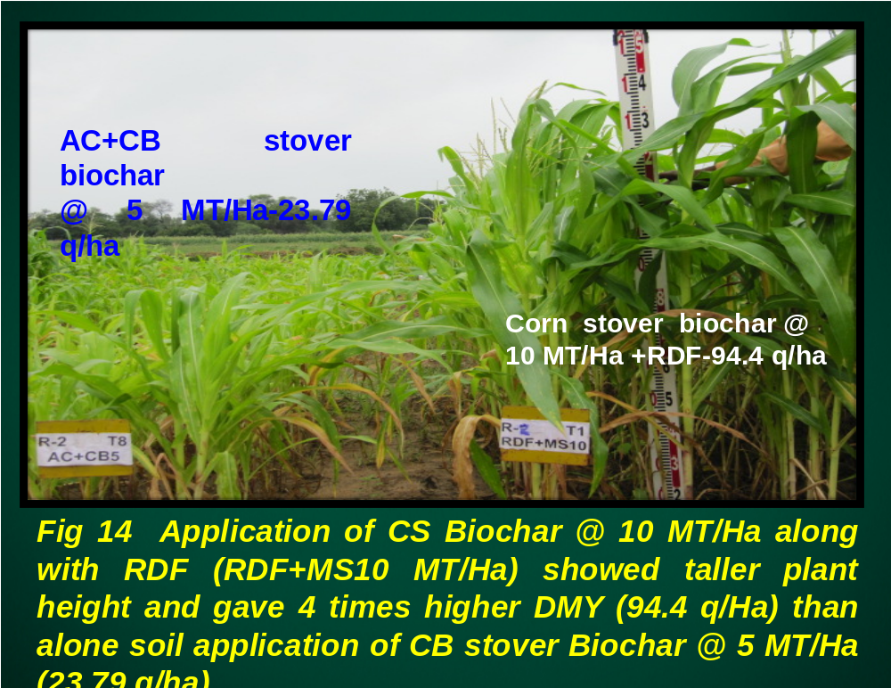

Recent Publications (minimum 5)
- Arif, Muhummad, Ali, Asad, Umair, Muhammad, Munsif, Fazal, Ali, Kawsar, Inamullah, Saleem, Muhammad, and Ayub, Gohar,.(2012).“Effect of biochar, FYM and Mineral Nitrogen alone and in combination on yield and yield components of maize” Sarhad J. Agric., 28,191-195.
- J. Lehmann, Jr. J.P Da Silva,. C. Steiner, T. Nehls, W. Zech, and B. Glaser,(2003). “Nutrient availability and leaching in an archaeological Anthrosol and a Ferralsol of the central Amazon Basin: fertilizer, manure and charcoal amendments”,Plant Soil., vol. 249, 343-357.
- B. Singh, B.P. Singh, and A.L. Cowie, (2010). ”Characterisation and evaluation of biochars for their application as a soil amendment. Aust. J. Soil Res., vol.48, 516–525
- E. Yeboah, P. Ofri, G.W.Quqnsah, E. Dugan, and S.P. Sohi, (2009). “Improving soil productivity through biochar amendments to soil”,Afr. J. Environ Sci. Technol, , 3, 34-41.
- M. Yamato, Y., Okimori., I.F. Wibowo, S. Anshori, and, M. Ogawa, (2006). Effect of the application ofcharred bark of Acacia mangium on the yield of maize, cowpea, and soil chemical properties in South Sumatra, Indonesia. Soil Sic. Plant Nut., 52, 489-495.

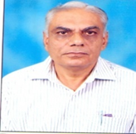

Biography (150 word limit)
At present, myself Dr. Pravinchandra C. Patel is a Professor at College of Agriculture, Parul University, Vadodara, Gujarat, India. He holds a PhD in Soil Science. He has 40 years experiences in agriculture teaching, research and extension. He has evolved 4 varieties of forage crops for the farmers and made 29 research recommendations for the farming communities to increase crop productivity. He obtained Hari Om Ashram Ayojit J. P. Trivedi Award during 2006 for the best contribution in Soil Science research. He has participated 2 national and 5 international conferences. He has attended 33 group meeting/workshop/conferences. He has participated in 18th WCSS, Frontiers of Soil Sci. Technology and the Information Age at Philadelphia, Pennsylvania,USA in 2006 & presented 3 research papers. He has contributed 52 research papers, 2 books, 3 bulletin, and 40 popular articles.
.
Email: patelpc12@gmail.com Contact;91-9909022116

