Effect of Drought Stress on Growth and Water Physiological Characteristics of Poa sibirica
Shah Saud¹†, Chen Yajun^{1:} Caowei li¹, Piatkovskaia Polina², Shah Fahad³ ,,
¹College of Horticulture, Northeast Agricultural University Harbin, Heilongjiang, China 150030
2 College of Landscape Architecture,Northeast Forestry University,Harbin 150040,China

³ College of Plant Science and Technology, Huazhong Agricultural University, Wuhan, Hubei 430070, China
*Corresponding Author: Shah Fahad (shah_fahad80@yahoo.com);

Abstract:
In order to develop the resources of native turfgrass, the morphological traits and drought resistance of native Siberian bluegrass (Poa sibirica, abbreviated as PS) was evaluated using the introduced Kentucky bluegrass ‘Midnight’ (Poa pratensis, abbreviated as PP) as a control. Two water schemes were imposed to plants in this pot culture study in greenhouse. One was with drought stress persistent limiting water supply for 20 d, and another was re-hydrated until 14 d after drought. The plants leaf shape, turf color, water status and cell plasma membrane permeability were evaluated. Similar changing trends with these parameters were showed for both species, and there were not significant differences on most evaluations during drought and re-water periods. The values leaf width and length of PS were higher while leaf color intensity was slightly lower than that in PP, but the greenness of PS leaf was still visually acceptable. There was not big difference with cell membrane stability between two specie. In comparison, the native wild species PS possesses the potential for cultivation a new cultivar for turf industry.
Key words: Turfgrass, drought, morphological characteristics, water status, membrane permeability
Introduction
As an important complement of urban landscape, turfgrass has been widely used in urban greening. Currently, the turf coverage is as one of the important indicators for modern cities [1] Compared with other landscape plants, turfgrass has the advantages of quick effect and simple planting, it has irreplaceable roles of landscape and ecology. It is necessary for turfgrass to require a large quantity of water to maintain a better landscape, which is a vital environmental issue that constrains the quality of the turfgrass. According to [2] generally the water consumption of the turfgrass can reach 3-8 mm per day, and even some can reach 12 mm per day, the cool-season turfgrass requires more water than other kinds of turfgrasses. Moreover, different degrees of water stress not only to decrease the growth of turfgrass, but also affect the turf performance such as turf quality [3] In recent years, as the water consumption in agriculture and industrial production has increased, water resources have limited the turfgrasses development which has also aggravated the degree of drought on turf fields[4-5] Harbin is situated in the northeastern part of China, and the climate of this region belongs to the northern temperate continental monsoon climate. The annual precipitation is between 500-600mm, with the characteristics of large spring dryness, warm and humid summer, rapidly cooling in autumn, then cold and dry in winter. Along with the improvement of urban municipal construction, the turfgrass has become an important plant material for urban greening and beautification, the proportion of turf coverage in urban greening is recently increased in this region. However, main turfgrasses varieties in Harbin rely on the introduced Kentucky bluegrass which is almost are from US [6, 7, 8, 9] it is urgently to need the germplasm of cool-season turfgrass with water saving attributes for reducing water supply. Therefore, the growth of native grasses and selecting drought-tolerant merits are crucial for local turfgrass management from water saving perspective.
Siberian bluegrass (Poa sibirica) is a native wild species of the genus Poa, it was discovered in the Changbai Mountains area of Jilin Province, with shorter rhizomes and fresh green color of leaf, which has potential for turf use in landscape. In this experiment, native Siberian bluegrass was evaluated on turf performance and drought resistance compared to Kentucky bluegrass. Some morphological and physiological indexes of the two bluegrasses were assessed by pot study in greenhouse. Hopefully, this research will provide theoretical and practical basis for developing new cool-season germplasm of native turfgrass with water saving characteristic.
Materials and Methods
Plant materials
The Siberian bluegrass (Poa sibirica abbreviated as PS), which was collected from Changbai Mountain of Jilin Province in the northeast of China (127°52′55″E, 42°15′18″N, 2150 m altitude) was used in this study, and the control was with the introduced Kentucky bluegrass cultivar named ‘Midnight’ (Poa pratensis, abbreviated as PP).
Methods
Each species was planted in a plastic tray (70cm×30cm×10cm) in greenhouse at the Horticultural Experimental Station of Northeast Agricultural University. After two leaves of the seedlings were emergent and were transplanted into a PVC pot (16cm in diameter and 40cm in height). The bottom of each PVC pot was covered with double-layer gauze (under the premise of ensuring water permeability, preventing the cultivation substrate from falling off), and each pot was filled with 5.2 kg of the mixed peat, vermiculite and decomposed loam with the proportioning ratio of 2:1:1, and pH7.0. 90 plants were transplanted evenly in each labeled pot. During maintenance period, watering once every 2 d, trimming to 10 cm once a week, applying 0.2 g fertilizer (N:P:K=17:6:10) every 15 d for pot cultivated seedlings. The environmental conditions in greenhouse were with 25±2/15±2℃day/night temperature, 700±10μmol m⁻²s⁻¹ light illumination and 75±2% relative humidity. After 60 d cultivation, continuous drought stress was imposed to the seedlings of two species until 20 d. Measurements were performed with 4 replicates on every 5 d during drought periods. After 20 d of drought stress treatment, the corresponding materials were re-hydrated immediately at 7:00 am on the next day, and the same measurements were carried out at 7 and 14 d after re-watering. The following indicators were examined. 1) Soil water content was detected at 20 cm depth in soil by a TDR200 (USA, SPECTRUM). 2) The leaf width and length were measured using a ruler (minimum scale of 0.01cm). 3) Leaf color intensity was measured using a SPAD502 chlorophyll meter (Konica Minolta, Japan). 4) The measurements of leaf relative water content, leaf electrolyte leakage (EL) and malondialdehyde (MDA) content were with reference to the methods of [10]. Relative water content (%) = (fresh weight - dry weight)/ (saturated weight - dry weight) × 100%. Relative electrolyte leakage (%) = primary value/ final value × 100%. MDA extraction was followed the method of [10] Briefly, 0.2 g leaves were grinded with 10mL of 10% TCA, then centrifuged at 4,000r/ min for 10min. 2ml of supernatant plused 2 mL of 0.6 % TBA (thiobarbituric acid) was centrifuged for 15min. The final top supernatant was used to inspect the spectrophotometric values at 532nm, 600nm and 450nm by a visible spectrophotometer (Model 721, China). MDA content (µmol g⁻¹)=C_{MDA}·× N·× W⁻¹, in which C_{MDA} = 6.45 × (A₅₃₂ - A₆₀₀) - 0.56A₄₅₀, N was the extraction volume (ml), and W was the leaf fresh weight (g). A was reprsented spectrophotometric value at 532nm, 600nm and 450nm respectively.
Data analysis
The ANOVA variance of data was analyzed by SPSS (Statistical Product and Service Solutions, Version 19.0). GraphPad Prism 7.00 software was used for describing figures.
Results
Morphological characteristics and turf color of PS under drought stress
Under normal condition (0 day), the width and length of leaves for two species were distinctly different. The width of PS leaves varied between 2.30~2.40 mm, and the length of PS leaves varied between 33.50~35.48 cm. While, the width of PP leaves varied between 1.60~1.90 mm, and the length of PP leaves varied between 28.6~32.8 cm. In comparison, the leaves of PS showed a little bit wider and longer than the leaves of PP. However, under different levels of drought stress, the width and length of leaves for two species changed in a similar trend that was increased first during light drought stress and decreased later along with the increased drought intensity, again increased after re-hydrated treatment (Fig. 1a and 1b). The values of leaf width and length for PS had been performed higher than that of PP during two water schemes treated. Leaf color intensity is usually positive to turf quality. While in this study, during the stress period of 10-20 d, the color values of the leaves of the two bluegrass showed a sharp decline, PS and PP decreased by 39.20% and 34.20%, respectively. After re-watered, the color values of the leaves of the two bluegrass increased. The changing trend of leaf color intensity for two species were opposite in corresponding to the leaf width and length whether under control condition or stressed period. The values of leaf color intensity of PS had been lowed than the PP, although the leaf color of PS was visually acceptable during light drought stress (Fig.1c).
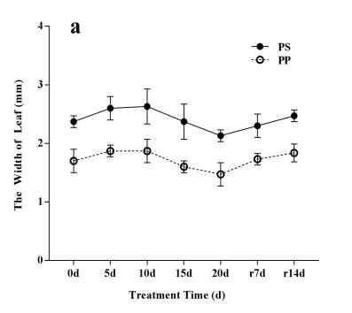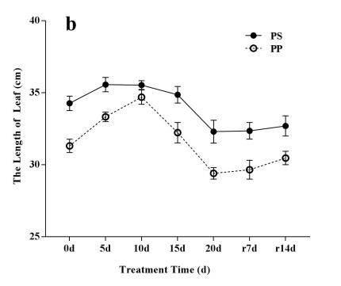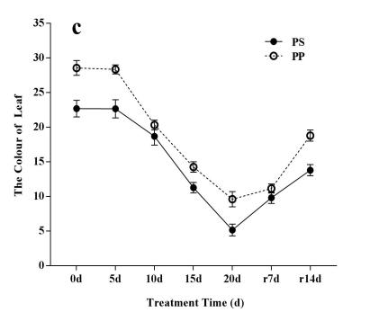
Fig.1 Changes in morphological characteristics (a and b) and leaf color (c) of PS and PP under drought stress and re-watering conditions
Fig.1 Changes in morphological characteristics under drought stress and rewatering conditions
(a: represents the change in leaf width; b: represents the change in leaf length; c: represents the change in leaf color)

Changes of water status of PS under drought conditions
With the increase of drought stress, the changing trend of soil water content of the two kinds of bluegrass were basically the same, indicated that the PS had a similar water evaporation rate in contrasted to PP. Although soil water content decreased much with the drought stress period extend, there were no significant differences between two species. On the 20 d drought stress, soil water content of PS and PP decreased by 88.94% and 90.17%, respectively, and all returned to control level after re-hydration to the 7 d (Fig. 2a).
With the drought stress intensity increased, the relative water content of leaves decreased for both species. In the early drought stress period, the changing trend declined slowly from 0 to 10 d, but from 15 to 20 d, it showed a sharp decline for two species (Fig. 2b). Comparatively, the leaf water content in PS was a little bit higher than that in the control species PP during drought stress, suggesting that the leaf water content was the species specific difference, and couldn’t say the drought resistance in PS was relatively stronger than PP. After re-watering, the leaf relative water content of the two species was similar to that of the leaves at 0 d.
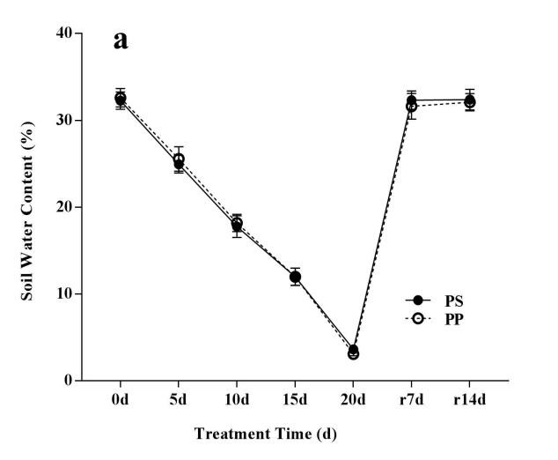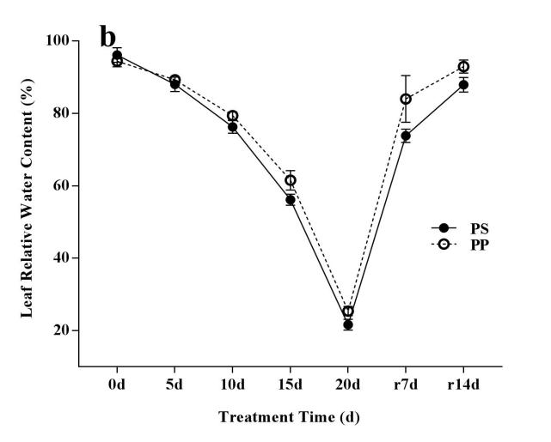
Fig.2 Changes of soil water content (a) and leaf relative water content (b) of two species under drought stress and re-watering conditions

Changes of plasma membrane permeability of PS under drought stress
As shown in Fig.3, the leaf electrical conductivity and MDA content of the two kinds of bluegrass increased along with the increasing of drought stress and recovered after re-hydration. When the drought stress was during 0~5 d, the leaf electrical conductivity and MDA of the two kinds of bluegrass did not change notably. With the stress time increased, the degree of the damage to the cell plasma membrane increased distinctly indicated by the significantly increased the leaf electrical conductivity (Fig.3a) and MDA (Fig.3b). In contrast, the electrical conductivity and the accumulation of MDA in PS appeared more aggressive in PS than that in PP, especially that performed on the 20 d drought stress, suggesting that the extent of the damage to cell membrane in PS was a little bit more severity than that in PP. However, from the perspective of the whole drought process, there was no significant difference in the degree of membrane damage between the two species
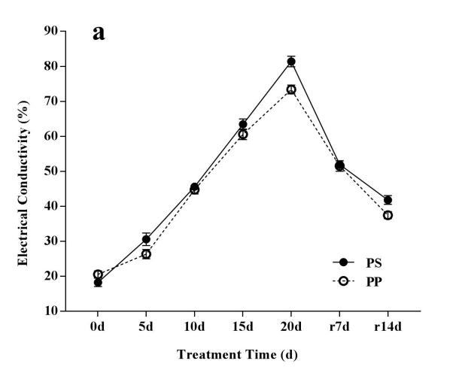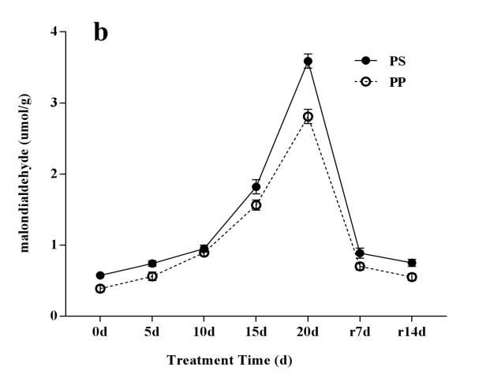
Fig.3 Changes in leaf electrical conductivity (a) and MDA content (b) of PS and PP under drought stress and re-hydration conditions

Discussion
Morphological attributes and turf color of PS under drought stress
Turfgrass leaves as an important indicator for assessing turf quality in practical turf management, and which also reflects the ability of turfgrass to tolerant to the drought environment and is closely relation to the physiological status of plants [11. 12. 13.] Because plant leaf morphology is extremely sensitive and environmentally malleable, it can adapt to the damage caused by environmental stress through changes in leaf morphology [14] When plants are exposed to water stress, the leaf area index decrease to reduce water dispersion loss [15] Leaves changing in morphology affects the exchange of matter and energy between plants and the surrounding environment [16] The results in this study showed that with the persistence of drought stress, the leaf length and leaf width of the two species showed a slow downward trend, that is, in the leaf area was reduced under water stress, and the water dispersion was reduced, thereby improving their drought resistance. The length and width of the two bluegrass leaves showed an upward trend with the re-water treatment, indicating that the both species have strong self-recovering ability in response to drought. In addition, compared to PP, longer and wider leaf of PS entailed the beneficial for its light absorption and energy storage, which may also improve drought resistance.
Turf color is considered as an important parameter for evaluating the quality of turf [17] Turfgrass with uniformly dark green leaf color means having a unique ornamental value for application. However, many abiotic and biotic factors influences leaf color thus reduce the turf quality [18] The normal physiological synthesis and metabolism of chlorophyll maintains the leaf greeness of plants.[19] The results of this experiment showed that before the water stress (0 d), the leaves color of PP was higher than that of PS, indicated that the possible reason for this phenomenon was much more chlorophyll in PP leaves than in PS. However, we didn’t measure the chlorophyll content in each species, although the leaf color intensity in this study can also as an inderictor for infering to it. Actually, as a measure of plant resistance to various stresses, the metabolism of chlorophyll is well worth studying, especially for turfgrass.
Water status and cell membrane stability of PS during drought
Soil water content can reflect the evapotranspiration rate of plants. Lower evapotranspiration rates can save water that is considered to be a good attibute for turgrass management due to the economic issues [20,21,22]. Turfgrass maintains higher leaf water content during drought may serve to the cell membrane stability thus for increasing drought resistance [23,24,]. Cell membrane stability plays a critical role in maintaining cell turgor and physiological functions, especially during plant facing drought stress, and electrical conductivity and MDA have been widely used to examine cell water status and membrane stability.[25, 26]. MDA is an indicative substance that can causes cell membrane peroxidation, increase cell membrane permeability and relative cytoplasmic conductivity [27. Drought stress has a great influence on the cell membrane of plants. When the leaves are arid and dehydrated, the structure of the cell membrane is damaged, the membrane protein structure is degenerated, and the fatty acid composition of the membrane is modified. These changes will increase the permeability of the cell membrane. When the permeability of the cell membrane increases, the membrane binding ability decreases, the extracellular cytoplasm and other electrolytes in the membrane will destroy the normal behavioral work of the physiological activities of the plant [28] in this study, there were no differences in soil water and leaf water content for both species during two water treatments schemes. Moreover, except for the 20 d drought stress, all results of electrical conductivity and MDA from two species with the rest evaluation days showed no notably differences, indicating that the water physiological attributes and the cell membrane stability with the species PS was close to the control species PP which is a popular variety of Kentucky bluegrass and has been widely used in the world [30]. This research revealed that the native wild species PS has the potential to develop a new cultivar for application in turf industry.
Conclusion
In summary, the plants growth characteristics, turf quality performance, water status in soil and plants, and cell plasma membrane permeability were evaluated for both native species PS and the introduced common turfgrass species PP. Drought stress and re-watering caused similar change patterns for all parameters in two species. There were not significant differences on most evaluations for each measurement. The values leaf width and length of PS were higher than that in PP. While the leaf color intensity was slightly lower than PP, but the leaf appearance still was visually acceptable. During the drought period, there was no significant difference in the extent of membrane damage between two specie. In comparison, the native wild species PS has the potential for developing a new cultivar for turf industry.

References
[1]. Liu LZ, Shen N, Zhang J.2018, Investigation and Analysis of Grass Weed Species in Kentucky Bluegrass in Shenyang. Modern Horticulture,(8):12-13
[2].Wu YH, Chen YJ, Xia ZQ.2005,Research progress on the physiological mechanism of turfgrass drought resistance. Sichuan Grassland,(8):37-39.
[3]. Gao H, Wu W, Liu XP,et al.2006,Study on drought resistance mechanism of several cold-season turfgrass under water stress.Soil and Water Conservation Research, 13(3): 126-128.
[4]. Wu YP.2017,Problems and Measures of Agricultural Water Use in Irrigation Districts. Henan Water Resources and South-to-North Water Transfer,(8):21-23.
[5]. Dong XF, Lai X, Dong W, et al.2019,Analysis of regional precipitation characteristics in China in the past 51 years.Jilin Agriculture,445(04):110-113.
[6]. Li LX.2018, Introduction of four perennial grasses forage introduction.Journal of Grassland, 26(01): 264-266.
[7]. Zhai XM.2018, Adaptability of turfgrass introduction in alpine region. Contemporary Animal Husbandry,(32):57-58.
[8]. Wang JL, Shen ZB, Pan DF, Zhang RB,Li Daoming, Zhong P,et al.2016,Adaptability evaluation of nine grassland bluegrass varieties in Harbin. Heilongjiang Agricultural Sciences,(06):110-114.
[9]. Zhao MF, Huang HP, Zhan RJ,Li ZB, Zhang LF.2014,Introduction and Screening of Eight Irish Turf Grass Species in Kunming. Heilongjiang Agricultural Sciences,(11): 99-101.
[10]. Zou Q.2000, Experimental guidance of plant physiology. Beijing: China Agriculture Press,11-12.
1[1]. Hao ZB. 2002. Experimental techniques of plant physiology.:Harbin Press.
[12]. Field C, Merino J, Mooney HA.1983,Compromises between water-use efficiency and nitrogen-use efficiency in five species of California evergreens.Oecologia,60, 384-389.
[13]. Vogel S.2009,Leaves in the lowest and highest winds: temperature, force and shape. New Phytologist,183, 13-26.
[14]. Zhang L, Luo TX.2004,Advances in, ecological studies on leaf lifespan and associated leaf traits. Acta Phytoecol Sinica,28,844-852.
[15]. LI YH, Lu Q,Wu B,et al.2012,Relationship between leaf morphological characteristics and plant response and adaptation in arid areas.Chinese Journal of Plant Ecology,36(1): 88-98.
[16]. Lambers H, Chapin FS III,Pons TL.2008,Plant Physiological Ecology.Springer-Verlag, New York.
[17]. Wright I J,Reich PB, Westoby M,et al.2004,The worldwide leaf economics spectrum. Nature,428,821-827.
[18]. Sun JX.2003,Lawnology. Beijing Agricultural Press,355-369.
[19]. Du LM,Shen DG.2007,Comparative Study on Value Evaluation of Five Cold Season Lawn Lawns in Ankang City.Anhui Agricultural Sciences,35(35):11452-11453.
[20]. Li SW,Li YC,Peng YX.2008,Changes of Chlorophyll Content in Different Turfgrass and Its Relationship with Greenness.Grassland and Lawn,131(6): 54-56.
[21]. Ma YX.1987,Study on the Dynamics of Wheat Root Growth by Different Soils.Acta Agronomica Sinica,3(1):37-44.
[22]. Xi WP,Yu SL,Wang YK,et al.2006,Physiological Response of Almond Seedlings to Water Stress.Northwest Agricultural Journal,15(6):135-139.
[23]. Sun JX.2003, Lawnology. Beijing Agricultural Press,355-369.
[24]. Luo SP.1989, Principles and techniques for identification of drought resistance of crops. Beijing:Beijing Agricultural University Press,:116-136.
[25]. Zhou XY,Cao FL,Liu GH.2004,Physiological responses of two warm-season turf grasses to soil drought stress.Journal of Grass Industry,1(31):84-88
[26]. Du JX,Sun JX,Liu JR,et al.2007,Physiological responses of five grassland cultivars under dry heat stress.Grassland and Lawn,(3):41-44.
[27]. Xu GF.2008,Effects of PEG stress on physiological and biochemical indexes of two kinds of crossing yellow resistance.Acta
[28]. Zhang HP,Niu JY,Xuan CX,et al.2008,Effects of drought stress and rewatering on the contents of proline and malondialdehyde in pea leaves.Journal of Gansu Agricultural University,43(5):50-54.
[29]. Muhetar·Zhazhe,Ziman Yunus,Shan ZD.2010,Effects of exogenous abscisic acid and silicon on water potential and protective enzyme activities of leaves of Elaeagnus angustifolia L. under drought stress.Plant research,30(4): 468-472.
[30]. Shah, S., Li, X., Chen, Y., Zhang, L., Fahad, S., Hussain, S., Sadiq, A., and Chen,Y (2014)Silicon application increases drought tolerance of Kentucky bluegrass by improving plant water relations and phophysiological functions. The Scientific World J. DOI: 10.1155/2014/368694.

