Isolation, characterization and application of beneficial bacteria for sustainable agriculture and horticulture

Ze-Chun Yuan^{1,2,†}
¹Department of Microbiology and Immunology, University of Western Ontario, London, Ontario, N6A 5C1. Canada. ²London Research and Development Centre, Agriculture and Agri-Food Canada, London, Ontario, N5V 4T3. Canada. E-mail: zyuan27@uwo.ca and yuanz@agr.gc.ca

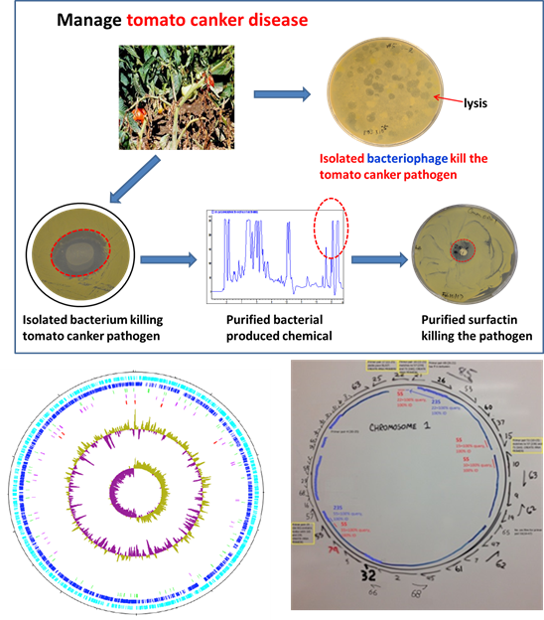
Abstract (300 word limit)

Chemical fertilizers and pesticides have been heavily used in agriculture and horticulture food production, resulting in serious concerns including food safety and eco-system sustainability. Plant growth promoting bacteria are able to improve plant health and productivity and reduce pathogens and diseases, representing an ecologically-friendly alternative to chemical fertilizers and pesticides. We recently isolated various beneficial bacterial species including Paenibacillus polymyxa CR1 (BMC Genomics 2014; Frontiers in Microbiology 2015; BMC Microbiology 2016); Bacillus velezensis strain 9D-6 (BMC Microbiology 2019); Bacillus velezensis strain 1B-23 (GenBank Accession: NZ_CP033967.1) and Burkholderia cenocepacia CR318 (Genome Announcements 2017). These beneficial bacteria are capable of promoting crop health and inhibiting the growth of wide range of bacterial and fungal pathogens. In particular, Bacillus velezensis strain 9D-6 and 1B-23 produce surfactin, the most powerful biosurfactant. Surfactin aids in biocontrol through its antimicrobial action and through contribution to reducing biofilm formation. Our study further indicated that Bacillus velezensis strain 9D-6 and 1B-23 protect tomato plants from bacterial canker disease caused by Clavibacter michiganensis pv michiganensis. Interestingly, we found strain 1B-23 produces surfactin more efficiently at temperature between 16 to 20 °C. Our results suggest the potential of using beneficial bacteria to develop inoculants to protect agricultural important crops while reducing the use of chemical fertilizers and pesticides, towards more sustainable agriculture and horticulture.
Image

Recent Publications (minimum 5)
2019. Elliot Grady; Jacqueline MacDonald; Margaret Ho; Brian Weselowski; Tim McDowell; Ori Solomon; Justin Renaud; Ze-Chun Yuan. Characterization and complete genome analysis of the surfactin-producing, plant-protecting bacterium Bacillus velezensis 9D-6. BMC Microbiology. 2019. Jan 8;19(1):5. doi: 10.1186/s12866-018-1380-8.
2019. Naeem Nathoo, Jacqueline MacDonald, Brian Weselowski and Ze-Chun Yuan. Comparative transcriptomic analysis reveals different responses of Arabidospsis thaliana roots and shoots to infection by Agrobacterium tumefaciens in a hydroponic co-cultivation system. 2019. Physiological and Molecular Plant Pathology. Volume 106, April 2019, Pages 109-119.
2018. Munmun Nandi, Jacqueline MacDonald, Peng Liu, Brian Weselowski and Ze-Chun Yuan. Clavibacter michiganensis subsp. michiganensis: Bacterial Canker of Tomato, Molecular Interactions and Disease Management. Review. Molecular Plant Pathology. 2018 Mar 12. doi: 10.1111/mpp.12678.
2017. Filip Zekic, Brian Weselowski, Ze-Chun Yuan. Complete Genome Sequence of Burkholderia cenocepacia CR318, a Phosphate-Solubilizing Bacterium Isolated from Corn Root. Genome Announcement. 2017. Jun 8;5(23). pii: e00490-17. doi: 10.1128/genomeA.00490-17.
2017. Naeem Nathoo, Mark A. Bernards, Jacqueline MacDonald and Ze-Chun Yuan. A hydroponic co-cultivation system for simultaneous and systematic analysis of plant-microbe molecular interactions and signaling. 2017. Journal of Visualized Experiments. doi: 10.3791/55955. PMID: 28784965.
2016. Elliot Nicholas Grady, Jacqueline MacDonald, Linda Liu, Alex Richman, Ze-Chun Yuan. Current Knowledge and Perspectives of Paenibacillus: A Review. BMC Microbial Cell Factories. 2016.
1;15(1):203.
2016. Brian Weselowski, Naeem Amirali Nathoo, Alexander Eastman, Jacqueline MacDonald and Ze-Chun Yuan. Isolation, Identification and characterization of Paenibacillus polymyxa CR1 with potentials For biopesticide, biofertilization, biomass degradation and biofuel production. BMC Microbiology, 2016 Oct 18;16(1):244.
2015. Alexander W. Eastman and Ze-Chun Yuan. Second-generation sequencing, assembly and finishing of Paenibacillus polymyxa CR1 genome using a novel and expedited strategy based on repetitive rDNA operons and primer walking. Frontier in Microbiology. 2015. 21;5:769.
2014. Alexander W. Eastman, David E. Heinrichs and Ze-Chun Yuan. Comparative and genetic analysis of four sequenced Paenibacillus polymyxa genomes reveals high genome plasticity but conservation of
genes relevant to host interaction and competitiveness. BMC Genomics. 2014. Oct 3; 15(1):851.
2014. Sujatha Subramoni, Naeem Nathoo, Eugene Klimov, and Ze-Chun Yuan. Agrobacterium response to plant-derived signaling molecules. Frontiers in Plant Science. 2014. 8; 5:322
2014. Alexander W. Eastman, Brian Weselowski, Naeem Nathoo, Ze-Chun Yuan. Complete genome sequence of Paenibacillus polymyxa CR1, a plant growth-promoting bacterium isolated from corn rhizosphere exhibiting potential for biocontrol, biomass degradation, and biofuel production. Genome Announcements. 2014. Jan. 23, 2(1). pii: e01218-13.
2012. Yuan, ZC., and Williams, M.E. A Really Useful Pathogen, Agrobacterium tumefaciens. Teaching Tools in Plant Biology. The Plant Cell. doi/10.1105/ tpc.109.tt1109.

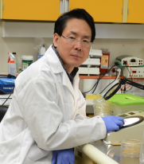
Biography (150 word limit)
Dr. Ze-Chun Yuan is a research scientist and principal investigator at Agriculture and Agri-Food Canada. He is also a research professor and graduate student supervisor at the Department of Microbiology and Immunology, University of Western Ontario, Canada. He has expertise in soil microbiology, bacterial genetics and genomics with great passion in improving crop health and productivity through alternative strategies. He has been isolating and characterizing beneficial microorganisms to manage crop disease or improve crop health and productivity, in particular, developing biofertilzers and biopesticides to reduce the use of classical chemical fertilizers and pesticides in agriculture and horticulture. Dr. Yuan is also interested in developing renewable bioproducts from biomass, in particular, crop residues. His research also involves synthetic biology and microbial engineering aiming at rewiring microbial metabolic pathways towards higher productivity of bio-based products and biochemicals. Dr. Yuan looks for opportunities for collaborative research and training of highly qualified personnel including graduate students and postdoctoral fellows. E-mail: zyuan27@uwo.ca and E-mail: yuanz@agr.gc.ca Contact No: 001-519-953-6641.

Notes/Comments:

