Potential Application of Selected Phosphate Solubilizing Bacteria Isolated from Rhizospheric Soil of Chenopodium quinoa in Plant Growth Promotion
Ismail MAHDI ^{ab}, Nidal FAHSI ^{ac}, Abdelmounaaim ALLAOUI ^{ac}, Mohamed HAFIDI ^{b ¥} , Latefa BISKRI *^{a ¥}
ª Medical Application Interface Center (CIAM), Mohammed VI Polytechnic University – Benguerir, Morocco.
^{b} Laboratory of Ecology and Environment (L2E), Faculty of Sciences Semlalia, University Cadi Ayyad, Marrakesh, Morocco.
^{c} Microbial Biotechnology Applied to Agriculture and Environment: Program MBAE (AgroBioScience), Mohammed VI Polytechnic University – Benguerir, Morocco.

Abstract
The use of plant growth promoting bacteria as biofertilizers provides a promising solution to enhance assimilation of nutrients carried by chemical fertilization. Phosphate solubilization is one of the major mechanisms of plant growth promotion by plant associated microorganisms. This involves bacteria release of low molecular weight molecules which solubilize the phosphate complexes converting them into ortho-phosphate available for plant uptake. In the present study, we screened 14 strains isolated from the rhizospheric soil of Chenopodium quinoa plant grown in the experimental farm of UM6P for plant growth promoting properties including their ability to solubilize phosphate, to produce indole acetic acid (IAA), and to tolerate salt stress. The isolated bacteria were first selected based on colony morphology and biochemical traits. Next, they were identified using 16S-rRNA DNA gene sequencing as Bacillus, Pseudomonas and Enterobacter. These strains showed dispersed capacities to solubilize phosphate (123,66 ± 2,51 ~ 346 ± 8,71 mg L⁻¹) following 5 days of incubation at 30°C. We also assessed their abilities for indole acetic acid (IAA) production (43,39 ±6,18 ~795,31± 80,06 µg ml⁻¹) and salt tolerance. Three Bacillus strains QA1, QA2, and S8 tolerated high salt stress induced by NaCl with a maximum tolerable concentration of 8% and total inhibition of growth occurred at 14%. Four performant isolates, S6, QA1, QA2 and QF11, were further selected for seed germination assay because of their pronounced abilities in terms of phosphate solubilization, IAA production and salt tolerance. The early plant growth potential of tested strains showed that inoculated seeds displayed greater germination rate (16.6~50.7%) and higher growth (50.5% ~ 281%) under bacterium treatments. The relevant positive effect on seed germination traits strongly suggest that tested strains are growth promoting, halotolerant and phosphate solubilizing bacteria which could be exploited as biofertilizers. This hypothesis is currently under investigation in vivo.

Image
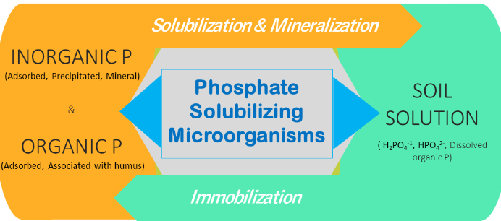

 Biography
Ismail MAHDI is a second year PhD student at Mohamed VI Polytechnic University – Morocco. His doctoral research investigates the biochemical and molecular mechanisms involved in the solubilization of phosphates and salt stress tolerance of rhizospheric and endophytic bacteria.He holds a master’s degree in Health and biology from the University of Fez, Morocco, and a bachelor’s degree in Cellular and molecular biology from the University of Agadir, Morocco.
Email: ismail.MAHDI@um6p.ma Contact No: 00212652074039

Notes/Comments:

