Cadmium stress in rice plants: The effect of cadmium on seed germination and seedling growth of rice plant (Oriza sativa L.)
Elham Abedi, PhD student, Department of Basic Sciences, Islamic Azad University, Science and Research Branch, Tehran, Iran
Ramazan Ali Khavari-Nejad, PhD, Faculty of Sciences, Kharazmi University, Tehran, Iran; Department of Biology, Islamic Azad University, Science and Research Branch, Tehran, Iran

Abstract
Cadmium (Cd) non-essential, but toxic, element for animals and plants is frequently present in paddy fields. Oryza sativa L., a staple food for at least the half of world population, also aquatic plants are known to accumulate heavy metals, easily absorbs Cd by the root, and in this organ the pollutants evoke consistent damages and reducing the root system. In this study the effects of different cadmium chloride concentrations (0 ,15, 25, 35, 45 and 55 µM) on some physiological and biochemical processes including seed germination, root and shoot fresh and dry weight in rice were investigated. The results showed that after treated, seed germination rate was less affected, but root growth was restrained evidently. It affected the subsequent growth rate in these plants. Higher cadmium concentrations specially at 45 and 55 µM reduced plant growth significantly. Leaf chlorosis, wilting and leaf abscission were observed in plants treated with cadmium. Also Cd treatment reduced the germination percentage 6.9%, root and shoots length 68.9% and 85.6%, respectively. The decrease of 42.3% in fresh weight was noticed following the treatment with 45, and 55 µM cadmium doses compared with control treatment, respectively.
Based on the results we concluded that, these traits of rice plant are seriously affected by Cd treatment and also these are symptoms of toxicity of Cd element. Our results demonstrate that Cd affect rice root system, by interfering with the formation of the roots and their development. This results into an important change in the root system architecture, which may negatively affect plant survival in highly polluted paddy soils. Therefore, less amount of reduction in a special genotype is referred to the index of tolerance to Cd. Finally, in the metal contaminated areas, further research is needed to determine different levels of metals in the environment and various parts of the plants. Having in mind the value of this crop as a food all over the world, the consequences of the reactivity of its root system to these pollutants is very important for evaluating possible economic losses, and for executing repair strategies.

Image
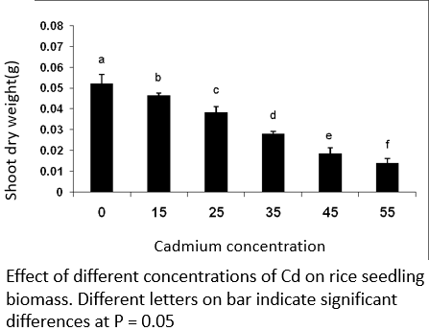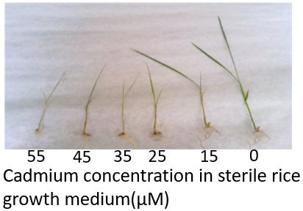
Recent Publications
- Ashraf, U.; Kanu, A.S.; Mo, Z.; Hussain, S.; Anjum, S.A.; Khan, I.; Abbas, R.N.; Tang, X. Lead toxicity in rice: Effects, mechanisms, and mitigation strategies—A mini review. Environ. Sci. Pollut. Res. 2015, 22, 18318–18332.
- Ge, L.; Cang, L.; Yang, J.; Zhou, D. Effects of root morphology and leaf transpiration on Cd uptake and translocation in rice under different growth temperature. Environ. Sci. Pollut. Res. 2016, 23, 24205–24214
- Liang, C.; Xiao, H.; Hu, Z.; Zhang, X.; Hu, J. Uptake, transportation, and accumulation of C60 fullerene and heavy metal ions (Cd, Cu, and Pb) in rice plants grown in an agricultural soil. Environ. Pollut. 2018, 235, 330–338.
- Masto, R.E.; George, J.; Rout, T.K.; Ram, L.C. Multi element exposure risk from soil and dust in a coal industrial area. J. Geochem. Explore. 2017, 176, 100–107.
- Room R, Lei, M.; Tie, B.; Williams, P.N.; Zheng, Y.; Huang, Y. Arsenic, cadmium, and lead pollution and uptake by rice (Oryza sativa L.) grown in greenhouse. J. Soils Sediments 2011, 11, 115–123.


Elham Abedi has studied in plant physiology. She received her B.S. and M.S. degrees in plant physiology from the Department of basic science, Isfahan University, and Science and Research Branch, Islamic Azad University, Tehran, Iran, respectively. In 2015, she started her Ph.D. in the same department where her thesis is about the Effect of different concentrations of Nanoparticles on germination and some physiological and biochemical parameters of Dorema ammoniacum D. Don.
She has worked in evaluation of some physiological parameters in several poaceae family plants under in vitro stresses, such as heavy metal and salt. Now she has focused on selenium supplement on endemic species plants.
.
Email: elham.abedi@srbiau.ac.ir Contact No: +989133084145

Notes/Comments:

