Assessment of variability in morphological traits of apricot germplasm issued from various genetic and environmental resources in Morocco
Jamal Ayour ^{1, 2, 3}, Catherine M.G.C. Renard ^{2, 3}, Mohamed Benichou ¹,

¹ Faculté des sciences, Université Cadi Ayyad, Laboratoire Sciences des Aliments, M-40090 Marrakech, Maroc
² UMR408 Sécurité et Qualité des Produits d’Origine Végétale, INRA, F-84000 Avignon, France
³ Université d’Avignon et des Pays du Vaucluse, UMR408 Sécurité et Qualité des Produits d’Origine Végétale, F-84000 Avignon, France

Abstract (300 word limit)

Agro-morphological traits were evaluated for 92 Moroccan apricot accessions issued from different geographical sites, using 34 morphological qualitative and quantitative characters. Strong correlations between studied traits were observed, especially between fruit weight, stone weight, fruit dimensions, flesh firmness and color traits. Significant variations (p ≤ 0.001) were observed among studied parameters which can help differentiate between different apricot accessions. The analysis of structure was able to show that the dimensions of the leaf and the fruit as well as the skin color of fruit represent the discriminating parameters of studied apricots. No clear morphological structure was displayed according to the geographical origin of accessions. However, the apricot genotype had a marked effect on the observed variability (More than 48 % of the total variance revealed in PCA analysis) and morphological structure of studied apricots. This study would provide a solid and genuine basis for effective management and sustainable use of apricot genetic material in future breeding programs in the Mediterranean region.

Image

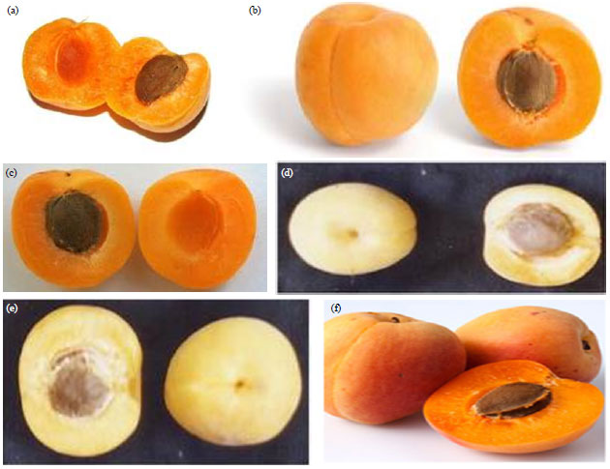

Recent Publications (minimum 5)
- Ayour, J., Sagar, M., Alfeddy, M. N., Taourirte, M., & Benichou, M. (2016). Evolution of pigments and their relationship with skin color based on ripening in fruits of different Moroccan genotypes of apricots (Prunus armeniaca L.). Scientia Horticulturae, 207,168–175.
- Ayour, J., Gouble, B., Reling, P., Ribas-Agustí, A., Audergon, J.M., Maingonnat, J.F., Benichou, M., Renard, C.M.G.C. (2017). Impact of cooking on apricot texture as a function of cultivar and maturity. LWT - Food Science and Technology, 85, 385-389.
- Ayour, J., Sagar, M., Harrak, H., Alahyane, A., Alfeddy, M. N., Taourirte, M., & Benichou, M. (2017). Evolution of some fruit quality criteria during ripening of twelve new Moroccan apricot clones (Prunus armeniaca L.). Scientia Horticulturae, 215, 72–79.
- Jamal Ayour, Hasnaâ Harrak, Abderrahim Alahyane, Moha Taourirte, Catherine M G C Renard and Mohamed Benichou. (2018). Pomological and antioxidant properties of apricot (Prunus armeniaca L.): Fruit management and quality analysis. J. Food Microbiol. Saf. Hyg, Volume 3.
- Jamal Ayour, Imane Elateri, Mohammed Alami, Abderrahim Alahyane, Mohamed Najib Alfeddy, Jean-Marc Audergon, Catherine M.G.C. Renard, and Mohamed Benichou. (2018). Genetic Variability Revealed by SSR (Simple Sequence Repeat) Markers of Apricot (Prunus armeniaca L.) Issued from Various Genetic and Environmental Resources in Morocco. In: Kassem et al. (2018). The Fourth International American Moroccan Agricultural Sciences Conference -Atlas Journal of Biology 2018, pp. 422–545.
- A. Alahyane, H. Harrak, J. Ayour, I. Elateri, A. Ait-Oubahou, M. Benichou. Bioactive compounds and antioxidant activity of seventeen Moroccan date varieties and clones (Phoenix dactylifera L.). South African Journal of Botany 121 (2019) 402–409.


Biography
Jamal AYOUR has completed his PhD at the age of 28 years from Avignon University (France / Agronomic Science) and Marrakech University (Morocco / Biotechnology and Food science). He has published 5 papers in reputed journals, 7 participations in international congresses and he has been serving as an editorial board member of repute.
Email: jamal.ayour@yahoo.fr Contact No: +33699754764

