Radical scavenging activity of flavonoids increased by metal ions.
Rui-Min Han, Yi Xu, Ling-Ling Qian, Jian-Ping Zhang, Skibsted L H, Beijing, China

Abstract (300 word limit)
Flavonoids are secondary plant metabolities of the polyphenol family with a diversity of biological functions. Most metal-flavonoid complexes are found to have considerably higher antioxidant effects than free flavonoids. Molecular mechanisms of antioxidant activity of flavonoids increased by metal ions are poorly understood.
In our studies, binding of flavonoids (apigenin, kaempferol and luteolin) with metal ions, and radical scavenging activities of corresponding complexes were investigated in detail. Structural factors, such as coordinate proportions of metal ions and flavonoids and steric orientations affecting activities of metal-flavonoid complexes as antioxidants, are elucidated.
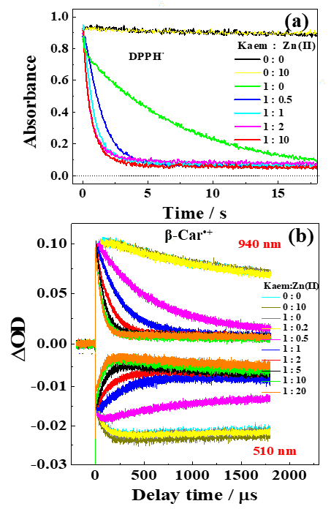
Figure 1. Absorbances for (a) DPPH• at 516 nm, and (b) β-Car^{•+} at 940 nm scavenged and β-carotene ground state bleaching at 510 nm recovered by indicated ratio of kaempferol (Kaem) and Zn(II). The concentration of Kaem is 100 μM.

Recent Publications (minimum 5)
- Xu Y, Qian L-L, Yang J, Han R-M, Zhang J-P, Skibsted L H (2018) Kaempferol Binding to Zinc(II), Eﬃcient Radical Scavenging through Increased Phenol Acidity. J. Phys. Chem. B 122: 10108−10117.
- Liu X-C, Du H-H, Fu L-M, Han R-M, Wang P, Ai X-C, Zhang J-P, Skibsted L H (2018) Integrity of Membrane Structures in Giant Unilamellar Vesicles as Assay for Antioxidants and Prooxidants. Anal. Chem. 90: 2126−2133.
- Yang J, Xu Y, Liu H-Y, Han R-M, Zhang J-P, Skibsted L H (2017) Genistein Binding to Copper(II)-Solvent Dependence and Effects on Radical Scavenging. Molecules 22: 1757−1771.
- Pereira J C M, Iretskii A V, Han R-M, Peter C. Ford (2015) Dinitrosyl Iron Complexes with Cysteine. Kinetics Studies of the Formation and Reactions of DNICs in Aqueous Solution. J. Am. Chem. Soc. 137: 328−336.
- Han R-M, Cheng H, Feng R, Li D-D, Lai W, Zhang J-P, Skibsted L H (2014) β‑Carotene As a Lipophilic Scavenger of Nitric Oxide. J. Phys. Chem. B 118: 11659−11666.

https://agriculture-horticulture.conferenceseries.com/abstract-submission.php

August 15-16, 2019 Rome, Italy

Theme: The Global State of Agriculture



Associate professor in Department of Chemistry, Renmin University of China, Beijing, 100872
Research interest: Antioxidant mechanism and application of phytochemicals and their metal complexes.
Speciality: time-resolved dynamics (stopped-flow, laser photolysis).
Email: rmhan@ruc.edu.cn Contact No: +86-10-62516604

