Highlight on the Parasitoids Species (Hymenoptera) of Important Crops Insect Pests in Malaysia

Salmah Yaakop, Safiah Shariff, Nurul Jannah Ibrahim, Siti Zafirah Ghazali, Ameyra Aman Zuki, Muhammad Azmi Mohammmad, Suhana Yusof, Abdullah Muhaimin Muhammad Din, Rabibah Razali, Wan Nur Madihah Wan Abdul Halim, Sharifah Zulaikha Syed Ahmad & Muhamad Azmi Mohammed², Badrul Munir Md-Zain¹, Izfa Riza Hazmi & Amirah Aqilah Badrulisham
.
Centre for Insect Systematics, Faculty of Science and Technology, Universiti Kebangsaaan Malaysia, 43600 Bangi, Selangor, MALAYSIA
¹School of Environmental and Natural Resource Sciences, Faculty of Science and Technology, Universiti Kebangsaan Malaysia, 43600 UKM Bangi, Selangor, Malaysia.
²Department of Crop Science, Faculty of Agriculture and Food Sciences, Universiti Putra Malaysia Bintulu Campus, 97000 Bintulu, Sarawak, Malaysia
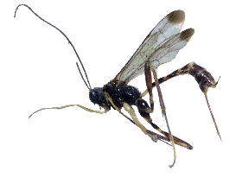
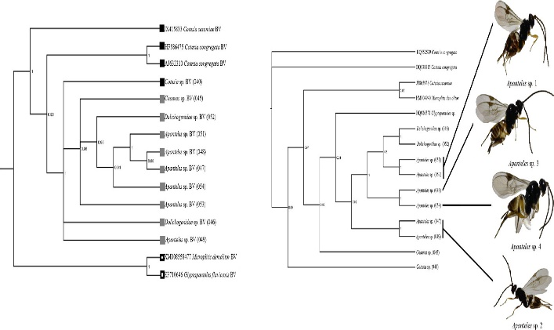
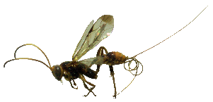

Abstract

Parasitoids are group of insects that play an important role in the agricultural ecosystem. They play a pivotal roles by laying eggs inside their host, get nutrient from the host and consequently kill the hosts. Their presence in the field are highly significant and influences yield production and sustainability of the ecosystem. Through several series of studies (2011-2018), we have presented and compiled several significant parasitoids that potential to be applied as natural enemies or parasitoids on several insect pests that infesting crops e.g. oil palm, cocoa, coconut, paddy, rice storage, fruits, vegetables etc. in Malaysia. The parasitoids for the pests of Bactrocera spp., stem borers, storage pests, bagworms, cocoa pod borer (CPB), sap beetles, Red Palm Weevil (RPW) and many more have been performed based on samples from various localities and populations throughout the Peninsular Malaysia. The identification status of the species has been verified based on molecular data in both species, the pests and the parasitoids. Besides that, phylogenetic analysis implemented and helps to investigate the species relationships, and promotes accurate classification and identification. Furthermore, the coevolution and evolution of the species also obtained to reveal some information on the particular species. Besides that, genetic diversity and species variation information are also necessary for population genetic study to enhance understanding on adaptability and survivability of a species. Therefore, the aim of this study is to update the current information of the Malaysian insect parasitoids-pests species for creating the best strategy towards sustainable species management.

Keywords: Natural enemy, Oriental region, genetic, phylogeny, barcoding analysis.

Acknowledgement: This project was supported by University grant: GUP-2018-037

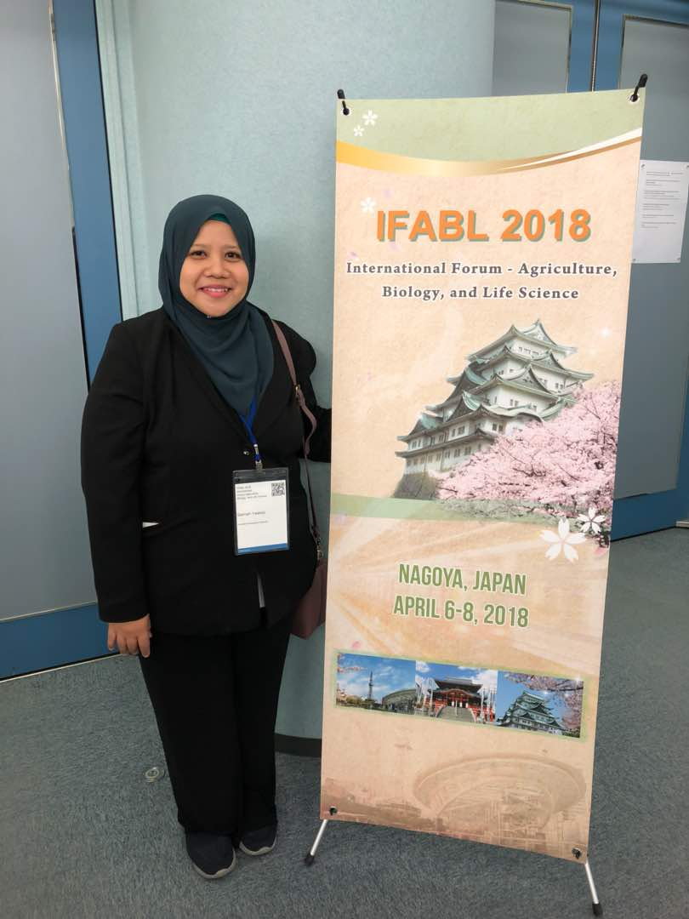
Image

Recent Publications
- Aman-Zuki A. Mohammed MA., Yaakop S. 2019. Phylogenetic relationships of five Oriental Apanteles species-groups (Hymenoptera: Braconidae: Microgastrinae) by concatenating four molecular markers. Journal of Asia-Pacific Entomology. 22(1): 341-352.
- Halim M., Aman-Zuki A., Syed Ahmad SZ., Md. Zain, B.M., Yaakop S. 2018. Exploring the abundance and DNA barcode information of eight parasitoid wasps species (Hymenoptera), the natural enemies of the important pest of oil palm, bagworm, Metisa plana (Lepidoptera: Psychidae) toward the biocontrol approach and it's application in Malaysia. Journal of Asia-Pacific Entomology 21(4): 1359-1365.
- Nur –Atiqah Lalaludin, Faszly Rahim & Salmah Yaakop. 2018. Termite associated to oil palm stands in three types of soils in Ladang Endau Rompin, Pahang, Malaysia
Sains Malaysiana 47(9)(2018): 1961–1967
- Muhamad Azmi MOHAMMED, Ameyra AMAN-ZUKI, Nurul Othman WAHIDA, Yohsuke TAGAMI, Salmah YAAKOP. 2018. The role of a novel Wolbachia (Rickettsiales: Anaplasmataceae) synthetic peptide, WolFar, in regulating prostaglandin levels in the hemolymph of Acheta domesticus (Orthoptera: Gryllidae). Turk J Zool. 42: 1-10
- Suhana Y, Mohd Shamsudin O, Sulaiman Z., Ahmad Zainuri MD, Hasan S. and Yaakop S. 2018. Effects of gamma irradiation on egg hatchability, pupation, and adult emergence of the immature stages of the oriental fruit fly, Bactrocera dorsalis (Hendel) (Diptera: Tephritidae) from Malaysia
Serangga. 23(2): 259-267

Biography
SALMAH YAAKOP, PhD, is a senior lecturer at the Centre for Insect Systematics, School of Environmental Science and Natural Resources, Faculty of Science and Technology (FST), Universiti Kebangsaan Malaysia (UKM). Her expertise is in the field of insects taxonomy and molecular systematic, specialising in parasitoids (Braconidae: Hymenoptera) and cicadas (Cicadidae : Homoptera). She has obtained her PhD degree from State University of Groningen, The Netherlands. She has published 83 reputed journals and conferences papers and actively conducting research on insects which have significance in agricultural areas.

Email: salmah78@ukm.edu.my Contact No: 0060389215698

