The Potential Anticancer Effects of Traditional Medicinal Herbs on Oral Squamous Cell Carcinoma
Mahboobeh Razmkhah^{1*}, Ali Dehghani Nazhvani^{2, 3}, Najmeh Sarafraz⁴, Fatemeh Askari⁵
¹Shiraz Institute for Cancer Research, School of Medicine, Shiraz University of Medical Sciences, Shiraz, Iran
²Department of Oral & Maxillofacial Pathology, School of Dentistry, Shiraz University of Medical Sciences, Shiraz, Iran.
³Biomaterials Research Center, School of Dentistry, Shiraz University of Medical Sciences, Shiraz, Iran.
⁴Department of Periodontics, School of Dentistry, Shiraz University of Medical Sciences, Shiraz, Iran.
⁵Department of phytopharmaceuticals, School of Pharmacy, Shiraz University of Medical Sciences, Shiraz, Iran.

Abstract
Introduction: Traditional herbs and spices are widely consumed in the world and contains numerous bioactive components that are beneficial to consumer health. Documents have endorsed that a diet enriched with fruit, vegetables and spices can reduce the risk of developing major cancers. Purpose: This study aimed to evaluate the growth inhibitory activities of four medicinal herbs including saffron, ginger, cinnamon and curcumin on oral squamous cell carcinoma (OSCC) cell line (KB). Materials and Method: Having obtained the aqueous extracts of the four herbs, they were administered on KB per se and in dual, triple, and quadruple combinations. Their cytotoxic effects were measured in different concentrations after 24 and 48 hours using MTT assay. Results: The minimum and maximum concentrations of extracts were respectively 108 and 217 mg/ml for curcumin with IC30 of 77 mg/ml, 108 and 270 mg/ml for ginger with IC30 of 58 mg/ml, 2 and 10 mg/ml for saffron with IC30 of 1.9 mg/ml, and 5 and 40 mg/ml (100% cytotoxicity) for cinnamon with IC30 of 3.3 mg/ml. The best cytotoxicity of the combination of extracts was seen in cinnamon-saffron after both 24 and 48 hours and the four herbs combination after 48 hours. Conclusion: The consumption of spices specially saffron and cinnamon may contribute to the prevention of certain types of cancer including OSCC.

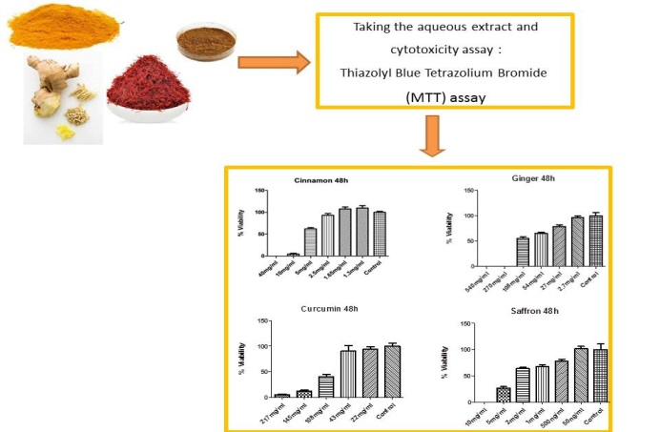
Image

Figure 1. Cytotoxic concentration (mg/ml) of curcumin, saffron, ginger, and cinnamon on OSCC cell line (KB) after 48 hrs.

Recent Publications
1. Aghbali A, Hosseini SV, Delazar A, Gharavi NK, Shahneh FZ, Orangi M, et al. (2013) Induction of apoptosis by grape seed extract (Vitis vinifera) in oral squamous cell carcinoma. Bosn J Basic Med Sci. 13:186-91.
2. Lauritano D, Lucchese A, Contaldo M, Serpico R, Lo ML, Biolcati F, et al. (2016) Oral squamous cell carcinoma: diagnostic markers and prognostic indicators. Journal of biological regulators and homeostatic agents. 30:169.
3. Buch ZM, Joshi J, Amonkar A, Vaidya AB (2012) Interventional role of Haridra (Curcuma longa Linn) in cancer. Clinical Cancer Investigation Journal. 1:45.
4. Zhang Z, Wang CZ, Wen XD, Shoyama Y, Yuan CS (2013) Role of saffron and its constituents on cancer chemoprevention. Pharm Biol. 51:920-4.
5. Herdwiani W (2016) A review of cinnamon as a potent anticancer. Asian Journal of Pharmaceutical and Clinical Research. 9:8-13.

Biography
As the presenting author I am Dr. Mahboobeh Razmkhah, Associate Professor of Immunology and one of the faculty members of Shiraz Institute for Cancer Research, Shiraz University of Medical Sciences. My main research field is cancer including genetics, stem cell and molecular mechanisms of cancer development which lead to the publication of 50 papers, and 40 research work presented at conferences, and two awards as follows: Excellent Poster Award by Asian Cellular Therapy Organization (ACTO), Japan, Oct 28, 2017 and Cha Award for best abstract, 7th ACTO Annual Meeting in Beijing, China, November 12, 2016.
Email: razmkhahm@sums.ac.ir, mrazmkhah2@gmail.com Contact No: 0098 9173076601

