The first report on factors affecting tissue culture of Thymus Transcaspicus Klokov from Iran

Mehrzad Honarvar ¹* and Mahnaz Shahi ²
1 and 2. Department of Horticultural Science, Estahban branch, Islamic Azad University, Estahban. Iran.

Correspondence details:
*Mehrazd Honarvar
Asst. Professor of Hort. Science,
Estahban Branch, Islamic Azad University, Estahban, Iran.
Email: mzhonarvar@gmail.com, mzhonarvar@iauest.ac.ir
Tel: +987132318555
Mobile: +989177106992
Fax: +987153222129

Abstract
Khorasani thyme (Thymus transcaspicus Klokov) is an important thyme species of Lamiaceae family. This species is an evergreen and aromatic herb with culinary and medicinal use. Thymus transcaspicus is distributed in Iran and Turkmenistan. There is no report on in vitro propagation of Khorasani thyme. This study was conducted in Thymus transcaspicus for studying the factors affecting tissue culture on this species for the first time. For this purpose, different concentrations of BAP (0, 0.25, 0.5, 1.5, 2 and 3 mg l⁻¹) and IBA (0, 0.5, 1, 1.5 and 2 mg l⁻¹) were added into MS and MS/2 media. The best result for disinfection obtained with the using 70% alcohol for 5 sec. and 20% Clorox for 10 min. The results indicated that MS/2 medium was more effective in terms of explant growth compared with MS medium. The results demonstrated that, application of 1.5 mg l⁻¹ IBA plus 0.5 mg l⁻¹ BAP increased plant height, leaf width, and internode length as well as internode number. Furthermore, application of 1 mg l⁻¹ IBA plus 3 mg l⁻¹ BAP increased leaf length, fresh and dry weight and plant number. According to the results, application of 1.5 mg l⁻¹ IBA improved root number and root length, while application of 1 and 2 mg l⁻¹ increased root diameter in thyme plants.

Keywords: Thyme, Micropropagation, Organogenesis, Benzyladenine, Indole butyric acid
Image
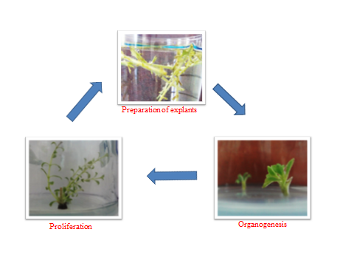
Figure 1: Different stages of proliferation of
Thymus transcaspicus explants
Recent Publications
Ahmadi-Dizaji J, Barnosi A, Jafari M, Rezae-danesh V (2012) The effect of TDZ and BAP on direct regeneration of stem node explants of Teucrium chamaedrys L. Special issue of 12th Iranian Genetic Congress; Tehran, Iran.
Karami A, Mozafari A, Ebrahimi M and Maarofi H (2011) The effect of different concentrations of benzyladenine on Satureja avromanica Maroofi regeneration. The 7th National Biotechnology Congress.
Bicca Dode L, Bobrowski VL, Bolacelbraga EJ, Seixas FK, Schuch MW (2003) In vitro propagation of Ocimum basilicum L. (Lamiaceae). Acta Scientiarum Biological Sciences 25: 435-437.
Rout GR (2000) In vitro manipulation and prorogation of medicinal plants. Biotechnology Advances 18: 91-120.
Saez F, Sanches P, Piqueras A (1994) Micropropagation of Thymus piperella. Plant Cell Tiss. Org. Cult. 39: 269-272.


Corresponding author:
*Mehrazd Honarvar
Asst. Professor of Hort. Science,
Department of Horticultural Science, Branch of Biotechnology and Medicinal Plants, Estahban Branch, Islamic Azad University, Estahban, Iran.
Email: mzhonarvar@gmail.com, mzhonarvar@iauest.ac.ir
Tel: +987132318555

