Morphologic and quality characteristics of cultivated einkorn wheat (Triticum monococcum L. subs. monococcum) lines sown in autumn and spring seasons
Servet KEFI, Ph.D., Kastamonu University, TURKEY

Abstract (300 word limit)
Statement of the Problem: As being the first cultivated wheat in the Fertile Crescent, diploid einkorn wheat (2n=2x=14, AA), Triticum monococcum L. subs. monococcum, was domesticated 9500 years ago in Karacadag Mountains of South-East Turkey. Nowadays it has been grown in only marginal lands of Turkey, Caucasus, Europe and Morocco. After having disappeared because of its replacement by high yielding modern wheat cultivars, recently einkorn wheat has been re-introduced in some countries, especially for organic farming, due to its high resistance to pests and diseases, adaptation to harsh climates, ability to provide acceptable yields on poor soils even with low/without inputs and high nutritional value. In order to maintain and utilize the genetic diversity of einkorn wheat, it is necessary to develop in situ conservation program to provide continuity of cultivation of its landraces; characterizing, analyzing and documenting of its accessions and identifying its genes for useful agronomical and nutritional traits to employ in breeding programs. Materials and Methods: Local 45 einkorn wheat lines, selected from 500 single rows planted by each single spikes collected from 50 farmers’ fields in Kastamonu/Turkey, were sown in autumn (9 November 2017) and in spring (20 February 2018) and were harvested on 30-31 July 2018 and on 8 August 2018, respectively. Morphologic and agronomic traits were observed and measured during growing period of plants and quality properties of harvested seeds were determined by using “Single Kernel Characterization System (SKCS)”. Findings: All of the einkorn wheat lines in the trial showed “facultative” growth habit, flowering well when sown both in autumn and in spring. Although lines sown in autumn had more yield, the same lines sown in spring provided higher quality and more resistance to lodging due to being shorter. Conclusions: Einkorn wheat lines sown in autumn and in spring seasons showed a significant variation for traits, which can be used for einkorn breeding program.

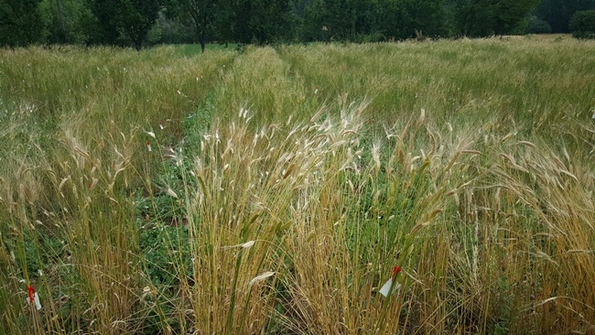
Figure 1: General view of einkorn wheat lines on 12 July 2018 (lines in front block were sown in autumn 2017 and lines in behind blocks were sown in spring 2018)

Recent Publications (minimum 5)
- Alvarez, J.B., Moral, A., Martin, L.M. (2006) Polymorphism and genetic diversity for the seed storage proteins in Spanish cultivated einkorn wheat (Triticum monococcum L. subsp. monococcum) Genet Resour Crop Evol 53:1061-1067.
- Empilli, S., Castagna, R., Brandolini, A. (2000) Morpho-agronomic variability of the diploid wheat Triticum monococcum L. Plant Genet Resour Newsl 124:36-40.
- Kilian, B., Ozkan, H., Walther, A., Kohl, J., Dagan, T., Salamani, F., Martin, W. (2007) Molecular diversity at 18 loci in 321 wild and 92 domesticate lines reveal no reduction of nucleotide diversity during Triticum monococcum (einkorn) domestication: implications for the origin of agriculture. Mol Biol Evol 24(12):2657-2668.
- Taddei, F., Gazza, L., Conti, S., Muccilli, V., Foti, S., Pogna, N.E. (2009) Starch-bound 2S proteins and kernel texture in einkorn, Triticum monococcum subsp. monococcum. Theor Appl Genet 119:1205-1212.
5. Zaharieva, M., Monneveux, P. (2014) Cultivated einkorn wheat (Triticum monococcum L. subsp. monococcum): the long life of a founder crop of agriculture. Genet Resour Crop Evol 61:677-706.

 | Biography (150 word limit)  Servet KEFI has completed her B.Sc. in 1983 and M.Sc. in 1985 at Agricultural Faculty of Aegean University, TURKEY and Ph.D. in 1995 in Dept. of Agriculture & Forestry, Univ. of Nebraska, Lincoln, USA. She had worked as extension specialist, researcher and director, respectively in the Ministry of Agriculture and Rural Affairs (1986-2004); General Secretary of the Executive Committee of Agriculture, Forestry & Veterinary Research Grant Group of the Scientific & Technological Research Council of Turkey, TUBITAK (2004-2007); Turkish Delegate of Food Quality & Safety Programme Committee in EU 6th Framework Programme (2005-2007) and Chair of Food & Agriculture Domain Committee in COST (16.05.2006-14.02.2007). Currently she is giving lectures at Kastamonu Univ., Fac. of Engineering and Architecture, Dept. of Genetics and Bioengineering. Her research areas include plant tissue culture applications (mainly in potato); plant growing, breeding and seed production techniques (potato & wheat). She has published more than 15 papers.  E-mail: servet.kefi@gmail.com; skefi@kastamonu.edu.tr Contact No:+90 532 5819497

Notes/Comments:

