Field evaluation and distribution uniformity of subsurface drip irrigation systems for half-high blueberry under different mulching practices
Lordwin Jeyakumar and David McKenzie
St. John’s Research and Development Centre, 308 Brookfield Road, BLDG 25, St. John’s, NL, A1E 0B2
Abstract

Emitter clogging is one of the major drawbacks of subsurface drip irrigation systems which can seriously affect crop-yields significantly. The uniformity of water application in a subsurface drip irrigation system is an important aspect of the system performance. The objectives of this study were to better understand the drivers of the clogging phenomena and evaluate the uniformity coefficients of subsurface drip irrigation systems.
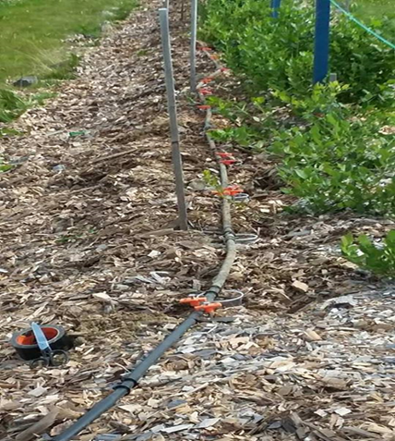
Figure 1: Clogging and uniformity studies in subsurface drip irrigation system
This study was undertaken at St. John’s Research and Development Centre, St. John’s, Newfoundland and Labrador. The subsurface drip irrigation was designed and installed on a blueberry field (Figure. 1). Subsurface drip irrigation lines were installed with a 30" emitter spacing and a flow rate of 0.42 gal per hour.
I am currently working for Agriculture and Agri-Food Canada as a Research Scientist. Earlier, I worked as a Associate Professor at Sam Higginbottom University of Agriculture, Technology and Sciences. I have worked as a Lead scientist on projects involving irrigation system design, rainfall-runoff modeling, evapotranspiration (ET), integrated water management and on-farm irrigation methods. Extensive experience in analyzing data including water quality, weather, soil, crop and flow for managing and supporting agricultural operations. I have over 15 years of scientific leadership in agri-environmental research, teaching, technology transfer and project management. Directed or co-directed 10+ projects addressing irrigation, water quality management and greenhouse gas emissions including field demonstrations. I have authored or co-authored 28 refereed journal papers and invited to deliver over 50 presentations at national and international conferences.
Email: lordwingirish@gmail.com; lordwin.jeyakumar@canada.ca Contact No.+1 709-699-5070



The blueberry field soil was slightly towards the clay side of the water depletion curve for the loam soil. Wood chip (10cm), sawdust (10 cm) and black plastic were used to maintain moisture and improve soil conditions. The distribution uniformity, emitter clogging and the performance of subsurface drip irrigation system were assessed using the randomly collected field data. Study results indicates that the coefficient of uniformity was found only 59.85% (wood chips), 34.25% (saw dust) and 33.65% (black plastic). It was found that the piping system was clogged in the mainline, submain line and the lateral pipes which eventually affected the flow rate through the emitters. An attempt to flush the main pipe lines reduced the emitter clogging significantly. This suggests that the lateral flushing and proper filtration system can control emitter clogging problems in subsurface drip irrigation systems.
Recent Publications
- Barragan J, Bralts V, Wu, IP (2006) Assessment of emission uniformity for micro-irrigation design. Biosystems Engineering, 93 (1), 89-97.
- Capra A, Scicolone B (1998) Water quality and distribution uniformity in drip/trickle irrigation systems. J Agric Eng Res 70(4):355–365
- Denis DM, Kumar JLG (2007) Response of Drip Irrigated Potato under Variable Irrigation Levels. International Agricultural Engineering Journal, 16(3-4), 87-95. ISSN: 0858-2114.
- Kumar, JLG, Imtiyaz, M (2007) Yield, Irrigation Production Efficiency and Economic Return of Broccoli under Variable Irrigation and Lateral Spacing. Journal of Science and Technology, 27 (2), 109-119. ISSN: 0855-0395
- Li, Y., Song, Pei, Y and Feng, J (2015) Effects of lateral flushing on emitter clogging and biofilm components in drip irrigation systems with reclaimed water. Irrigation Science, 33: 235-245.

