Histopathological and biochemical response of selected maize cultivars to post flowering stalk rot in maize

Shekhar M Plant Quarantine Division, ICAR-National Bureau of Plant Genetic Resources, Pusa Campus, New Delhi
Sunaina Department of plant pathology, Central Agricultural University, Jhansi
Singh N Division of Genetics and Plant Breeding IARI Pusa Campus, New Delhi
Singh V Department of Plant Pathology, CCS HAU, Regional Research Station, Karnal
Bahukhandi D Division of Plant Pathology, IARI Pusa Campus, New Delhi

Abstract
Macrophomina phaseolina and Fusarium verticilloides are one of the most devastating pathogens causing post flowering stalk rot (PFSR) disease in maize. Post flowering stalk rots of maize is globally important and among the most destructive diseases of maize. In India it poses moderate to severe threat to maize production in areas where it occurs endemically. Yield losses as high as 70% and economic losses up to 51% are recorded in susceptible verities. Investigation was undertaken to study the host pathogen interaction and response of contrasts cultivars against this disease. Various studies were done at histopathological, biochemical and genotypic level. This revealed that the asymptomatic behavior of inoculated contrast genotypes up-to knee-high level. However, histopathological studies exhibited the invasion of fungi in the roots and stem of young plants from where the pathogen enters in vascular bundle and adjacent tissues including the protoxylem lacuna, xylem vessels and metaxylem, this was observed in histopathological studies. To determine content of total phenolic compounds (TPC) of resistant lines developed from different genetic background, biochemical analysis was done. Hence, the biochemical analysis of inoculated and uniniclated genotypes was done which confirmed 3 to 4 fold increase in total phenolic compounds in diseased tested plants. This itself confirms the elicitation of biochemical defence by the host. The findings were validated by amplification of PR protein, β-1-3 glucanase in the test plant by casting gel of inoculated and uninoculated plants. Observations were compared with control plants.

Image
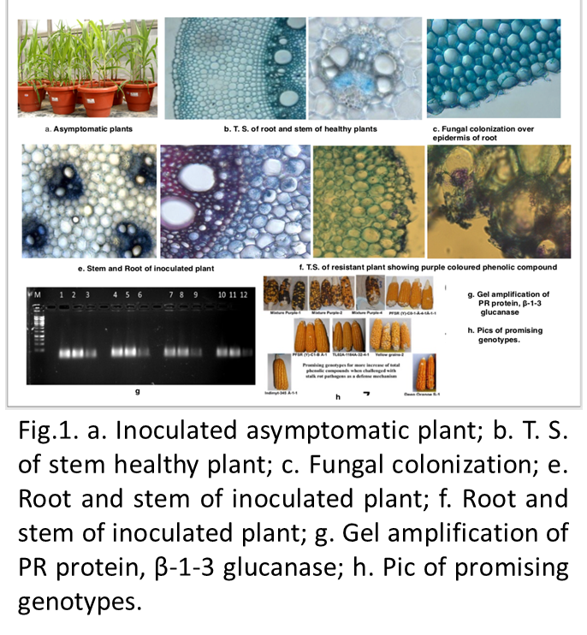

Recent Publications (minimum 5)
- Shekhar M, Singh N, Dutta R, Kumar S, Mahajan V (2017) Comparative study of qualitative and quantitative methods to determine toxicity level of Aspergillus flavus isolates in maize. PLoS ONE 12(12): e0189760. https://doi.org/10.1371/journal.pone.0189760.
- M. Shekhar, N. Singh, S. Kumar, R. Kiran (2016) Role of mould occurrence in aflatoxin build-up and variability of Aspergillus flavus isolates from maize grains across India. Quality Assurance and Safety of Crops & Foods: DOI: http://dx.doi.org/10.3920/QAS2015.0720
- M. Shekhar, R. Kiran and N. Singh (2016) Genotypic variability in Maize for Total Phenolic, Total Flavonoids and sugar in response to stalk rot pathogens. Indian phytopathology, 69, (45): 260-265 (NAAS ID I094, 5.90)
- Meena Shekhar, Nirupma Singh, Sunaina Bisht, Vimla Singh and Arvind Kumar (2018) Biological Control of Aflatoxin in Maize Grain at Ambient Storage Conditions International. Journal of Current Microbiology and Applied Sciences, Vol. 7 (4): 3031-3037.
- Meena Shekhar, Nirupma Singh, Sunaina, Vimla Singh and Arvind Kumar. 2018. Effects of Climate Change on Occurrence of Aflatoxin and Its Impacts on Maize in India. Int.J.Curr.Microbiol.App.Sci.7 (06): xx-xx. doi: https://doi.org/ 10.20546 /ijcmas.2018.706.xx




Biography (150 word limit)
Dr. Meena Shekhar is Principal scientist in Plant Quarantine Division, National Bureau of Plant Genetic Resources, Pusa Campus, New Delhi. She completed her Ph. D in 2004 in Plant pathology. She worked in Indian Institute of maize Research during 1984-2018. She has long experience in working in Post flowering stalk rot of maize. She worked on host pathogen interaction of PFSR pathogen and maize, developed management module, resistant line for PFSR. She also worked on Prevention and Management of mycotoxin contamination in important Commodities and Genes Pyramiding for Resistance to Turcicum Leaf Blight and Polysora Rust in Maize. She investigated rapid Technique developed/ validated for the first time in maize to identify the toxic and nontoxic strain of Aspergillus flavus through Ammonia vapor test. Dr. Shekhar has published several papers in reputed Journals/Book chapters/Books/ Popular Magazines. She is also editorial board member of National Journals.

Email: shekhar.meena@gmail.com Contact No: +919968010340

Notes/Comments:

Submitting the abstract for oral presentation.

