New approach for production of volatile and acephenanthrylene constituents (anti-breast cancer) using biotic and abiotic elicitors in cell cultures of Pimpinella anisum L.

Nermeen M. Arafa

Assistant Professor, Plant Biotechnology Department, Genetic Engineering and Biotechnology Division, National Research Center, Egypt.

Abstract
Pimpinella anisum L. (anise) is a worthy aromatic medicinal plant involving medical and pharmacological potentials. Our study aimed to apply the biotechnological techniques using biotic (yeast) and abiotic (L.phenylalanine) elicitors for enhancement callus productivity of anise and enrichment their content of biological efficient phytochemical constituents to be applicable in medical and pharmacological purposes. Total 15 of volatile constituents and acephenanthrylene skeleton were detected comparatively in callus cultures of Pimpinella anisum L. and were identified by GC-MS. Cytotoxicity of the extracts for suppression breast cancer cell lines (MCF7) proliferation was evaluated. Leaf, stem and shoot tip explants of in vitro seedlings were examined for callus initiation, shoot tip was the best on medium containing 1mg/l IAA+1mg/l 2.4-D+2mg/l kin. Fresh weight, growth rate and increase value of shoot tip calli were maximum values (18.356±0.269, 2.407±0.038, and 11.237±0.179, respectively) after 4 weeks as the optimal period for sub-culture. Shoot tip calli were improved by culturing on medium containing either yeast at 0.5, 1.0, 1.5 g/l concentrations or L.phenylalanine at 2, 4, 6 mM/l concentrations. Treatments of yeast (0.5, 1.0, 1.5 g/l) and 2mM/l L.phenylalanine increased callus fresh weight (17.556±0.195, 21.864±0.428, 26.92±0.440 and 13.734±0.199, respectively) compared to calli grown on medium free elicitors (control) which recorded 12.996±0.284. Total volatile constituents content were boosted to be 32.38%, 40.96%, 43.51% in treatments of 2, 4, 6 mM/l L.phenylalanine, respectively and 45.45%, 31.09%, 26.01% in treatments of 0.5, 1.0, 1.5 g/l yeast, respectively, in comparison to the control (16.83%). 1,2-Diphenyl-5-(t-butyl) acephenanthrylene was detected in all treatments at different proportions. Anise callus extracts possessed high positive efficiency against breast cancer prevalence. Cytotoxic activity of callus extracts was between IC50 of 1.33 μg/ml to IC50 of 2.39 μg/ml. From the phytocomponents point of view, the percents of acephenanthrylene and volatile constituents in anise callus contributed to their anticancer influence.

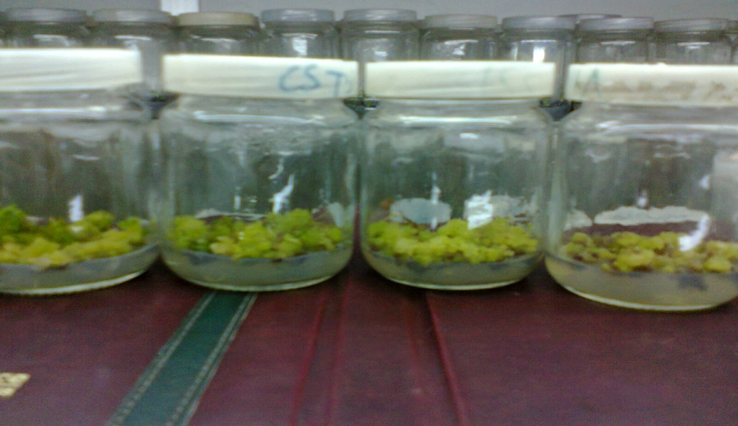

Y1
Y2
Y3
Control

Figure 1: Shoot tip calli of Pimpinella anisum L. cultured on MS-medium containing 1mg/l IAA+1mg/l 2.4-D+2mg/l kin(control) plus either 0.5(Y1) or 1.0(Y2) or 1.5(Y3) g/l of yeast after four weeks of cultivation.
Recent Publications
1- Naher, S.; Ghosh, A. and Aziz, S. (2012). Comparative Studies on Physicochemical Properties and GC-MS Analysis of Essential Oil of the Two Varieties of the Aniseed (Pimpinella anisum Linn.) in Bangladesh. Int.J.Pharm.Phytopharmacol.Res., 2 (2): 92-95.
2- Shojaii, A. and Fard, M.A. (2012). Review of Pharmacological Properties and Chemical Constituents of Pimpinella anisum. ISRN Pharmaceutics. Volume 2012, Article ID 510795, 8 pages.
3- Kadan,S.; Rayan,M. and Rayan, A.(2013). Anticancer Activity of Anise (Pimpinella anisum L.) Seed Extract. The Open Nutraceuticals Journal, 6, 1-5.
4- Ullah,H. Mahmood, A. and Honermeier, B. (2014). Essential Oil and Composition of Anise (Pimpinella Anisum L.) With Varying Seed Rates and Row Spacing. Pak. J. Bot., 46(5): 1859-1864.
5- Mohamed, K. and Koriem, M. (2015). Approach to pharmacological and clinical applications of Anisi aetheroleum. Asian Pacific Journal of Tropical Biomedicine. 5(1): 60-67.
6- Guedouar,H.; Aloui, F.; Beltifa,A.; Mansour, H.B. and Hassine, B.B.(2017).Synthesis and characterization of phenanthrene derivatives with anticancer property against human colon and epithelial cancer cell lines. C.R.Chimie, 20, 841-849.
7- Sirisha, K.B. and Sujathamma, P. (2018). In Vitro Propagation of Few Pimpinella Species: A Review. Research Journal of Life Sciences, Bioinformatics, Pharmaceutical and Chemical Sciences. 4(5) Page No.336

CURRICULUM VITAE
Full Name: Nermeen Mohammad Fouad Sayed Mahmoud Arafa.
Education Qualification:
B.Sc. in Agricultural Biochemistry, Agriculture Faculty, Cairo University, 1999. M.Sc. in Agricultural Biochemistry, Agriculture Faculty, Cairo University, 2006. Ph.D. in Agricultural Biochemistry, Agriculture Faculty, Cairo University, 2012. Ass. Prof. Dr. in plant Biotechnology, National Research Center.
Employment History:
Researcher Assistant from 1 August 2000 to 14 May 2006, National Research Center. Assistant Researcher from 30 July 2006 to 7 March 2012, National Research Center. Researcher from 3 July 2012 to 20 March 2018, National Research Center. Assistant Professor from 3 May 2018 till now, National Research Center.
Number of Publications: (10).
Research Work Presented at Conference:
Recognition of Participating as organizer in [The First Egyptian
Conference of Plant Biotechnology]. 26-27 December, 2016, National
Research Center, Egypt.
Recognition of presenting a lecture in the symposium entitled [Plant
Biotechnology] : Applications.21-21 December, 2015, National
Research Center, Egypt.
Email: nermeenfouad78@yahoo.com
Contact Number: (+2)01221787862

