Study on salt tolerance mechanisms of Halogeton glomeratus

and identification of genes for drought resistance and salt tolerance
Huajun Wang, Prof. Dr., Agronomy College, Gansu Agricultural University, China

Abstract
Soil salinization has become a major challenge for sustainable development of global agriculture. Given the limited range of genetic diversity in salt tolerance within traditional crops, stress tolerance mechanisms and genes must be identified in extreme halophytes and then introduced into traditional crops. Halogeton glomeratus (H. glomeratus) is a succulent annual halophyte and is one of the most widely distributed halophytes in Central Asia and arid regions in northwestern China. However, little is known about the physiological and molecular adaptive mechanism of tolerance to salt in this species. For this study, we analyzed the salt tolerance mechanisms of H. glomeratus under different NaCl stress conditions using morphology, cytology, physiology, biochemistry, and molecular biology approaches. Our results showed that H. glomeratus has a robust ability to tolerate salt and belongs to tolerance to osmotic stress category halophytes. The restrictive absorption of Na⁺ into roots and compartmentalization of Na⁺ into vacuoles of mesophyllous cell were considered to be the most critical aspect of salt tolerance in H. glomeratus. Then, three genes (HgS2, HgS3, and HgS4) were identified as candidate genes for drought resistance and salt tolerance in plants. These findings provide new insights into the molecular mechanisms that underlie salt tolerance of H. glomeratus and abundant gene resources to improve salt tolerance in plants. But so far we were unable to clearly address the question of how sodium is compartmentalized in the vacuoles and absorbed restrictively in roots of H. glomeratus. We speculated that different sodium transporters may be present in H. glomeratus and may efficiently compartmentalize sodium in the vacuoles and restrictive absorb in roots. Certainly, it is necessary to the further study to characterize sodium transporters in H. glomeratus.

Image

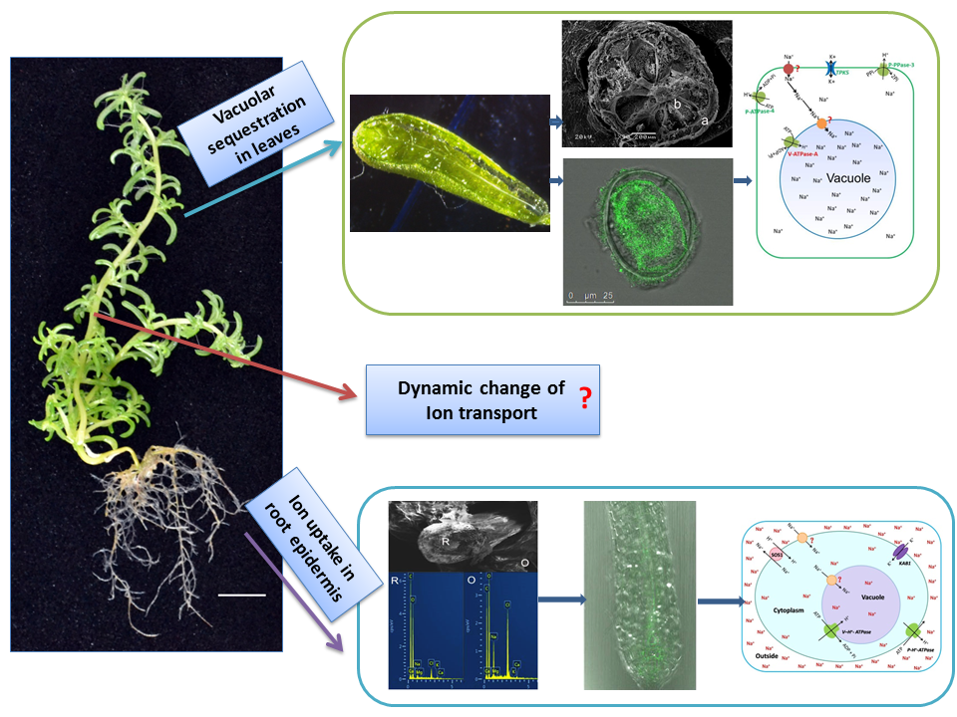

Figure 1: The pattern of on salt tolerance mechanisms of
halophyte Halogeton glomeratus
Recent Publications
- Wang H, et al. (2015) Physiological and proteomic analyses of salt stress response in the halophyte Halogeton glomeratus. Plant, cell & environment 38: 655-669.
- Wang H, et al. (2015) Transcriptomic profiling of the salt-stress response in the halophyte Halogeton glomeratus. BMC genomics 16:169.
- Wang H, et al. (2016) Comparative proteomic analysis of cultured suspension cells of the halophyte Halogeton glomeratus by iTRAQ provides insights into response mechanisms to salt stress Shock Frontiers in plant science 7:110.
- Wang H, et al. (2017) Single-molecule long-read transcriptome dataset of halophyte Halogeton glomeratus. Frontiers in genetics
8: 197.
- Wang H, et al. (2018) Transcriptome sequencing and comparative analysis of differentially-expressed isoforms in the roots of Halogeton glomeratus under salt stress. Gene 646, 159-168.

 Biography
Huajun Wang has her specific expertise and interests in the area of crop improvement and germplasm enhancement, particularly focusing on plant adaptive responses to environment, such as salinity, drought, nutritional disorders, biotic stresses. He is also interested in to apply high throughput methods to screen crop germplasm for stress tolerance and identify QTLs conferring abiotic and biotic stress tolerance to salinity, drought, nutrient deficiency, and fungal disease. The ultimate goal of his research is to improve crop yield and quality to achieve agricultural sustainability under abiotic and biotic stress conditions.
.
Email: huajunwang@sina.com Contact No: +86-09317631145

Notes/Comments:

