Pesticides Removal and Preservation of Fruit and Vegetables by Using Ultrasound Ozone and Edible Coating
Dewi Ermawati¹, Ismail Eddy Kurniawan², Yukari Laifatul Aulia³
¹ Department of Agricultural Product Technology, ^{2.3} Department of Agricultural Engineering
Faculty of Agricultural Technology
Brawijaya University

Abstract
Food safety in Indonesia is still not meet the standards of the use of chemicals such as pesticides in excess by local farmers. Basically fruits and vegetables after being harvested will be susceptible to damage due to some physical, chemical, microbiological (viral, bacterial, pathogenic) and physiological effects such as respiration that cause fruits and vegetables to wither and can not be resold. The application of ozone (O3) in the handling of fruits and vegetables has good prospects because it is safe and effective, and ozone has high oxidation potential that can be used to kill pathogenic microbes (Haifan, 2017). Based on these problems, the new innovation ideas which is sterilizer machines based on ultrasonic and ozone waves and Edible Coating. Ultrasonic-Ozone with a 40 kHz ultrasound frequency, serves as a bacterial killer and reduces pesticide. Edible Coating for fruit and vegetable aim to extend its shelf life. According Garnida (2006), edible coating is an advanced handling alternative for fruit and vegetable. Advantages of Edible Coating in addition to protecting food products, also the original appearance of the product can be maintained, can be eaten and safe.Ultrasonic-Ozone is a technology that can be utilized to reduce pesticide residue by lifting up to 91.2% (Lozowicka et al, 2015). The combination of Ultrasonic-Ozone and Automatic Edible Coating is expected to reduce pesticide residues and extend the shelf life of fruits and vegetables to create good quality and food safety.

Image
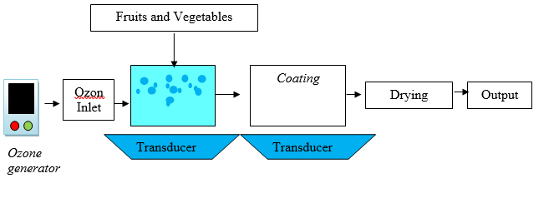
Recent Publications
- Ercan, S., et al. 2013. Use of Ultrasound in Food Preservation. Gaizentep: University of Gaizentep
- Haifan, M. 2017. Review Kajian Aplikasi Teknologi Ozon untuk Penanganan Buah, Sayuran dan Hasil Perikanan. Jurnal IPTEK Vol.1 No.1 Hal 15-21
- Hariyadi, P. 2015. Tantangan Ganda Keamanan Pangan Di Indonesia: Peranan Rekayasa Proses Pangan. Bogor: Institut Pertanian Bogor
- Hou, R., Zhang, Z., Pang, S., Yang, T., Clark, J. M., & He, L. (2016). Alteration of the nonsystemic behavior of the pesticide ferbam on tea leaves by engineered gold nanoparticles. Environmental science & technology, 50(12), 6216-6223
- Huse, M, dkk. 2014. Aplikasi Edible Coating dari Karagenan dan Gliserol untuk Mengurangi Penurunan Kerusakan Apel Romebeauty. Malang: Universitas Brawijaya
- Lozowicka, B, et al. 2015. Removal of 16 Pesticide Residues from Strawberries by Washing with Tap and Ozone Water, Ultrasonic cleaning and Boilin
- Suslow, T. 2004. Ozone Applications For Postharvest Disinfection Of Edible Horticultural Crops. UCANR Publications
- Sutrisno, Tri. 2011. Studi Karakteristik Transduser Ultrasonik Berbahan Piezoelektrik Dan Rangkaian AmplifierSwitching Terhadap Perubahan Amplitudo DanFrekuensi 1khz - 50 Khz. Skripsi. Depok: Universitas Indonesia
- Wispriyono, B, dkk. 2013. Tingkat Keamanan Konsumsi Residu Karbamat dalam Buah dan Sayur Menurut Analisis Pascakolom Kromatografi Cair Kinerja Tinggi. Jurnal Kesehatan Masyarakat Nasional Vol. 7, No. 7
- Yunita, M, dkk. 2015. Analisis Kuantitatif Mikrobiologi Pada Makanan Penerbangan (Aerofood ACS) Garuda Indonesia Berdasarkan TPC (Total Plate Count) Dengan Metode Pour Plate. Jurnal Keteknikan Pertanian Tropis dan Biosistem, 3(3), 237-248
.

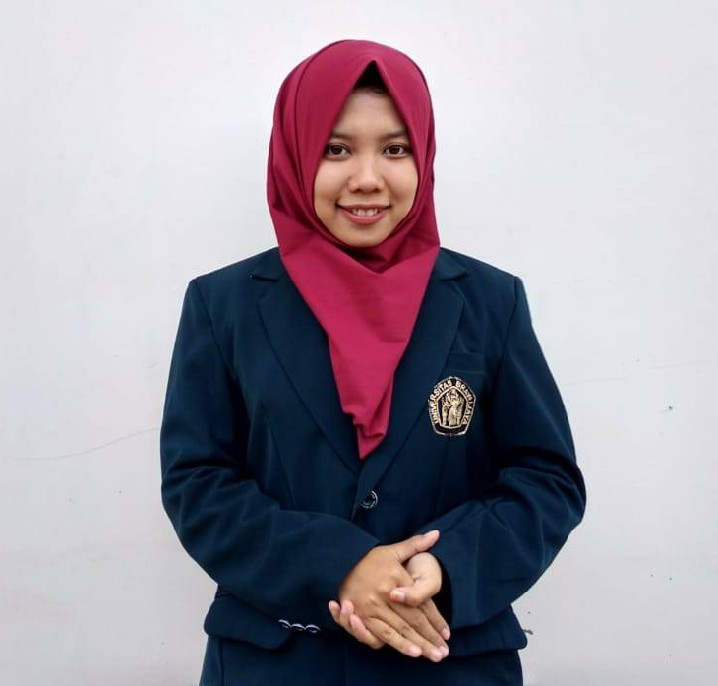 Biography
Dewi Ermawati is a student in Food Technology, Department of Post Agricultural Technology, Brawijaya University. She is passionate about food security and nutrition issues on the domestic. She wants to be able to help locale farmer to meetinternational standards as well as consumer demands..
Email: dewiermawati0326@gmail.com Contact No: 085746134369

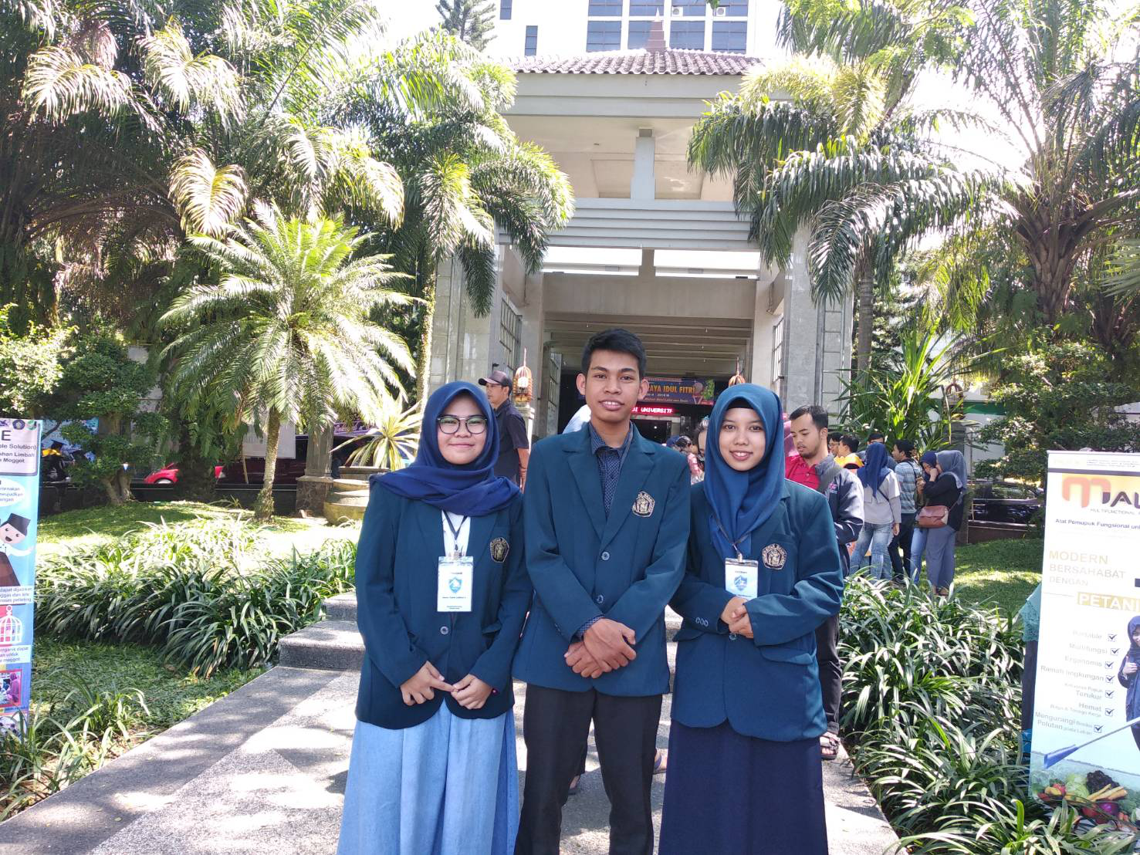 Biography
Ismail Eddy Kurniawan is a student in agriculture engineering , Department of agricultural engineering, Brawijaya University. He is passionate to develop applicable technology about food security on the domestic issues. His goal is to help changing young students’ mind-set to view farming as a business.
Email: ismaileddyk@gmail.com Contact No: 085731088259

 Biography
Yukari Latifatul Aulia is a student in bioprocess engineering , Department of agricultural engineering, Brawijaya University.She has her expertise in evaluation and controlling system of food technology. She wants to be able to create a technology that can benefit the community in terms of food security.

Email: yukariauia@gmail.com Contact No: 082244848993

