Adaptive but static: Seed yield responses of creeping red fescue (Festuca rubra L. ssp. rubra) to environmental and management factors in the Peace River Region of western Canada
Nityananda Khanal, PhD
Agriculture and Agri-Food Canada, Canada

Abstract (300 word limit)
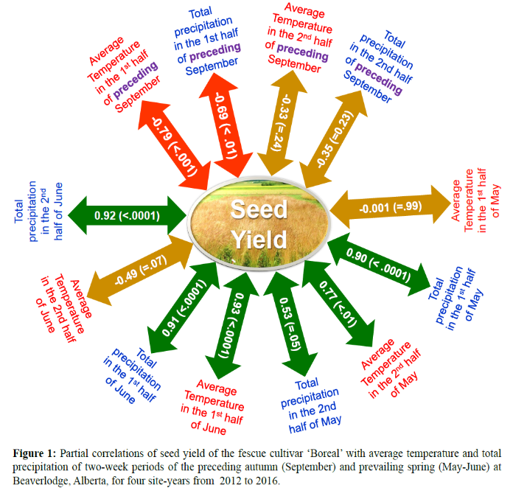
Peace River region covering about 230,000 square kilometers around 55° north Latitude and 119° west longitude is the north western agricultural frontier of Canada. The cropping environment is typified by long photoperiods during short growing season and predominance of acidic luvisolic soils with poorly developed profile. This region has evolved to be one of the major pockets of seed production of forages and turf-grasses which are exported to 34 countries with major proportion destined to the USA, China, Netherlands, Germany, Poland, Denmark and Argentina. Creeping red fescue seed constitutes major bulk of export with primary use as turf-grass for lawns and gulf courses in the temperate regions. Despite being one of the pioneer crops in the region, relatively few publications exist about yield constraints analysis and optimal crop management practices. The knowledge and technology gaps are manifested by the stagnation in seed yield of the crop. This presentation synthesizes the results of studies on creeping red fescue in the Peace River region. Relevant information will also be excerpted from studies about the temperate forage seed crops to identify potential agronomic options and knowledge gaps for enhancing the seed yield of creeping red fescue.
Recent Publications
- Fairey, N. A., & Lefkovitch, L. P. (2001). Effect of post-harvest management on seed production of creeping red fescue, tall fescue, and Kentucky bluegrass in the Peace River region of north-western Canada. Canadian journal of plant science 81: 693-701.
- Fairey, N. A., & Lefkovitch, L. P. (2000). Effect of method and time of application of nitrogen fertilizer on yield and quality of seed of creeping red fescue. Canadian journal of plant science 80: 809-811.
- Fairey, N. A., & Lefkovitch, L. P. (1996). Crop density and seed production of creeping red fescue (Festuca rubra L. var. rubra). 1. Yield and plant development. Canadian journal of plant science, 76: 291-298.
- Khanal, N., Azooz, R., Otani, J., Yoder, C. & Gauthier, T. (2017) Response of creeping red fescue (Festuca rubra L.) seed crop to timing, rate and forms of nitrogen application in the Peace region of western Canada. Poster presented in the IX International Herbage Seed Group Conference held in Pergamino, Argentina on October 31 – November 6, 2017.

Image
- Khanal, N., Azooz, R., Otani, J., Yoder, C. & Gauthier, T. (2017) Environmental correlates of creeping red fescue (Festuca rubra L. var rubra) seed yield in Peace River region of western Canada. Poster presented in the 88th Annual Meeting of the Canadian Phytopathological Society and Annual Meeting of the Canadian Society of Agronomy, held in Winnipeg, MB, Canada, June 18-20, 2017.
- Yoder, C., Khanal, N., Azooz, R., & Gauthier, T. (2017) Effect of Trinexapac-ethyl applied at three rates and two stages on timothy, meadow bromegrass and creeping red fescue seed stands in the Peace River Region of Alberta, Canada. Poster presented in the IX International Herbage Seed Group Conference held in Pergamino, Argentina on October 31 – November 6, 2017.
- Zapiola, M. L., Chastain, T. G., Garbacik, C. J., Silberstein, T. B., & Young, W. C. (2006). Trinexapac-ethyl and open-field burning maximize seed yield in creeping red fescue. Agronomy journal, 98: 1427-1434.


Biography
Nityananda Khanal is a forage research scientist at Agriculture and Agri-Food Canada. He has expertise in the agronomy of forage, field and horticultural crops with diverse work experience from tropical to temperate region, from subsistence-oriented to mechanized industrial production systems from Canada, Thailand and Nepal. His current research focusses on developing crop management practices for enhancing seed yield and quality of forage seed crops and designing cropping systems with a rational integration of perennial forage seed and annual food crops.
Email: nityananda.khanal@agr.gc.ca Contact No: 17803545111
Notes/Comments:

