Pro-vitamin A biofortification of banana by transgenic and genome editing approaches

Siddharth Tiwari, Ph.D.* and Navneet Kaur, M.Sc.
National Agri-Food Biotechnology Institute (NABI) (An autonomous Institute of Department of Biotechnology, Govt. of India), Sector-81 (Knowledge City), S.A.S. Nagar, Mohali 140306, Punjab, India.

Abstract

Statement of the Problem: Vitamin A deficiency (VAD) is a severe health problem, especially in Africa and South-East Asia. The WHO estimates show 250 million preschool children suffering from VAD worldwide and 250,000–500,000 children become blind every year and half of them die within 12 months of losing their sight. Currently, vitamin A supplementation has been implemented to alleviate VAD. However, it has other serious effects on overdosing; this can be toxic and can cause blurred vision, liver damage, reduced bone strength, headaches, birth defects, loss of hair, nausea, menstrual irregularities, skin rash, apathy, and stupor. Biofortification of staple crops is a feasible and cost-effective means of delivering micronutrients to populations that may have limited access to diverse diets and other micronutrient interventions. Banana plays important role towards nutritional security in the world. The application of conventional breeding for genetic improvement in banana is difficult due to the ploidy level and nature of parthenocarpic fruit development. Methodology & Theoretical Orientation: We aimed at enhancing pro-vitamin A (β-carotene) in banana by using gain-of-function (over-expression) and loss-of-function (CRISPR/Cas9) approaches. 1-deoxyxylulose-5-phosphate synthase (DXS), phytoene synthase (PSY) and ε-lycopene epsilon-cyclase (LCY-ε) have been identified as rate-limiting enzymes in carotenoid biosynthesis pathway. DXS provides the substrate flux while PSY performs first committed step towards the carotenoid biosynthesis pathway, whereas LCY-ε acts at branching point and diverts lycopene towards α-carotene. DXS, PSY genes were cloned from Indian banana varieties having the contrasting level of β-carotene in their fruit pulp (Nendran and Rasthali) and functionally characterized using bacterial complementation assay. DXS2 and PSY1 were found to be promising candidate genes for over-expression study. Besides, targeted gene editing was established in banana by editing of phytoene desaturase (PDS) gene through CRISPR/Cas9 approach, and subsequently, implemented for mutation of LCY-ε gene in the banana genome. Conclusion & Significance: We observed increase in β-carotene content in fruits of LCY-ε edited banana lines, whereas α-carotene and lutein found to be reduced. The best DXS2 overexpressing line is showing nearly 20-fold higher content of β-carotene with respect to control in fruits. Our results demonstrate genome editing through CRISPR/Cas9 and overexpression of DXS can be applied as efficient tools for pro-vitamin A biofortification of banana.

Image
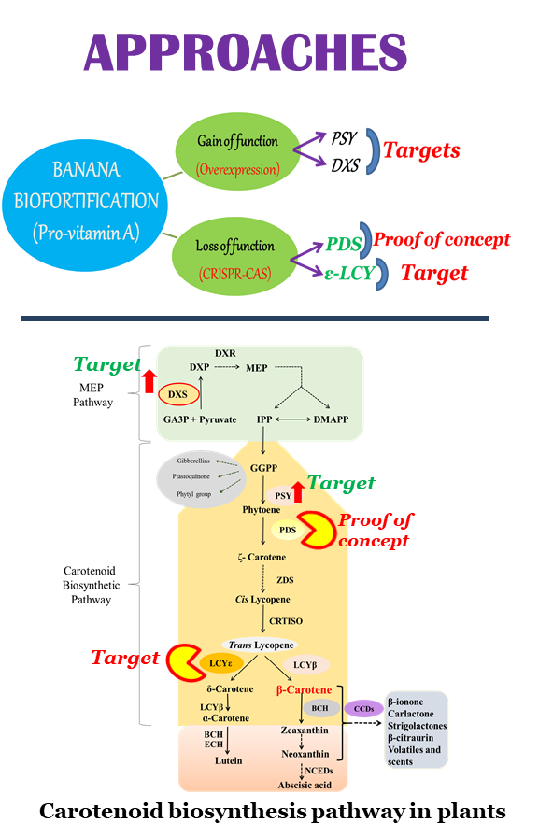

Recent Publications (minimum 5)
- Kaur N, Alok A, Shivani, Kaur N, Pandey P, Awasthi P, Tiwari S* (2018) CRISPR/Cas9 mediated efficient editing in phytoene desaturase (PDS) demonstrates precise manipulation in banana cv. Rasthali genome". Functional & Integrative Genomics. 18:89-99
- Shivani, Awasthi P, Sharma V, Kaur N, Kaur N, Pandey P, Tiwari S* (2017) Genome-wide analysis of transcription factors during somatic embryogenesis in banana (Musa spp.) cv. Grand Naine. PLoS ONE 12 (8): e0182242.
- Kaur N, Pandey A, Shivani, Kumar P, Pandey P, Kesarwani AK, Mantri SS, Awasthi P, Tiwari S* (2017) Regulation of banana phytoene synthase (MaPSY) expression, characterization and their modulation under various abiotic stress conditions. Frontiers in Plant Science. 8:462.
- Flowerika, Alok A, Kumar J, Thakur N, Pandey A, Pandey AK, Upadhyay SK, Tiwari S* (2016) Characterization and expression analysis of phytoene synthase from bread wheat (Triticum aestivum L.). PLoS ONE 11 (10):e0162443.
- Bhati KK, Alok A, Kumar A, Kaur J, Tiwari S*, Pandey AK* (2016) Silencing of ABCC13 transporter in wheat reveals its involvement in grain development, phytic acid accumulation and lateral root formation. Journal of Experimental Botany. 67:4379–4389.


Biography (150 word limit)

Siddharth Tiwari has an academic background of Genetics in Master and Plant Biotechnology in the Doctoral. He has credit prestigious national awards i.e., BioAsia Innovation Young Scientist Award, 2010 (on rabies glycoprotein antigen expression in groundnut seed) and Indian Science Congress Association (ISCA) Young Scientist Award, 2010 (on development of insect resistance transgenic variety of groundnut). He is presently working as a Scientist D at NABI and focusing his research on pro-vitamin A biofortification in banana fruit. Dr Tiwari has very recently demonstrated CRISPR/Cas mediated genome editing in cultivated variety of Indian banana (Kaur et al., 2018). It is a first-ever published report on genome editing in any fruit crops from India. This work has got wide attention by global scientific community and covered by the print and broadcast media. Recently the scientific achievement of Dr Tiwari’s lab has been telecasted by Rajya Sabha National Channel in Science Monitor program (http://nabi.res.in/researchinterview.aspx).

Email: siddharth@nabi.res.in; siddharthdna@gmail.com Contact No: +91-172-5221138 (Off.); +91-9915035533; URL: http://nabi.res.in/sidd.aspx

